UNITED STATES
SECURITIES AND EXCHANGE COMMISSION
Washington, D.C. 20549
FORM 8-K
CURRENT REPORT
Pursuant to Section 13 or 15(d) of the Securities Exchange Act of 1934
Date of Report (Date of earliest event reported): October 22, 2026
AMERICAN AIRLINES GROUP INC.
AMERICAN AIRLINES, INC.
(Exact name of registrant as specified in its charter)
Delaware |  |  |  |  |  | 1-8400 |  |  |  |  |  | 75-1825172
Delaware |  |  |  |  |  | 1-2691 |  |  |  |  |  | 13-1502798
(State or other Jurisdiction of Incorporation) |  |  |  |  |  | (Commission File Number) |  |  |  |  |  | (IRS Employer Identification No.)

1 Skyview Drive, |  |  | Fort Worth, |  |  | Texas |  |  |  |  |  |  |  |  | 76155
1 Skyview Drive, |  |  | Fort Worth, |  |  | Texas |  |  |  |  |  |  |  |  | 76155
(Address of principal executive offices) |  |  |  |  |  |  |  |  |  |  |  |  |  |  | (Zip Code)
Registrant’s telephone number, including area code:
(682) 278-9000
(682) 278-9000
Check the appropriate box below if the Form 8-K filing is intended to simultaneously satisfy the filing obligation of the registrant under any of the following provisions:
☐ |  |  | Written communications pursuant to Rule 425 under the Securities Act (17 CFR 230.425)
☐ |  |  | Soliciting material pursuant to Rule 14a-12 under the Exchange Act (17 CFR 240.14a-12)
☐ |  |  | Pre-commencement communications pursuant to Rule 14d-2(b) under the Exchange Act (17 CFR 240.14d-2(b))
☐ |  |  | Pre-commencement communications pursuant to Rule 13e-4(c) under the Exchange Act (17 CFR 240.13e-4(c))
Securities registered pursuant to Section 12(b) of the Act:
Title of each class |  |  |  |  |  | Trading  Symbol(s) |  |  |  |  |  | Name of each exchange  on which registered
Common Stock, $0.01 par value per share |  |  |  |  |  | AAL |  |  |  |  |  | The Nasdaq Global Select Market
Preferred Stock Purchase Rights |  |  |  |  |  | — |  |  |  |  |  | (1)
(1) Attached to the Common Stock
Indicate by check mark whether the registrant is an emerging growth company as defined in Rule 405 of the Securities Act of 1933 (§230.405 of this chapter) or Rule 12b-2 of the Securities Exchange Act of 1934 (§240.12b-2 of this chapter).
Emerging growth company |  |  | ☐

If an emerging growth company, indicate by check mark if the registrant has elected not to use the extended transition period for complying with any new or revised financial accounting standards provided pursuant to Section 13(a) of the Exchange Act. ☐

ITEM 2.02. |  |  | RESULTS OF OPERATIONS AND FINANCIAL CONDITION.
On October 22, 2026, American Airlines Group Inc. (the Company) issued a news release reporting financial results for the three and nine months ended September 30, 2026. The news release is furnished as Exhibit 99.1 to this report.
ITEM 7.01. |  |  | REGULATION FD DISCLOSURE.
On October 22, 2026, the Company provided a presentation to investors. This investor presentation is located on the Company’s website at www.aa.com under “Investor Relations” and is furnished as Exhibit 99.2 to this report.
The information in Items 2.02 and 7.01 of this Current Report on Form 8-K, including Exhibits 99.1 and 99.2, is being furnished and shall not be deemed to be “filed” for purposes of Section 18 of the Securities Exchange Act of 1934, as amended, or otherwise subject to the liabilities of that Section and shall not be deemed incorporated by reference into any registration statement or other document filed pursuant to the Securities Act of 1933, as amended, except as shall be expressly set forth by specific reference in such filing.
ITEM 9.01. |  |  | FINANCIAL STATEMENTS AND EXHIBITS.
(d) Exhibits.
Exhibit No. |  |  |  |  |  | Description
99.1 |  |  |  |  |  | News Release, dated October 22, 2026.
99.2 |  |  |  |  |  | Investor Presentation, dated October 22, 2026.
104.1 |  |  |  |  |  | Cover page interactive data file (embedded within the Inline XBRL document).

SIGNATURES
Pursuant to the requirements of the Securities Exchange Act of 1934, American Airlines Group Inc. has duly caused this report to be signed on its behalf by the undersigned hereunto duly authorized.
 |  |  | AMERICAN AIRLINES GROUP INC.
Date: October 22, 2026 |  |  | By: |  |  |  |  |  | /s/ Devon E. May
 |  |  |  |  |  |  |  |  | Devon E. May
Executive Vice President and
Chief Financial Officer
Pursuant to the requirements of the Securities Exchange Act of 1934, American Airlines, Inc. has duly caused this report to be signed on its behalf by the undersigned hereunto duly authorized.
 |  |  | AMERICAN AIRLINES, INC.
Date: October 22, 2026 |  |  | By: |  |  |  |  |  | /s/ Devon E. May
 |  |  |  |  |  |  |  |  | Devon E. May
Executive Vice President and
Chief Financial Officer

Exhibit 99.1

 |  |  | 
 |  |  |  |  |  | Corporate Communications
 |  |  |  |  |  | mediarelations@aa.com
 |  |  |  |  |  | Investor Relations
 |  |  |  |  |  | investor.relations@aa.com
FOR RELEASE: Thursday, Oct. 22, 2026
American sets new revenue records amid historic fuel cost pressure
FORT WORTH, Texas — American Airlines Group Inc. (NASDAQ: AAL) today reported its third-quarter 2026 financial results, reflecting execution of its commercial strategy and the benefits of long-term investments in its customers, team members, network, fleet and technology.
Third-quarter financial highlights:
•Total revenue of $16.3 billion, up 19.3% year over year, above the high end of the previously announced guidance range.
•Delivered the best unit cost performance among the network carriers, with CASM-ex1 up 3.0%.
•Fuel expense for the quarter increased $1.9 billion, or 67.5%, year over year.
•GAAP net loss of $269 million, or ($0.41) per diluted share.
•Adjusted net loss of $182 million2, or ($0.28) per diluted share. Adjusted net loss was only $71 million below third quarter 2025 despite the $1.9 billion increase in fuel expense.
“American delivered record third-quarter revenue and the strongest year-over-year revenue growth in my career, with premium performance leading the way,” said American’s CEO Robert Isom. “The investments we are making across the four pillars of our commercial strategy are working, and we expect another quarter of record revenue growth to close out the year. While historically high fuel prices significantly impacted our financial results, our focus remains on restoring profitability and building a stronger American for the long term. I’m grateful to the American Airlines team for making this progress possible.”
The company’s third-quarter results were driven by strong revenue performance across all geographies and cabins:
•Premium revenue increased 22.9%, and Main Cabin revenue increased 19.5% year over year.
•Total unit revenue increased 14.5% year over year, reflecting continued strength in demand for travel.
•Domestic passenger unit revenue increased 13.6% year over year in the third quarter.
•International passenger unit revenue increased 16.4%, with the Latin America entity up 21.1%, the Atlantic entity up 14.5% and the Pacific entity up 11.3% compared to the third quarter of 2025.
•AAdvantage® enrollments increased 27.4% year over year.
•Demand for business travel remained strong, with managed corporate revenue increasing 27.6% year over year, marking the sixth consecutive quarter of double-digit growth.
American sets new revenue records amid historic fuel cost pressure

Oct. 22, 2026 | Page 2

This revenue performance was a result of the company’s continued focus on its four commercial pillars: elevate the customer experience, grow the global network, drive premium revenue and lead in loyalty.
1) Elevate the customer experience
American’s investments in high-speed connectivity, lounges, seatback entertainment, airport facilities and fleet modernization are creating the foundation for a best-in-class customer experience.
In May, American announced plans to equip more than 500 aircraft with high-speed Starlink Wi-Fi, representing the largest in-flight connectivity upgrade in the airline’s history. Building on that commitment, the company announced on Oct. 8 that it plans to expand Starlink installation across its entire mainline fleet, bringing the technology to more than 1,000 aircraft. Once installation is complete, American will offer one of the largest fleets of Starlink-connected aircraft in the world.
The company also continues to grow its Admirals Club® and premium lounge network with more lounges opening or being renovated than at any point in company history. Additionally, American announced the expansion of seatback entertainment to the narrowbody fleet, including screens on new deliveries beginning in 2028. With these foundational investments underway, American remains focused on further improving customer satisfaction through enhanced operational reliability, better disruption management and a more consistent travel experience.
2) Grow the global network
American continues to strengthen its global network, offering customers more destinations, better connectivity and greater schedule utility. At Dallas Fort Worth International Airport (DFW), this year’s rebank produced record passenger volumes, fewer misconnections and mishandled bags, and unit revenue that outpaced the rest of the system. In Chicago, Miami, Philadelphia and Phoenix, American is building stronger schedules for local customers.
3) Drive premium revenue
American continues to see momentum in premium demand, demonstrating the benefits of recent investments across its premium products and customer experience. Premium passenger unit revenue increased 18.5% year over year during the third quarter, compared with an increase of 14.4% in Main Cabin.
American plans to continue expanding premium seating through the delivery of new aircraft and the retrofit of existing aircraft. Premium products generate roughly half of the company’s ticket revenue on approximately 30% of seats today. Through the recently announced narrowbody retrofit program, American expects premium seats on narrowbody aircraft to increase to 40% in the coming years.
The company also continues to take actions to improve revenue quality and provide customers with a broader range of choices. These initiatives contributed to a 6-point increase in the upsell rate from Basic Economy to Main Cabin during the quarter.
American sets new revenue records amid historic fuel cost pressure

Oct. 22, 2026 | Page 3

4) Lead in loyalty
The AAdvantage® program remains one of American’s strongest competitive advantages, driving customer engagement, premium demand and long-term value creation. The program continues to benefit from strong member activity, increased engagement and enhancements to American’s co-branded credit card program.
Enrollments in the AAdvantage® program increased 27.4% year over year in the third quarter. American’s co-branded credit card partnership with Citi saw year-over-year third-quarter card spend growth of nearly 10%.
Efficiency and cost performance
American continues to benefit from long-term investments in technology, procurement and other initiatives designed to build a more efficient and resilient airline. The company is reengineering how work gets done across the business, improving productivity and simplifying processes while continuing to invest in the customer and team member experience.
By the end of 2026, the company expects to have achieved nearly $1 billion in annual run rate savings and more than $900 million in working capital improvements through its multiyear reengineering efforts. American continues to identify opportunities to use technology, automation and artificial intelligence to simplify the business and equip team members with better tools to improve decision-making.
“We remain focused on the factors that drive the most value,” said American’s Chief Financial Officer Devon May. “Our long-term focus on efficiency supported industry-leading unit cost results in the quarter, with CASM-ex increasing 3.0% year over year. For the full year, we expect to lead the network carriers in the spread between year-over-year unit revenue and CASM-ex growth.”
Overall financial results were pressured by a significant increase in fuel costs. American paid an average of $3.85 per gallon in the third quarter, which increased fuel expense by $1.9 billion year over year.
Balance sheet and liquidity
American ended the third quarter with $11.8 billion of total available liquidity and more than $26 billion of unencumbered assets and first-lien capacity. The company remains committed to reducing debt, lowering interest expense and achieving its target of 3.0x net debt3 to EBITDAR, in line with BB credit metrics.

Outlook and financial guidance
In the fourth quarter, the company expects continued revenue strength, with year-over-year revenue growth between 19.5% and 22.5%. Based on the forward fuel curve as of Oct. 19, American anticipates an average fuel price of approximately $4.70 per gallon, nearly double the price paid in the fourth quarter of 2025. At that price, fuel expense is expected to increase approximately $2.8 billion versus the fourth quarter of 2025.
Given elevated fuel prices, American expects network growth in 2027 to slow from 2026 levels.

American sets new revenue records amid historic fuel cost pressure

Oct. 22, 2026 | Page 4

4Q 2026E (vs. 4Q 2025)
Available seat miles |  |  | +5.5% – +6.5%
Total revenue |  |  | +19.5% – +22.5%
CASM excluding net special items, fuel and profit sharing1 |  |  | +2.5% – +3.5%
Adjusted loss per diluted share4 |  |  | ($1.10) – ($0.50)
FY 2026E
Adjusted loss per diluted share4 |  |  | ($1.60) – ($1.00)

Conference call and webcast
American will host a conference call at 7:30 a.m. CT today. A live webcast and replay will be available at American’s investor relations website.
Notes
See the accompanying notes in the financial tables section of this news release for further explanation, including reconciliations of certain GAAP to non-GAAP financial information.
1.Cost per available seat mile excluding net special items, fuel and profit sharing, or CASM-ex, is a non-GAAP measure. The company is unable to reconcile certain forward-looking information to GAAP because the nature or amount of net special items cannot be determined at this time.
2.Adjusted net loss is a non-GAAP financial measure and excludes $87 million of net special items after the effect of taxes that the company recognized in the third quarter.
3.Net debt includes debt, finance and operating lease liabilities and pension obligations less unrestricted cash and short-term investments.
4.Adjusted loss per diluted share guidance excludes the impact of net special items and represents an absolute number, not a year-over-year comparison. The company is unable to reconcile certain forward-looking information to GAAP as the nature or amount of net special items cannot be determined at this time.
Other: Third-quarter revenue growth of 19.3% is the highest in company history excluding the years following the pandemic.

About American Airlines Group (NASDAQ: AAL)
American Airlines is a premium global airline connecting more of the U.S. to the world. With roots tracing back to an air mail carrier in the Midwestern United States in 1926, American now operates more than 6,000 daily flights to more than 350 destinations in more than 60 countries and serves more than 200 million customers annually. Powered by a proud and talented team of 140,000 aviation professionals, American’s team lives out the airline’s purpose of caring for people on life’s journey every day.
The world’s largest airline proudly celebrates its centennial year in 2026, reaching a milestone that reflects a century of innovation and the Forever ForwardSM spirit that changed the industry and the world. American introduced the first scheduled air cargo service, the first airport lounge and the first airline loyalty program and continues to reinvent the customer experience today. The airline is also a founding member of the oneworld alliance, whose members serve more than 900 destinations around the globe.
Get the latest about American at news.aa.com and @AmericanAir.
American sets new revenue records amid historic fuel cost pressure

Oct. 22, 2026 | Page 5

Use of websites and social media to disclose information
American routinely uses the investor relations section of its website as well as its social media pages, including on Facebook and X, and its newsroom at news.aa.com, to disclose important information about American Airlines Group Inc. and its subsidiaries and to comply with its disclosure obligations under Regulation Fair Disclosure. The information contained on, or that may be accessed through, the company’s website, social media channels or newsroom is not incorporated by reference into, and is not a part of, this document, and all website addresses in this document are intended to be inactive textual references only.

Cautionary statement regarding forward-looking statements and information
Certain of the statements contained in this document should be considered forward-looking statements within the meaning of the Securities Act of 1933, as amended, the Securities Exchange Act of 1934, as amended, and the Private Securities Litigation Reform Act of 1995. These forward-looking statements may be identified by words such as “may,” “will,” “expect,” “intend,” “anticipate,” “believe,” “estimate,” “plan,” “project,” “could,” “should,” “would,” “continue,” “seek,” “target,” “guidance,” “outlook,” “if current trends continue,” “optimistic,” “forecast” and other similar words. Such statements include, but are not limited to, statements about the company’s plans, objectives, expectations, intentions, estimates and strategies for the future, and other statements that are not historical facts. These forward-looking statements are based on the company’s current objectives, beliefs and expectations, and they are subject to significant risks and uncertainties that may cause actual results and financial position and timing of certain events to differ materially from the information in the forward-looking statements. These risks and uncertainties include, but are not limited to, downturns in economic conditions could adversely affect our business; we will need to obtain sufficient financing or other capital to operate successfully; our high level of debt and other obligations may limit our ability to fund general corporate requirements and obtain additional financing, may limit our flexibility in responding to competitive developments and may cause our business to be vulnerable to adverse economic and industry conditions; if our financial condition worsens, provisions in our credit card processing and other commercial agreements may adversely affect our liquidity; the loss of key personnel whom we depend on to operate our business, or the inability to attract, develop and retain additional qualified personnel could adversely affect our business; our business has been and will continue to be materially affected by many changing economic, geopolitical, commercial, regulatory and other conditions beyond our control, including global events that affect travel behavior; the airline industry is intensely competitive and dynamic; union disputes, employee strikes and other labor-related disruptions may adversely affect our operations and financial performance; if we encounter problems with any of our third-party regional operators or third-party service providers, our operations could be adversely affected by a resulting decline in revenue or negative public perception about our services; any damage to our reputation or brand image could adversely affect our business or financial results; risks of losses and adverse publicity from any public incidents involving our company, people or brand; changes to our business model that are designed to increase revenues and reduce costs may not be successful and may cause operational difficulties or decreased demand; our intellectual property rights, particularly our branding rights, are valuable, and any inability to protect them may adversely affect our business and financial results; we may be a party to litigation in the normal course of business or otherwise, which could affect our financial position and liquidity; we rely heavily on technology and automated systems, including artificial intelligence, to operate our business, and any failures could harm our business, results of operations and financial condition; evolving data privacy requirements could increase our costs, and any significant cybersecurity incident
American sets new revenue records amid historic fuel cost pressure

Oct. 22, 2026 | Page 6

could disrupt our operations, harm our reputation, expose us to legal risks and otherwise materially adversely affect our business, results of operations and financial condition; we are exposed to risks from cyberattacks, and any cybersecurity incidents involving us, our third-party service providers, or one of our AAdvantage partners or other business partners; we have a significant amount of goodwill, which is assessed for impairment at least annually. We may never realize the full value of our intangible or long-lived assets, causing us to record material impairment charges; the commercial relationships that we have with other companies, including any related equity investments, may not produce the returns or results we expect; our business is very dependent on the price and availability of aircraft fuel. Continued periods of high volatility in fuel costs, increased fuel prices or significant disruptions in the supply of aircraft fuel could have a significant negative impact on consumer demand, our operating results and liquidity; our business is subject to extensive government regulation; we can be adversely affected by any prolonged partial or full U.S. Government shutdown; we operate a global business with international operations that are subject to economic and political instability and have been, and in the future may continue to be, adversely affected by numerous events, circumstances or government actions beyond our control; we may be adversely affected by conflicts overseas, terrorist attacks or other acts of violence, domestically or abroad; the travel industry continues to face ongoing security concerns; we are subject to risks associated with climate change, including increased regulation of our greenhouse gas emissions, changing consumer preferences and the potential for increased impacts of severe weather events on our operations and infrastructure; we are subject to various risks associated with environmental and social matters, and many forms of environmental and noise regulation; a shortage of pilots or other personnel could materially adversely affect our business; we depend on a limited number of suppliers for aircraft, aircraft engines and parts. Delays in scheduled aircraft deliveries, unexpected grounding of aircraft or aircraft engines whether by regulators or by us, or other loss of anticipated fleet capacity, and failure of new aircraft to receive regulatory approval, be produced or otherwise perform as and when expected, adversely impacts our business, results of operations and financial condition; we rely on third-party distribution channels and must effectively manage the costs, rights and functionality of these channels; if we are unable to obtain and maintain adequate facilities and infrastructure throughout our system and, at some airports, adequate slots, we may be unable to operate our existing flight schedule and to expand or change our route network in the future; interruptions or disruptions in service at one of our key facilities; increases in insurance costs or reductions in insurance coverage, and heavy taxation of the airline industry; risks related to ownership of AAG common stock; and other risks set forth herein as well as in the company’s latest annual report on Form 10-K for the year ended December 31, 2025 (especially in Part I, Item 1A. Risk Factors and Part II, Item 7. Management’s Discussion and Analysis of Financial Condition and Results of Operations) and subsequent quarterly reports on Form 10-Q (especially in Part I, Item 2. Management’s Discussion and Analysis of Financial Condition and Results of Operations and Part II, Item 1A. Risk Factors), and other risks and uncertainties listed from time to time in the company’s other filings with the Securities and Exchange Commission. Additionally, there may be other factors of which the company is not currently aware that may affect matters discussed in the forward-looking statements and may also cause actual results to differ materially from those discussed. The company does not assume any obligation to publicly update or supplement any forward-looking statement to reflect actual results, changes in assumptions or changes in other factors affecting these forward-looking statements other than as required by law. Any forward-looking statements speak only as of the date hereof or as of the dates indicated in the statement.

American sets new revenue records amid historic fuel cost pressure

Oct. 22, 2026 | Page 7

American Airlines Group Inc.
Condensed Consolidated Statements of Operations
(In millions, except share and per share amounts)
(Unaudited)
 |  |  | 3 Months Ended  September 30, |  |  |  |  |  |  |  |  |  |  |  | Percent  Increase  (Decrease) |  |  |  |  |  | 9 Months Ended  September 30, |  |  |  |  |  |  |  |  |  |  |  | Percent  Increase  (Decrease)
 |  |  | 2026 |  |  |  |  |  | 2025 |  |  |  |  |  |  |  |  |  |  |  | 2026 |  |  |  |  |  | 2025
Operating revenues:
Passenger |  |  | $ | 14,900 |  |  |  |  | $ | 12,471 |  |  |  |  | 19.5 |  |  |  |  |  | $ | 42,609 |  |  |  |  | $ | 36,985 |  |  |  |  | 15.2
Cargo |  |  | 274 |  |  |  |  |  | 212 |  |  |  |  |  | 29.1 |  |  |  |  |  | 761 |  |  |  |  |  | 612 |  |  |  |  |  | 24.3
Other |  |  | 1,161 |  |  |  |  |  | 1,008 |  |  |  |  |  | 15.2 |  |  |  |  |  | 3,612 |  |  |  |  |  | 3,037 |  |  |  |  |  | 18.9
Total operating revenues |  |  | 16,335 |  |  |  |  |  | 13,691 |  |  |  |  |  | 19.3 |  |  |  |  |  | 46,982 |  |  |  |  |  | 40,634 |  |  |  |  |  | 15.6
Operating expenses:
Aircraft fuel and related taxes |  |  | 4,635 |  |  |  |  |  | 2,767 |  |  |  |  |  | 67.5 |  |  |  |  |  | 12,444 |  |  |  |  |  | 8,017 |  |  |  |  |  | 55.2
Salaries, wages and benefits |  |  | 4,713 |  |  |  |  |  | 4,461 |  |  |  |  |  | 5.7 |  |  |  |  |  | 14,027 |  |  |  |  |  | 13,065 |  |  |  |  |  | 7.4
Regional expenses:
Regional operating expenses |  |  | 1,356 |  |  |  |  |  | 1,286 |  |  |  |  |  | 5.5 |  |  |  |  |  | 4,012 |  |  |  |  |  | 3,809 |  |  |  |  |  | 5.3
Regional depreciation and amortization |  |  | 93 |  |  |  |  |  | 84 |  |  |  |  |  | 10.5 |  |  |  |  |  | 276 |  |  |  |  |  | 244 |  |  |  |  |  | 13.0
Maintenance, materials and repairs |  |  | 1,092 |  |  |  |  |  | 1,028 |  |  |  |  |  | 6.2 |  |  |  |  |  | 3,100 |  |  |  |  |  | 2,876 |  |  |  |  |  | 7.8
Other rent and landing fees |  |  | 996 |  |  |  |  |  | 906 |  |  |  |  |  | 9.9 |  |  |  |  |  | 2,862 |  |  |  |  |  | 2,627 |  |  |  |  |  | 9.0
Aircraft rent |  |  | 309 |  |  |  |  |  | 310 |  |  |  |  |  | (0.5) |  |  |  |  |  | 926 |  |  |  |  |  | 910 |  |  |  |  |  | 1.7
Selling expenses |  |  | 553 |  |  |  |  |  | 483 |  |  |  |  |  | 14.7 |  |  |  |  |  | 1,664 |  |  |  |  |  | 1,467 |  |  |  |  |  | 13.4
Depreciation and amortization |  |  | 493 |  |  |  |  |  | 474 |  |  |  |  |  | 3.9 |  |  |  |  |  | 1,446 |  |  |  |  |  | 1,418 |  |  |  |  |  | 2.0
Special items, net |  |  | 9 |  |  |  |  |  | 7 |  |  |  |  |  | 22.5 |  |  |  |  |  | 29 |  |  |  |  |  | 125 |  |  |  |  |  | (76.6)
Other |  |  | 1,971 |  |  |  |  |  | 1,734 |  |  |  |  |  | 13.7 |  |  |  |  |  | 5,675 |  |  |  |  |  | 5,061 |  |  |  |  |  | 12.1
Total operating expenses |  |  | 16,220 |  |  |  |  |  | 13,540 |  |  |  |  |  | 19.8 |  |  |  |  |  | 46,461 |  |  |  |  |  | 39,619 |  |  |  |  |  | 17.3
Operating income |  |  | 115 |  |  |  |  |  | 151 |  |  |  |  |  | (23.4) |  |  |  |  |  | 521 |  |  |  |  |  | 1,015 |  |  |  |  |  | (48.7)
Nonoperating income (expense):
Interest income |  |  | 87 |  |  |  |  |  | 90 |  |  |  |  |  | (3.8) |  |  |  |  |  | 217 |  |  |  |  |  | 285 |  |  |  |  |  | (24.0)
Interest expense, net |  |  | (435) |  |  |  |  |  | (432) |  |  |  |  |  | 0.7 |  |  |  |  |  | (1,242) |  |  |  |  |  | (1,294) |  |  |  |  |  | (4.0)
Other income (expense), net |  |  | (101) |  |  |  |  |  | 49 |  |  |  |  |  | nm |  |  | (1) |  |  | (198) |  |  |  |  |  | 42 |  |  |  |  |  | nm
Total nonoperating expense, net |  |  | (449) |  |  |  |  |  | (293) |  |  |  |  |  | 53.8 |  |  |  |  |  | (1,223) |  |  |  |  |  | (967) |  |  |  |  |  | 26.5
Income (loss) before income taxes |  |  | (334) |  |  |  |  |  | (142) |  |  |  |  |  | nm |  |  |  |  |  | (702) |  |  |  |  |  | 48 |  |  |  |  |  | nm
Income tax provision (benefit) |  |  | (65) |  |  |  |  |  | (28) |  |  |  |  |  | nm |  |  |  |  |  | (122) |  |  |  |  |  | 36 |  |  |  |  |  | nm
Net income (loss) |  |  | $ | (269) |  |  |  |  | $ | (114) |  |  |  |  | nm |  |  |  |  |  | $ | (580) |  |  |  |  | $ | 12 |  |  |  |  | nm
Earnings (loss) per common share:
Basic |  |  | $ | (0.41) |  |  |  |  | $ | (0.17) |  |  |  |  |  |  |  |  |  |  | $ | (0.88) |  |  |  |  | $ | 0.02
Diluted |  |  | $ | (0.41) |  |  |  |  | $ | (0.17) |  |  |  |  |  |  |  |  |  |  | $ | (0.88) |  |  |  |  | $ | 0.02
Weighted average shares outstanding (in thousands):
Basic |  |  | 662,706 |  |  |  |  |  | 660,358 |  |  |  |  |  |  |  |  |  |  |  | 662,026 |  |  |  |  |  | 659,788
Diluted |  |  | 662,706 |  |  |  |  |  | 660,358 |  |  |  |  |  |  |  |  |  |  |  | 662,026 |  |  |  |  |  | 660,784
Note: Percent change may not recalculate due to rounding.
(1)Not meaningful or greater than 100% change.

American sets new revenue records amid historic fuel cost pressure

Oct. 22, 2026 | Page 8

American Airlines Group Inc.
Consolidated Operating Statistics (1)
(Unaudited)
 |  |  | 3 Months Ended  September 30, |  |  |  |  |  |  |  |  |  |  |  | Increase  (Decrease) |  |  |  |  |  | 9 Months Ended  September 30, |  |  |  |  |  |  |  |  |  |  |  | Increase  (Decrease)
 |  |  | 2026 |  |  |  |  |  | 2025 |  |  |  |  |  |  |  |  |  |  |  | 2026 |  |  |  |  |  | 2025
Revenue passenger miles (millions) |  |  | 67,265 |  |  |  |  |  | 66,580 |  |  |  |  |  | 1.0 % |  |  |  |  |  | 193,934 |  |  |  |  |  | 188,698 |  |  |  |  |  | 2.8 %
Available seat miles (ASM) (millions) |  |  | 80,680 |  |  |  |  |  | 77,400 |  |  |  |  |  | 4.2 % |  |  |  |  |  | 234,533 |  |  |  |  |  | 224,939 |  |  |  |  |  | 4.3 %
Passenger load factor (percent) |  |  | 83.4 |  |  |  |  |  | 86.0 |  |  |  |  |  | (2.6) pts |  |  |  |  |  | 82.7 |  |  |  |  |  | 83.9 |  |  |  |  |  | (1.2) pts
Yield (cents) |  |  | 22.15 |  |  |  |  |  | 18.73 |  |  |  |  |  | 18.3 % |  |  |  |  |  | 21.97 |  |  |  |  |  | 19.60 |  |  |  |  |  | 12.1 %
Passenger revenue per ASM (cents) |  |  | 18.47 |  |  |  |  |  | 16.11 |  |  |  |  |  | 14.6 % |  |  |  |  |  | 18.17 |  |  |  |  |  | 16.44 |  |  |  |  |  | 10.5 %
Total revenue per ASM (cents) |  |  | 20.25 |  |  |  |  |  | 17.69 |  |  |  |  |  | 14.5 % |  |  |  |  |  | 20.03 |  |  |  |  |  | 18.06 |  |  |  |  |  | 10.9 %
Cargo ton miles (millions) |  |  | 625 |  |  |  |  |  | 545 |  |  |  |  |  | 14.7 % |  |  |  |  |  | 1,790 |  |  |  |  |  | 1,550 |  |  |  |  |  | 15.5 %
Cargo yield per ton mile (cents) |  |  | 43.86 |  |  |  |  |  | 38.94 |  |  |  |  |  | 12.6 % |  |  |  |  |  | 42.52 |  |  |  |  |  | 39.52 |  |  |  |  |  | 7.6 %
Fuel consumption (gallons in millions) |  |  | 1,204 |  |  |  |  |  | 1,169 |  |  |  |  |  | 3.0 % |  |  |  |  |  | 3,473 |  |  |  |  |  | 3,375 |  |  |  |  |  | 2.9 %
Average aircraft fuel price including related taxes (dollars per gallon) |  |  | 3.85 |  |  |  |  |  | 2.37 |  |  |  |  |  | 62.7 % |  |  |  |  |  | 3.58 |  |  |  |  |  | 2.38 |  |  |  |  |  | 50.8 %
Operating cost per ASM (cents) |  |  | 20.10 |  |  |  |  |  | 17.49 |  |  |  |  |  | 14.9 % |  |  |  |  |  | 19.81 |  |  |  |  |  | 17.61 |  |  |  |  |  | 12.5 %
Operating cost per ASM excluding net special items (cents) |  |  | 20.08 |  |  |  |  |  | 17.48 |  |  |  |  |  | 14.9 % |  |  |  |  |  | 19.79 |  |  |  |  |  | 17.56 |  |  |  |  |  | 12.7 %
Operating cost per ASM excluding net special items and fuel (cents) |  |  | 14.34 |  |  |  |  |  | 13.91 |  |  |  |  |  | 3.1 % |  |  |  |  |  | 14.49 |  |  |  |  |  | 13.99 |  |  |  |  |  | 3.5 %
Operating cost per ASM excluding net special items, fuel and profit sharing (cents) |  |  | 14.34 |  |  |  |  |  | 13.92 |  |  |  |  |  | 3.0 % |  |  |  |  |  | 14.49 |  |  |  |  |  | 13.98 |  |  |  |  |  | 3.6 %
Passenger enplanements (thousands) |  |  | 58,143 |  |  |  |  |  | 58,474 |  |  |  |  |  | (0.6) % |  |  |  |  |  | 169,014 |  |  |  |  |  | 168,220 |  |  |  |  |  | 0.5 %
Departures (thousands):
Mainline |  |  | 304 |  |  |  |  |  | 298 |  |  |  |  |  | 2.3 % |  |  |  |  |  | 896 |  |  |  |  |  | 881 |  |  |  |  |  | 1.7 %
Regional |  |  | 281 |  |  |  |  |  | 267 |  |  |  |  |  | 5.3 % |  |  |  |  |  | 820 |  |  |  |  |  | 787 |  |  |  |  |  | 4.2 %
Total |  |  | 585 |  |  |  |  |  | 565 |  |  |  |  |  | 3.7 % |  |  |  |  |  | 1,716 |  |  |  |  |  | 1,668 |  |  |  |  |  | 2.9 %
Average stage length (miles):
Mainline |  |  | 1,220 |  |  |  |  |  | 1,201 |  |  |  |  |  | 1.6 % |  |  |  |  |  | 1,212 |  |  |  |  |  | 1,188 |  |  |  |  |  | 2.0 %
Regional |  |  | 471 |  |  |  |  |  | 464 |  |  |  |  |  | 1.4 % |  |  |  |  |  | 473 |  |  |  |  |  | 465 |  |  |  |  |  | 1.9 %
Total |  |  | 861 |  |  |  |  |  | 853 |  |  |  |  |  | 0.9 % |  |  |  |  |  | 859 |  |  |  |  |  | 846 |  |  |  |  |  | 1.5 %
Aircraft at end of period:
Mainline |  |  | 1,037 |  |  |  |  |  | 998 |  |  |  |  |  | 3.9 % |  |  |  |  |  | 1,037 |  |  |  |  |  | 998 |  |  |  |  |  | 3.9 %
Regional (2) |  |  | 587 |  |  |  |  |  | 557 |  |  |  |  |  | 5.4 % |  |  |  |  |  | 587 |  |  |  |  |  | 557 |  |  |  |  |  | 5.4 %
Total |  |  | 1,624 |  |  |  |  |  | 1,555 |  |  |  |  |  | 4.4 % |  |  |  |  |  | 1,624 |  |  |  |  |  | 1,555 |  |  |  |  |  | 4.4 %
Full-time equivalent employees at end of period:
Mainline |  |  | 107,700 |  |  |  |  |  | 104,900 |  |  |  |  |  | 2.7 % |  |  |  |  |  | 107,700 |  |  |  |  |  | 104,900 |  |  |  |  |  | 2.7 %
Regional (3) |  |  | 33,400 |  |  |  |  |  | 32,000 |  |  |  |  |  | 4.4 % |  |  |  |  |  | 33,400 |  |  |  |  |  | 32,000 |  |  |  |  |  | 4.4 %
Total |  |  | 141,100 |  |  |  |  |  | 136,900 |  |  |  |  |  | 3.1 % |  |  |  |  |  | 141,100 |  |  |  |  |  | 136,900 |  |  |  |  |  | 3.1 %
Note: Amounts may not recalculate due to rounding.
(1)Unless otherwise noted, operating statistics include mainline and regional operations. Regional includes wholly-owned regional airline subsidiaries and operating results from capacity purchase carriers.
(2)Includes aircraft owned and leased by American as well as aircraft operated by third-party regional carriers under capacity purchase agreements. Excluded from the aircraft count above are two Bombardier CRJ900 regional aircraft that are held in temporary storage as of September 30, 2026.
(3)Regional full-time equivalent employees only include our wholly-owned regional airline subsidiaries.

American sets new revenue records amid historic fuel cost pressure

Oct. 22, 2026 | Page 9

American Airlines Group Inc.
Consolidated Revenue Statistics by Region
(Unaudited)
 |  |  | 3 Months Ended  September 30, |  |  |  |  |  |  |  |  |  |  |  | Increase  (Decrease) |  |  |  |  |  | 9 Months Ended  September 30, |  |  |  |  |  |  |  |  |  |  |  | Increase  (Decrease)
 |  |  | 2026 |  |  |  |  |  | 2025 |  |  |  |  |  |  |  |  |  |  |  | 2026 |  |  |  |  |  | 2025
Domestic (1)
Revenue passenger miles (millions) |  |  | 44,579 |  |  |  |  |  | 43,741 |  |  |  |  |  | 1.9 % |  |  |  |  |  | 129,068 |  |  |  |  |  | 125,206 |  |  |  |  |  | 3.1 %
Available seat miles (ASM) (millions) |  |  | 54,096 |  |  |  |  |  | 51,106 |  |  |  |  |  | 5.9 % |  |  |  |  |  | 157,579 |  |  |  |  |  | 149,762 |  |  |  |  |  | 5.2 %
Passenger load factor (percent) |  |  | 82.4 |  |  |  |  |  | 85.6 |  |  |  |  |  | (3.2) pts |  |  |  |  |  | 81.9 |  |  |  |  |  | 83.6 |  |  |  |  |  | (1.7) pts
Passenger revenue (dollars in millions) |  |  | 10,489 |  |  |  |  |  | 8,723 |  |  |  |  |  | 20.2 % |  |  |  |  |  | 30,205 |  |  |  |  |  | 26,010 |  |  |  |  |  | 16.1 %
Yield (cents) |  |  | 23.53 |  |  |  |  |  | 19.94 |  |  |  |  |  | 18.0 % |  |  |  |  |  | 23.40 |  |  |  |  |  | 20.77 |  |  |  |  |  | 12.7 %
Passenger revenue per ASM (cents) |  |  | 19.39 |  |  |  |  |  | 17.07 |  |  |  |  |  | 13.6 % |  |  |  |  |  | 19.17 |  |  |  |  |  | 17.37 |  |  |  |  |  | 10.4 %
Latin America (2)
Revenue passenger miles (millions) |  |  | 7,706 |  |  |  |  |  | 7,726 |  |  |  |  |  | (0.3) % |  |  |  |  |  | 26,612 |  |  |  |  |  | 26,106 |  |  |  |  |  | 1.9 %
Available seat miles (millions) |  |  | 8,807 |  |  |  |  |  | 8,832 |  |  |  |  |  | (0.3) % |  |  |  |  |  | 31,379 |  |  |  |  |  | 30,560 |  |  |  |  |  | 2.7 %
Passenger load factor (percent) |  |  | 87.5 |  |  |  |  |  | 87.5 |  |  |  |  |  | — pts |  |  |  |  |  | 84.8 |  |  |  |  |  | 85.4 |  |  |  |  |  | (0.6) pts
Passenger revenue (dollars in millions) |  |  | 1,618 |  |  |  |  |  | 1,340 |  |  |  |  |  | 20.7 % |  |  |  |  |  | 5,307 |  |  |  |  |  | 4,795 |  |  |  |  |  | 10.7 %
Yield (cents) |  |  | 20.99 |  |  |  |  |  | 17.34 |  |  |  |  |  | 21.1 % |  |  |  |  |  | 19.94 |  |  |  |  |  | 18.37 |  |  |  |  |  | 8.6 %
Passenger revenue per ASM (cents) |  |  | 18.37 |  |  |  |  |  | 15.17 |  |  |  |  |  | 21.1 % |  |  |  |  |  | 16.91 |  |  |  |  |  | 15.69 |  |  |  |  |  | 7.8 %
Atlantic
Revenue passenger miles (millions) |  |  | 12,746 |  |  |  |  |  | 12,951 |  |  |  |  |  | (1.6) % |  |  |  |  |  | 30,802 |  |  |  |  |  | 30,317 |  |  |  |  |  | 1.6 %
Available seat miles (millions) |  |  | 15,023 |  |  |  |  |  | 14,878 |  |  |  |  |  | 1.0 % |  |  |  |  |  | 36,708 |  |  |  |  |  | 36,255 |  |  |  |  |  | 1.2 %
Passenger load factor (percent) |  |  | 84.8 |  |  |  |  |  | 87.0 |  |  |  |  |  | (2.2) pts |  |  |  |  |  | 83.9 |  |  |  |  |  | 83.6 |  |  |  |  |  | 0.3 pts
Passenger revenue (dollars in millions) |  |  | 2,438 |  |  |  |  |  | 2,109 |  |  |  |  |  | 15.6 % |  |  |  |  |  | 5,893 |  |  |  |  |  | 5,160 |  |  |  |  |  | 14.2 %
Yield (cents) |  |  | 19.13 |  |  |  |  |  | 16.28 |  |  |  |  |  | 17.5 % |  |  |  |  |  | 19.13 |  |  |  |  |  | 17.02 |  |  |  |  |  | 12.4 %
Passenger revenue per ASM (cents) |  |  | 16.23 |  |  |  |  |  | 14.17 |  |  |  |  |  | 14.5 % |  |  |  |  |  | 16.05 |  |  |  |  |  | 14.23 |  |  |  |  |  | 12.8 %
Pacific
Revenue passenger miles (millions) |  |  | 2,234 |  |  |  |  |  | 2,162 |  |  |  |  |  | 3.3 % |  |  |  |  |  | 7,452 |  |  |  |  |  | 7,069 |  |  |  |  |  | 5.4 %
Available seat miles (millions) |  |  | 2,754 |  |  |  |  |  | 2,584 |  |  |  |  |  | 6.6 % |  |  |  |  |  | 8,867 |  |  |  |  |  | 8,362 |  |  |  |  |  | 6.0 %
Passenger load factor (percent) |  |  | 81.1 |  |  |  |  |  | 83.7 |  |  |  |  |  | (2.6) pts |  |  |  |  |  | 84.0 |  |  |  |  |  | 84.5 |  |  |  |  |  | (0.5) pts
Passenger revenue (dollars in millions) |  |  | 355 |  |  |  |  |  | 299 |  |  |  |  |  | 18.5 % |  |  |  |  |  | 1,204 |  |  |  |  |  | 1,020 |  |  |  |  |  | 18.0 %
Yield (cents) |  |  | 15.88 |  |  |  |  |  | 13.84 |  |  |  |  |  | 14.8 % |  |  |  |  |  | 16.15 |  |  |  |  |  | 14.43 |  |  |  |  |  | 11.9 %
Passenger revenue per ASM (cents) |  |  | 12.88 |  |  |  |  |  | 11.58 |  |  |  |  |  | 11.3 % |  |  |  |  |  | 13.57 |  |  |  |  |  | 12.20 |  |  |  |  |  | 11.3 %
Total International
Revenue passenger miles (millions) |  |  | 22,686 |  |  |  |  |  | 22,839 |  |  |  |  |  | (0.7) % |  |  |  |  |  | 64,866 |  |  |  |  |  | 63,492 |  |  |  |  |  | 2.2 %
Available seat miles (millions) |  |  | 26,584 |  |  |  |  |  | 26,294 |  |  |  |  |  | 1.1 % |  |  |  |  |  | 76,954 |  |  |  |  |  | 75,177 |  |  |  |  |  | 2.4 %
Passenger load factor (percent) |  |  | 85.3 |  |  |  |  |  | 86.9 |  |  |  |  |  | (1.6) pts |  |  |  |  |  | 84.3 |  |  |  |  |  | 84.5 |  |  |  |  |  | (0.2) pts
Passenger revenue (dollars in millions) |  |  | 4,411 |  |  |  |  |  | 3,748 |  |  |  |  |  | 17.7 % |  |  |  |  |  | 12,404 |  |  |  |  |  | 10,975 |  |  |  |  |  | 13.0 %
Yield (cents) |  |  | 19.44 |  |  |  |  |  | 16.41 |  |  |  |  |  | 18.5 % |  |  |  |  |  | 19.12 |  |  |  |  |  | 17.29 |  |  |  |  |  | 10.6 %
Passenger revenue per ASM (cents) |  |  | 16.59 |  |  |  |  |  | 14.25 |  |  |  |  |  | 16.4 % |  |  |  |  |  | 16.12 |  |  |  |  |  | 14.60 |  |  |  |  |  | 10.4 %
Note: Amounts may not recalculate due to rounding.
(1)Domestic results include Canada, Puerto Rico and U.S. Virgin Islands.
(2)Latin America results include the Caribbean.

American sets new revenue records amid historic fuel cost pressure

Oct. 22, 2026 | Page 10

Reconciliation of GAAP Financial Information to Non-GAAP Financial Information
American Airlines Group Inc. (the Company) sometimes uses financial measures that are derived from the condensed consolidated financial statements but that are not presented in accordance with GAAP to understand and evaluate its current operating performance and to allow for period-to-period comparisons. The Company believes these non-GAAP financial measures may also provide useful information to investors and others. These non-GAAP measures may not be comparable to similarly titled non-GAAP measures of other companies, and should be considered in addition to, and not as a substitute for or superior to, any measure of performance, cash flow or liquidity prepared in accordance with GAAP. The Company is providing a reconciliation of reported non-GAAP financial measures to their comparable financial measures on a GAAP basis.
The tables below present the reconciliations of the following GAAP measures to their non-GAAP measures:
- Operating Income (GAAP measure) to Operating Income Excluding Net Special Items (non-GAAP measure)
- Operating Margin (GAAP measure) to Operating Margin Excluding Net Special Items (non-GAAP measure)
- Pre-Tax Income (Loss) (GAAP measure) to Pre-Tax Income (Loss) Excluding Net Special Items (non-GAAP measure)
- Pre-Tax Margin (GAAP measure) to Pre-Tax Margin Excluding Net Special Items (non-GAAP measure)
- Net Income (Loss) (GAAP measure) to Net Income (Loss) Excluding Net Special Items (non-GAAP measure)
- Basic and Diluted Earnings (Loss) Per Share (GAAP measure) to Basic and Diluted Earnings (Loss) Per Share Excluding Net Special Items (non-GAAP measure)
Management uses these non-GAAP financial measures to evaluate the Company’s current operating performance and to allow for period-to-period comparisons. As net special items may vary from period-to-period in nature and amount, the adjustment to exclude net special items provides management with an additional tool to understand the Company’s core operating performance.
Additionally, the tables below present the reconciliations of total operating costs (GAAP measure) to total operating costs excluding net special items, fuel and profit sharing (non-GAAP measure) and total operating costs per ASM (CASM) to CASM excluding net special items, fuel and profit sharing. Management uses total operating costs excluding net special items, fuel and profit sharing and CASM excluding net special items, fuel and profit sharing to evaluate the Company’s current operating performance and to allow for period-to-period comparisons. The price of fuel, over which the Company has no control, impacts the comparability of period-to-period financial performance. Additionally, the Company excludes profit sharing to allow investors to better understand and analyze its operating cost performance and to provide a more meaningful comparison of its core operating costs to the airline industry. The adjustment to exclude net special items, fuel and profit sharing provides management with an additional tool to understand and analyze the Company’s non-fuel costs and core operating performance.
Reconciliation of Operating Income Excluding Net Special Items |  |  |  |  |  | 3 Months Ended  September 30, |  |  |  |  |  |  |  |  |  |  |  | Percent  Increase  (Decrease) |  |  |  |  |  | 9 Months Ended  September 30, |  |  |  |  |  |  |  |  |  |  |  | Percent  Increase  (Decrease)
 |  |  |  |  |  | 2026 |  |  |  |  |  | 2025 |  |  |  |  |  |  |  |  |  |  |  | 2026 |  |  |  |  |  | 2025
 |  |  | (in millions) |  |  |  |  |  |  |  |  |  |  |  |  |  |  |  |  |  | (in millions)
Operating income as reported |  |  |  |  |  | $ | 115 |  |  |  |  | $ | 151 |  |  |  |  |  |  |  |  |  |  | $ | 521 |  |  |  |  | $ | 1,015
Operating net special items:
Mainline operating special items, net (1) |  |  |  |  |  | 9 |  |  |  |  |  | 7 |  |  |  |  |  |  |  |  |  |  |  | 29 |  |  |  |  |  | 125
Regional operating special items, net |  |  |  |  |  | 8 |  |  |  |  |  | — |  |  |  |  |  |  |  |  |  |  |  | 8 |  |  |  |  |  | —
Operating income excluding net special items |  |  |  |  |  | $ | 132 |  |  |  |  | $ | 158 |  |  |  |  | (16.2%) |  |  |  |  |  | $ | 558 |  |  |  |  | $ | 1,140 |  |  |  |  | (51.0%)
Calculation of Operating Margin
Operating income as reported |  |  |  |  |  | $ | 115 |  |  |  |  | $ | 151 |  |  |  |  |  |  |  |  |  |  | $ | 521 |  |  |  |  | $ | 1,015
Total operating revenues as reported |  |  |  |  |  | $ | 16,335 |  |  |  |  | $ | 13,691 |  |  |  |  |  |  |  |  |  |  | $ | 46,982 |  |  |  |  | $ | 40,634
Operating margin |  |  |  |  |  | 0.7 |  | % |  |  |  | 1.1 |  | % |  |  |  |  |  |  |  |  |  | 1.1 |  | % |  |  |  | 2.5 |  | %
Calculation of Operating Margin Excluding Net Special Items
Operating income excluding net special items |  |  |  |  |  | $ | 132 |  |  |  |  | $ | 158 |  |  |  |  |  |  |  |  |  |  | $ | 558 |  |  |  |  | $ | 1,140
Total operating revenues as reported |  |  |  |  |  | $ | 16,335 |  |  |  |  | $ | 13,691 |  |  |  |  |  |  |  |  |  |  | $ | 46,982 |  |  |  |  | $ | 40,634
Operating margin excluding net special items |  |  |  |  |  | 0.8 |  | % |  |  |  | 1.2 |  | % |  |  |  |  |  |  |  |  |  | 1.2 |  | % |  |  |  | 2.8 |  | %
Reconciliation of Pre-Tax Income (Loss) Excluding Net Special Items
Pre-tax income (loss) as reported |  |  |  |  |  | $ | (334) |  |  |  |  | $ | (142) |  |  |  |  |  |  |  |  |  |  | $ | (702) |  |  |  |  | $ | 48
Pre-tax net special items:
Mainline operating special items, net (1) |  |  |  |  |  | 9 |  |  |  |  |  | 7 |  |  |  |  |  |  |  |  |  |  |  | 29 |  |  |  |  |  | 125
Regional operating special items, net |  |  |  |  |  | 8 |  |  |  |  |  | — |  |  |  |  |  |  |  |  |  |  |  | 8 |  |  |  |  |  | —
Nonoperating special items, net (2) |  |  |  |  |  | 95 |  |  |  |  |  | (4) |  |  |  |  |  |  |  |  |  |  |  | 259 |  |  |  |  |  | 28
Total pre-tax net special items |  |  |  |  |  | 112 |  |  |  |  |  | 3 |  |  |  |  |  |  |  |  |  |  |  | 296 |  |  |  |  |  | 153
Pre-tax income (loss) excluding net special items |  |  |  |  |  | $ | (222) |  |  |  |  | $ | (139) |  |  |  |  | 60.1% |  |  |  |  |  | $ | (406) |  |  |  |  | $ | 201 |  |  |  |  | nm
Calculation of Pre-Tax Margin
Pre-tax income (loss) as reported |  |  |  |  |  | $ | (334) |  |  |  |  | $ | (142) |  |  |  |  |  |  |  |  |  |  | $ | (702) |  |  |  |  | $ | 48
Total operating revenues as reported |  |  |  |  |  | $ | 16,335 |  |  |  |  | $ | 13,691 |  |  |  |  |  |  |  |  |  |  | $ | 46,982 |  |  |  |  | $ | 40,634
Pre-tax margin |  |  |  |  |  | (2.0 |  | %) |  |  |  | (1.0 |  | %) |  |  |  |  |  |  |  |  |  | (1.5 |  | %) |  |  |  | 0.1 |  | %
Calculation of Pre-Tax Margin Excluding Net Special Items
Pre-tax income (loss) excluding net special items |  |  |  |  |  | $ | (222) |  |  |  |  | $ | (139) |  |  |  |  |  |  |  |  |  |  | $ | (406) |  |  |  |  | $ | 201
Total operating revenues as reported |  |  |  |  |  | $ | 16,335 |  |  |  |  | $ | 13,691 |  |  |  |  |  |  |  |  |  |  | $ | 46,982 |  |  |  |  | $ | 40,634
Pre-tax margin excluding net special items |  |  |  |  |  | (1.4 |  | %) |  |  |  | (1.0 |  | %) |  |  |  |  |  |  |  |  |  | (0.9 |  | %) |  |  |  | 0.5 |  | %
American sets new revenue records amid historic fuel cost pressure

Oct. 22, 2026 | Page 11

Reconciliation of Net Income (Loss) Excluding Net Special Items |  |  |  |  |  | 3 Months Ended  September 30, |  |  |  |  |  |  |  |  |  |  |  | Percent  Increase  (Decrease) |  |  |  |  |  | 9 Months Ended  September 30, |  |  |  |  |  |  |  |  |  |  |  | Percent  Increase  (Decrease)
 |  |  |  |  |  | 2026 |  |  |  |  |  | 2025 |  |  |  |  |  |  |  |  |  |  |  | 2026 |  |  |  |  |  | 2025
 |  |  | (in millions, except share and per share amounts) |  |  |  |  |  |  |  |  |  |  |  |  |  |  |  |  |  | (in millions, except share and per share amounts)
Net income (loss) as reported |  |  |  |  |  | $ | (269) |  |  |  |  | $ | (114) |  |  |  |  |  |  |  |  |  |  | $ | (580) |  |  |  |  | $ | 12
Net special items:
Total pre-tax net special items (1), (2) |  |  |  |  |  | 112 |  |  |  |  |  | 3 |  |  |  |  |  |  |  |  |  |  |  | 296 |  |  |  |  |  | 153
Net tax effect of net special items |  |  |  |  |  | (25) |  |  |  |  |  | — |  |  |  |  |  |  |  |  |  |  |  | (66) |  |  |  |  |  | (34)
Net income (loss) excluding net special items |  |  |  |  |  | $ | (182) |  |  |  |  | $ | (111) |  |  |  |  | 63.7% |  |  |  |  |  | $ | (350) |  |  |  |  | $ | 131 |  |  |  |  | nm
Reconciliation of Basic and Diluted Earnings (Loss) Per Share Excluding Net Special Items
Net income (loss) excluding net special items |  |  |  |  |  | $ | (182) |  |  |  |  | $ | (111) |  |  |  |  |  |  |  |  |  |  | $ | (350) |  |  |  |  | $ | 131
Shares used for computation (in thousands):
Basic |  |  |  |  |  | 662,706 |  |  |  |  |  | 660,358 |  |  |  |  |  |  |  |  |  |  |  | 662,026 |  |  |  |  |  | 659,788
Diluted |  |  |  |  |  | 662,706 |  |  |  |  |  | 660,358 |  |  |  |  |  |  |  |  |  |  |  | 662,026 |  |  |  |  |  | 660,784
Earnings (loss) per share excluding net special items:
Basic |  |  |  |  |  | $ | (0.28) |  |  |  |  | $ | (0.17) |  |  |  |  |  |  |  |  |  |  | $ | (0.53) |  |  |  |  | $ | 0.20
Diluted |  |  |  |  |  | $ | (0.28) |  |  |  |  | $ | (0.17) |  |  |  |  |  |  |  |  |  |  | $ | (0.53) |  |  |  |  | $ | 0.20
Reconciliation of Total Operating Costs per ASM Excluding Net Special Items, Fuel and Profit Sharing
Total operating expenses as reported |  |  |  |  |  | $ | 16,220 |  |  |  |  | $ | 13,540 |  |  |  |  |  |  |  |  |  |  | $ | 46,461 |  |  |  |  | $ | 39,619
Operating net special items:
Mainline operating special items, net (1) |  |  |  |  |  | (9) |  |  |  |  |  | (7) |  |  |  |  |  |  |  |  |  |  |  | (29) |  |  |  |  |  | (125)
Regional operating special items, net |  |  |  |  |  | (8) |  |  |  |  |  | — |  |  |  |  |  |  |  |  |  |  |  | (8) |  |  |  |  |  | —
Total operating expenses excluding net special items |  |  |  |  |  | 16,203 |  |  |  |  |  | 13,533 |  |  |  |  |  |  |  |  |  |  |  | 46,424 |  |  |  |  |  | 39,494
Aircraft fuel and related taxes |  |  |  |  |  | (4,635) |  |  |  |  |  | (2,767) |  |  |  |  |  |  |  |  |  |  |  | (12,444) |  |  |  |  |  | (8,017)
Total operating expenses excluding net special items and fuel |  |  |  |  |  | 11,568 |  |  |  |  |  | 10,766 |  |  |  |  |  |  |  |  |  |  |  | 33,980 |  |  |  |  |  | 31,477
Profit sharing |  |  |  |  |  | — |  |  |  |  |  | 8 |  |  |  |  |  |  |  |  |  |  |  | — |  |  |  |  |  | (33)
Total operating expenses excluding net special items, fuel and profit sharing |  |  |  |  |  | $ | 11,568 |  |  |  |  | $ | 10,774 |  |  |  |  |  |  |  |  |  |  | $ | 33,980 |  |  |  |  | $ | 31,444
 |  |  |  |  |  | (in cents) |  |  |  |  |  |  |  |  |  |  |  |  |  |  |  |  |  | (in cents)
Total operating expenses per ASM as reported |  |  |  |  |  | 20.10 |  |  |  |  |  | 17.49 |  |  |  |  |  |  |  |  |  |  |  | 19.81 |  |  |  |  |  | 17.61
Operating net special items per ASM:
Mainline operating special items, net (1) |  |  |  |  |  | (0.01) |  |  |  |  |  | (0.01) |  |  |  |  |  |  |  |  |  |  |  | (0.01) |  |  |  |  |  | (0.06)
Regional operating special items, net |  |  |  |  |  | (0.01) |  |  |  |  |  | — |  |  |  |  |  |  |  |  |  |  |  | — |  |  |  |  |  | —
Total operating expenses per ASM excluding net special items |  |  |  |  |  | 20.08 |  |  |  |  |  | 17.48 |  |  |  |  |  |  |  |  |  |  |  | 19.79 |  |  |  |  |  | 17.56
Aircraft fuel and related taxes per ASM |  |  |  |  |  | (5.74) |  |  |  |  |  | (3.58) |  |  |  |  |  |  |  |  |  |  |  | (5.31) |  |  |  |  |  | (3.56)
Total operating expenses per ASM excluding net special items and fuel |  |  |  |  |  | 14.34 |  |  |  |  |  | 13.91 |  |  |  |  |  |  |  |  |  |  |  | 14.49 |  |  |  |  |  | 13.99
Profit sharing per ASM |  |  |  |  |  | — |  |  |  |  |  | 0.01 |  |  |  |  |  |  |  |  |  |  |  | — |  |  |  |  |  | (0.01)
Total operating expenses per ASM excluding net special items, fuel and profit sharing |  |  |  |  |  | 14.34 |  |  |  |  |  | 13.92 |  |  |  |  |  |  |  |  |  |  |  | 14.49 |  |  |  |  |  | 13.98
Note: Amounts may not recalculate due to rounding.
FOOTNOTES:
(1)The 2025 nine month period mainline operating special items, net principally included a one-time charge resulting from adjustments to vacation accruals due to pay rate increases effective January 1, 2025, following the ratification of the contract extension in the fourth quarter of 2024 with the Company’s mainline maintenance and fleet service team members and adjustments to litigation reserves.
(2)Principally included mark-to-market net unrealized gains and losses associated with certain equity investments as well as charges associated with debt refinancings and extinguishments. Additionally, the 2026 third quarter and nine month period included an impairment charge related to the Company’s equity investment in Republic Airways Holdings Inc.

American sets new revenue records amid historic fuel cost pressure

Oct. 22, 2026 | Page 12

American Airlines Group Inc.
Condensed Consolidated Statements of Cash Flows
(In millions)(Unaudited)
9 Months Ended
September 30,
 |  |  | 2026 |  |  |  |  |  | 2025
Net cash provided by operating activities |  |  | $ | 4,541 |  |  |  |  | $ | 3,373
Cash flows from investing activities:
Capital expenditures and aircraft purchase deposits |  |  | (2,728) |  |  |  |  |  | (2,149)
Proceeds from sale-leaseback transactions and sale of property and equipment |  |  | 77 |  |  |  |  |  | 243
Purchases of short-term investments |  |  | (5,026) |  |  |  |  |  | (4,801)
Sales of short-term investments |  |  | 2,751 |  |  |  |  |  | 4,944
Decrease (increase) in restricted short-term investments |  |  | 180 |  |  |  |  |  | (20)
Other investing activities |  |  | (79) |  |  |  |  |  | 279
Net cash used in investing activities |  |  | (4,825) |  |  |  |  |  | (1,504)
Cash flows from financing activities:
Proceeds from issuance of long-term debt |  |  | 5,933 |  |  |  |  |  | 2,169
Payments on long-term debt and finance leases |  |  | (5,347) |  |  |  |  |  | (4,087)
Other financing activities |  |  | (130) |  |  |  |  |  | 85
Net cash provided by (used in) financing activities |  |  | 456 |  |  |  |  |  | (1,833)
Net increase in cash and restricted cash |  |  | 172 |  |  |  |  |  | 36
Cash and restricted cash at beginning of period |  |  | 1,056 |  |  |  |  |  | 902
Cash and restricted cash at end of period (1) |  |  | $ | 1,228 |  |  |  |  | $ | 938
(1)The following table provides a reconciliation of cash and restricted cash to amounts reported within the condensed consolidated balance sheets:
Cash |  |  | $ | 1,124 |  |  |  |  | $ | 835
Restricted cash included in restricted cash and short-term investments |  |  | 104 |  |  |  |  |  | 103
Total cash and restricted cash |  |  | $ | 1,228 |  |  |  |  | $ | 938

American sets new revenue records amid historic fuel cost pressure

Oct. 22, 2026 | Page 13

American Airlines Group Inc.
Condensed Consolidated Balance Sheets
(In millions, except shares)
 |  |  | September 30, 2026 |  |  |  |  |  | December 31, 2025
 |  |  | (unaudited)
Assets
Current assets
Cash |  |  | $ | 1,124 |  |  |  |  | $ | 954
Short-term investments |  |  | 7,163 |  |  |  |  |  | 4,882
Restricted cash and short-term investments |  |  | 555 |  |  |  |  |  | 735
Accounts receivable, net |  |  | 1,928 |  |  |  |  |  | 2,075
Aircraft fuel, spare parts and supplies, net |  |  | 3,171 |  |  |  |  |  | 2,792
Prepaid expenses and other |  |  | 800 |  |  |  |  |  | 767
Total current assets |  |  | 14,741 |  |  |  |  |  | 12,205
Operating property and equipment
Flight equipment |  |  | 48,715 |  |  |  |  |  | 46,597
Ground property and equipment |  |  | 10,808 |  |  |  |  |  | 10,479
Equipment purchase deposits |  |  | 633 |  |  |  |  |  | 656
Total property and equipment, at cost |  |  | 60,156 |  |  |  |  |  | 57,732
Less accumulated depreciation and amortization |  |  | (26,530) |  |  |  |  |  | (25,192)
Total property and equipment, net |  |  | 33,626 |  |  |  |  |  | 32,540
Operating lease right-of-use assets |  |  | 6,744 |  |  |  |  |  | 7,091
Other assets
Goodwill |  |  | 4,091 |  |  |  |  |  | 4,091
Intangibles, net |  |  | 2,067 |  |  |  |  |  | 2,066
Deferred tax asset |  |  | 2,477 |  |  |  |  |  | 2,368
Other assets |  |  | 1,272 |  |  |  |  |  | 1,413
Total other assets |  |  | 9,907 |  |  |  |  |  | 9,938
Total assets |  |  | $ | 65,018 |  |  |  |  | $ | 61,774
Liabilities and Stockholders’ Equity (Deficit)
Current liabilities
Current maturities of long-term debt and finance leases |  |  | $ | 3,692 |  |  |  |  | $ | 3,753
Accounts payable |  |  | 3,334 |  |  |  |  |  | 2,840
Accrued salaries and wages |  |  | 2,175 |  |  |  |  |  | 2,128
Air traffic liability |  |  | 9,414 |  |  |  |  |  | 7,158
Loyalty program liability |  |  | 4,446 |  |  |  |  |  | 3,725
Operating lease liabilities |  |  | 1,032 |  |  |  |  |  | 1,058
Fuel financing |  |  | 933 |  |  |  |  |  | 914
Other accrued liabilities |  |  | 2,997 |  |  |  |  |  | 2,916
Total current liabilities |  |  | 28,023 |  |  |  |  |  | 24,492
Noncurrent liabilities
Long-term debt and finance leases, net of current maturities |  |  | 25,943 |  |  |  |  |  | 25,254
Pension and postretirement benefits |  |  | 1,099 |  |  |  |  |  | 1,568
Loyalty program liability |  |  | 7,068 |  |  |  |  |  | 6,839
Operating lease liabilities |  |  | 5,607 |  |  |  |  |  | 5,905
Other liabilities |  |  | 1,502 |  |  |  |  |  | 1,443
Total noncurrent liabilities |  |  | 41,219 |  |  |  |  |  | 41,009
Stockholders’ equity (deficit)
Common stock, 662,618,434 shares outstanding at September 30, 2026 |  |  | 7 |  |  |  |  |  | 7
Additional paid-in capital |  |  | 7,424 |  |  |  |  |  | 7,387
Accumulated other comprehensive loss |  |  | (4,343) |  |  |  |  |  | (4,389)
Retained deficit |  |  | (7,312) |  |  |  |  |  | (6,732)
Total stockholders’ deficit |  |  | (4,224) |  |  |  |  |  | (3,727)
Total liabilities and stockholders’ equity (deficit) |  |  | $ | 65,018 |  |  |  |  | $ | 61,774

American sets new revenue records amid historic fuel cost pressure

Oct. 22, 2026 | Page 14

Total Debt and Net Debt
The Company’s total debt and net debt are presented below, which are non-GAAP measures that management believes are useful for assessing the Company’s debt profile. Total debt is defined as debt, finance and operating lease liabilities and pension obligations, and net debt is defined as total debt, net of unrestricted cash and short-term investments.
Total Debt and Net Debt (at end of period) |  |  |  |  |  | September 30, 2026
 |  |  | (in millions)
Debt and finance leases |  |  |  |  |  | $ | 29,635
Operating lease liabilities |  |  |  |  |  | 6,639
Pension obligations |  |  |  |  |  | 92
Total debt |  |  |  |  |  | 36,366
Less: cash and short-term investments |  |  |  |  |  | 8,287
Net debt |  |  |  |  |  | $ | 28,079


October 22, 2026 American Airlines Group Inc. THIRD-QUARTER 2026 FINANCIAL RESULTS Exhibit 99.2

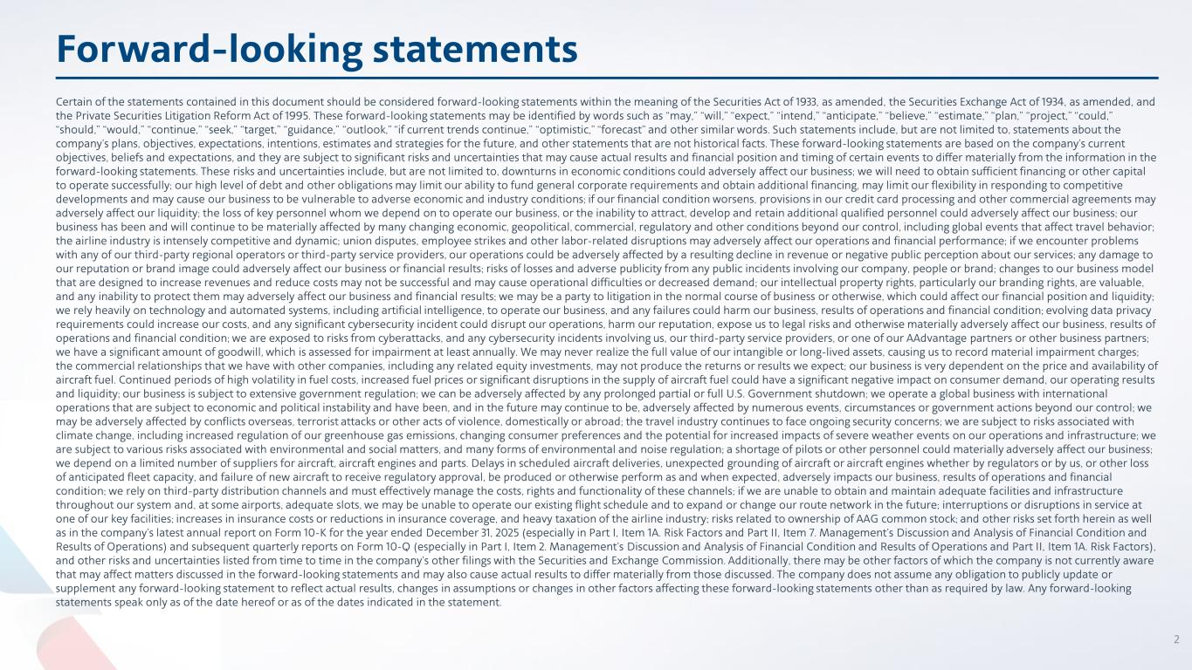
Certain of the statements contained in this document should be considered forward-looking statements within the meaning of the Securities Act of 1933, as amended, the Securities Exchange Act of 1934, as amended, and the Private Securities Litigation Reform Act of 1995. These forward-looking statements may be identified by words such as “may,” “will,” “expect,” “intend,” “anticipate,” “believe,” “estimate,” “plan,” “project,” “could,” “should,” “would,” “continue,” “seek,” “target,” “guidance,” “outlook,” “if current trends continue,” “optimistic,” “forecast” and other similar words. Such statements include, but are not limited to, statements about the company’s plans, objectives, expectations, intentions, estimates and strategies for the future, and other statements that are not historical facts. These forward-looking statements are based on the company’s current objectives, beliefs and expectations, and they are subject to significant risks and uncertainties that may cause actual results and financial position and timing of certain events to differ materially from the information in the forward-looking statements. These risks and uncertainties include, but are not limited to, downturns in economic conditions could adversely affect our business; we will need to obtain sufficient financing or other capital to operate successfully; our high level of debt and other obligations may limit our ability to fund general corporate requirements and obtain additional financing, may limit our flexibility in responding to competitive developments and may cause our business to be vulnerable to adverse economic and industry conditions; if our financial condition worsens, provisions in our credit card processing and other commercial agreements may adversely affect our liquidity; the loss of key personnel whom we depend on to operate our business, or the inability to attract, develop and retain additional qualified personnel could adversely affect our business; our business has been and will continue to be materially affected by many changing economic, geopolitical, commercial, regulatory and other conditions beyond our control, including global events that affect travel behavior; the airline industry is intensely competitive and dynamic; union disputes, employee strikes and other labor-related disruptions may adversely affect our operations and financial performance; if we encounter problems with any of our third-party regional operators or third-party service providers, our operations could be adversely affected by a resulting decline in revenue or negative public perception about our services; any damage to our reputation or brand image could adversely affect our business or financial results; risks of losses and adverse publicity from any public incidents involving our company, people or brand; changes to our business model that are designed to increase revenues and reduce costs may not be successful and may cause operational difficulties or decreased demand; our intellectual property rights, particularly our branding rights, are valuable, and any inability to protect them may adversely affect our business and financial results; we may be a party to litigation in the normal course of business or otherwise, which could affect our financial position and liquidity; we rely heavily on technology and automated systems, including artificial intelligence, to operate our business, and any failures could harm our business, results of operations and financial condition; evolving data privacy requirements could increase our costs, and any significant cybersecurity incident could disrupt our operations, harm our reputation, expose us to legal risks and otherwise materially adversely affect our business, results of operations and financial condition; we are exposed to risks from cyberattacks, and any cybersecurity incidents involving us, our third-party service providers, or one of our AAdvantage partners or other business partners; we have a significant amount of goodwill, which is assessed for impairment at least annually. We may never realize the full value of our intangible or long-lived assets, causing us to record material impairment charges; the commercial relationships that we have with other companies, including any related equity investments, may not produce the returns or results we expect; our business is very dependent on the price and availability of aircraft fuel. Continued periods of high volatility in fuel costs, increased fuel prices or significant disruptions in the supply of aircraft fuel could have a significant negative impact on consumer demand, our operating results and liquidity; our business is subject to extensive government regulation; we can be adversely affected by any prolonged partial or full U.S. Government shutdown; we operate a global business with international operations that are subject to economic and political instability and have been, and in the future may continue to be, adversely affected by numerous events, circumstances or government actions beyond our control; we may be adversely affected by conflicts overseas, terrorist attacks or other acts of violence, domestically or abroad; the travel industry continues to face ongoing security concerns; we are subject to risks associated with climate change, including increased regulation of our greenhouse gas emissions, changing consumer preferences and the potential for increased impacts of severe weather events on our operations and infrastructure; we are subject to various risks associated with environmental and social matters, and many forms of environmental and noise regulation; a shortage of pilots or other personnel could materially adversely affect our business; we depend on a limited number of suppliers for aircraft, aircraft engines and parts. Delays in scheduled aircraft deliveries, unexpected grounding of aircraft or aircraft engines whether by regulators or by us, or other loss of anticipated fleet capacity, and failure of new aircraft to receive regulatory approval, be produced or otherwise perform as and when expected, adversely impacts our business, results of operations and financial condition; we rely on third-party distribution channels and must effectively manage the costs, rights and functionality of these channels; if we are unable to obtain and maintain adequate facilities and infrastructure throughout our system and, at some airports, adequate slots, we may be unable to operate our existing flight schedule and to expand or change our route network in the future; interruptions or disruptions in service at one of our key facilities; increases in insurance costs or reductions in insurance coverage, and heavy taxation of the airline industry; risks related to ownership of AAG common stock; and other risks set forth herein as well as in the company’s latest annual report on Form 10-K for the year ended December 31, 2025 (especially in Part I, Item 1A. Risk Factors and Part II, Item 7. Management’s Discussion and Analysis of Financial Condition and Results of Operations) and subsequent quarterly reports on Form 10-Q (especially in Part I, Item 2. Management’s Discussion and Analysis of Financial Condition and Results of Operations and Part II, Item 1A. Risk Factors), and other risks and uncertainties listed from time to time in the company’s other filings with the Securities and Exchange Commission. Additionally, there may be other factors of which the company is not currently aware that may affect matters discussed in the forward-looking statements and may also cause actual results to differ materially from those discussed. The company does not assume any obligation to publicly update or supplement any forward-looking statement to reflect actual results, changes in assumptions or changes in other factors affecting these forward-looking statements other than as required by law. Any forward-looking statements speak only as of the date hereof or as of the dates indicated in the statement. Forward-looking statements 2

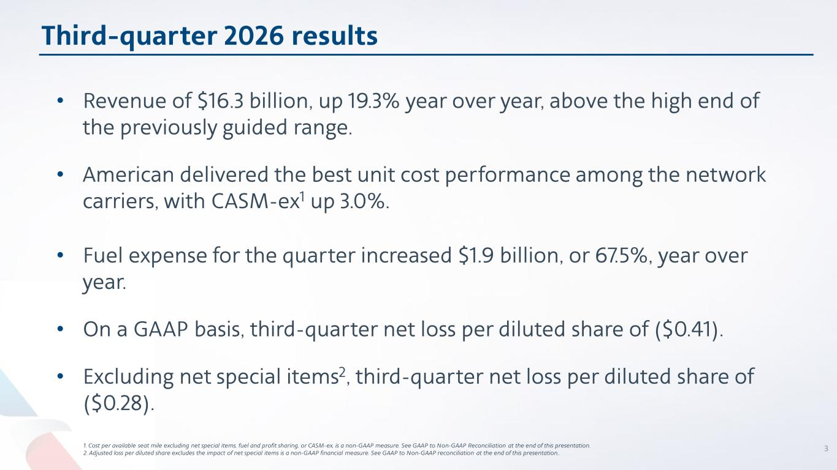
Third-quarter 2026 results • Revenue of $16.3 billion, up 19.3% year over year, above the high end of the previously guided range. • American delivered the best unit cost performance among the network carriers, with CASM-ex1 up 3.0%. • Fuel expense for the quarter increased $1.9 billion, or 67.5%, year over year. • On a GAAP basis, third-quarter net loss per diluted share of ($0.41). • Excluding net special items2, third-quarter net loss per diluted share of ($0.28). 1. Cost per available seat mile excluding net special items, fuel and profit sharing, or CASM-ex, is a non-GAAP measure. See GAAP to Non-GAAP Reconciliation at the end of this presentation. 2. Adjusted loss per diluted share excludes the impact of net special items is a non-GAAP financial measure. See GAAP to Non-GAAP reconciliation at the end of this presentation.. 3

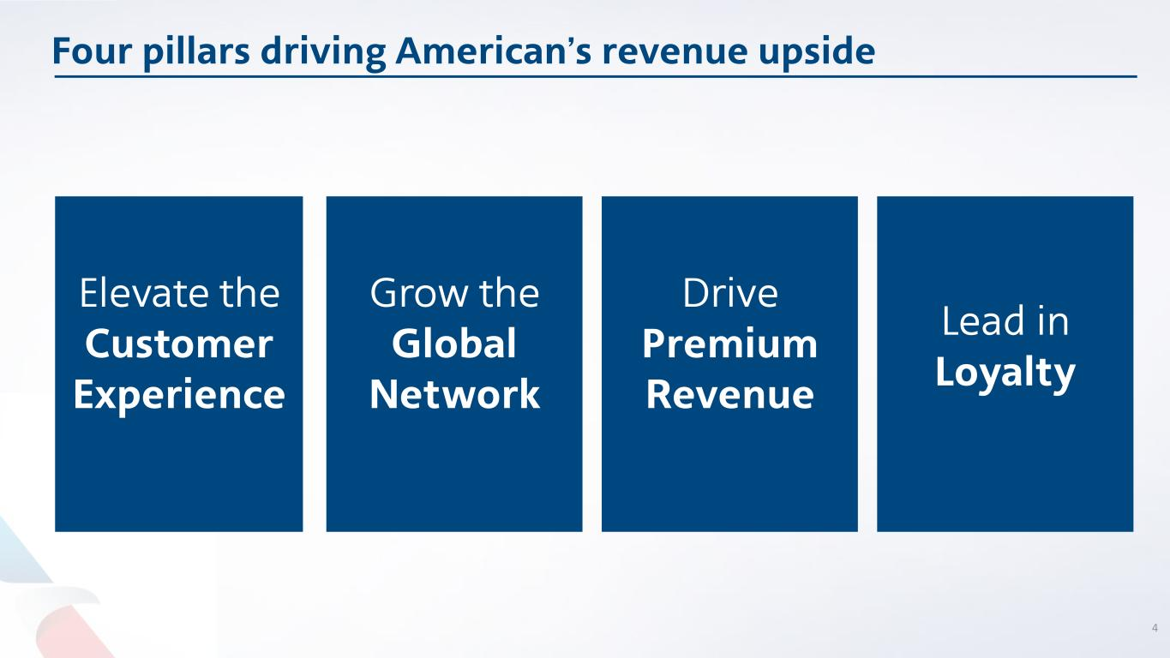
Four pillars driving American’s revenue upside Elevate the Customer Experience Lead in Loyalty Grow the Global Network Drive Premium Revenue 4

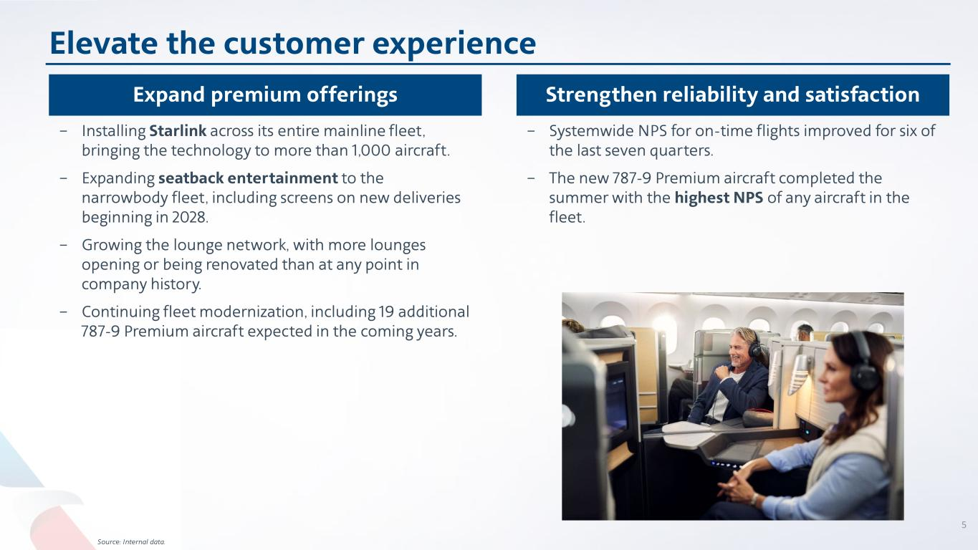
Elevate the customer experience 5 Expand premium offerings Strengthen reliability and satisfaction − Installing Starlink across its entire mainline fleet, bringing the technology to more than 1,000 aircraft. − Expanding seatback entertainment to the narrowbody fleet, including screens on new deliveries beginning in 2028. − Growing the lounge network, with more lounges opening or being renovated than at any point in company history. − Continuing fleet modernization, including 19 additional 787-9 Premium aircraft expected in the coming years. − Systemwide NPS for on-time flights improved for six of the last seven quarters. − The new 787-9 Premium aircraft completed the summer with the highest NPS of any aircraft in the fleet. Source: Internal data.

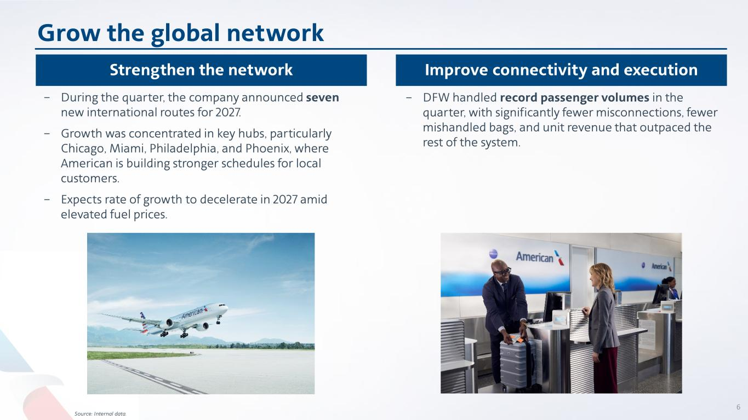
Grow the global network 6 Strengthen the network Improve connectivity and execution − During the quarter, the company announced seven new international routes for 2027. − Growth was concentrated in key hubs, particularly Chicago, Miami, Philadelphia, and Phoenix, where American is building stronger schedules for local customers. − Expects rate of growth to decelerate in 2027 amid elevated fuel prices. − DFW handled record passenger volumes in the quarter, with significantly fewer misconnections, fewer mishandled bags, and unit revenue that outpaced the rest of the system. Source: Internal data.

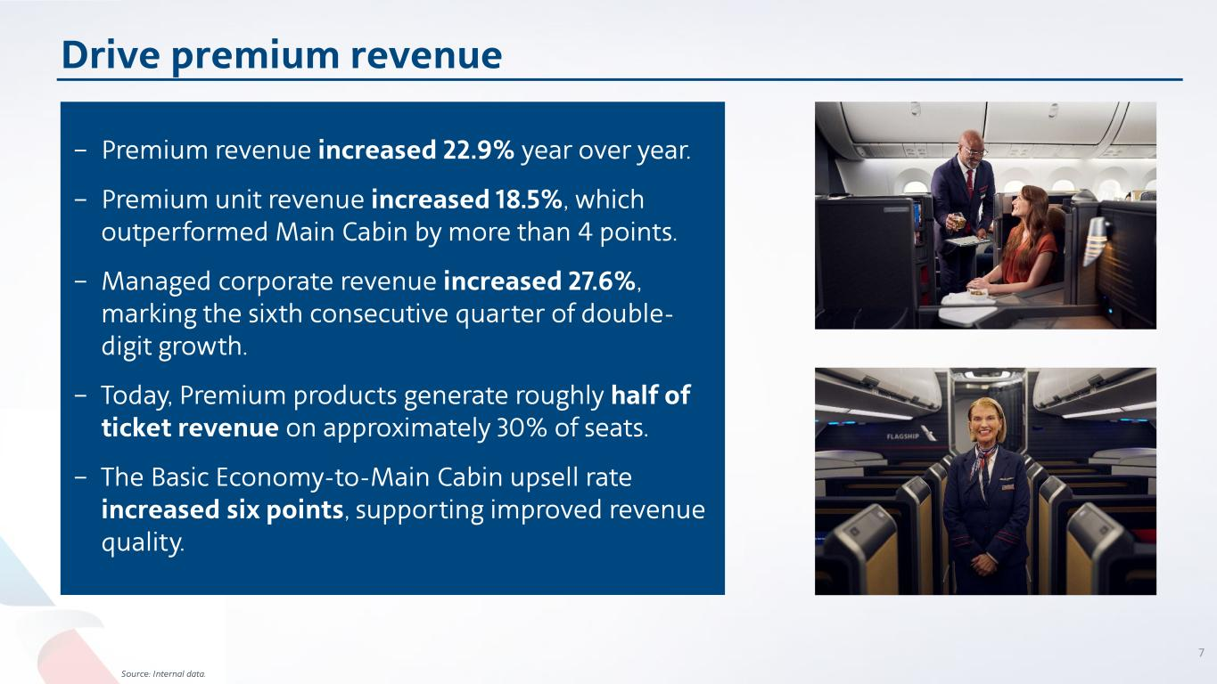
Drive premium revenue 7 Source: Internal data. − Premium revenue increased 22.9% year over year. − Premium unit revenue increased 18.5%, which outperformed Main Cabin by more than 4 points. − Managed corporate revenue increased 27.6%, marking the sixth consecutive quarter of double- digit growth. − Today, Premium products generate roughly half of ticket revenue on approximately 30% of seats. − The Basic Economy-to-Main Cabin upsell rate increased six points, supporting improved revenue quality.


Lead in loyalty 8 Source: Internal data. − AAdvantage® enrollments increased 27.4% year over year. − Enrollment growth of 35% to 65% in New York, Los Angeles and Chicago. Expanding loyalty ecosystem − Third-quarter card spend increased nearly 10% year- over-year, demonstrating sustained engagement across the portfolio. − New cash-and-miles functionality provides customers additional flexibility in how they book travel. Driving long-term value Industry-leading loyalty program continues to evolve and offers exclusive benefits

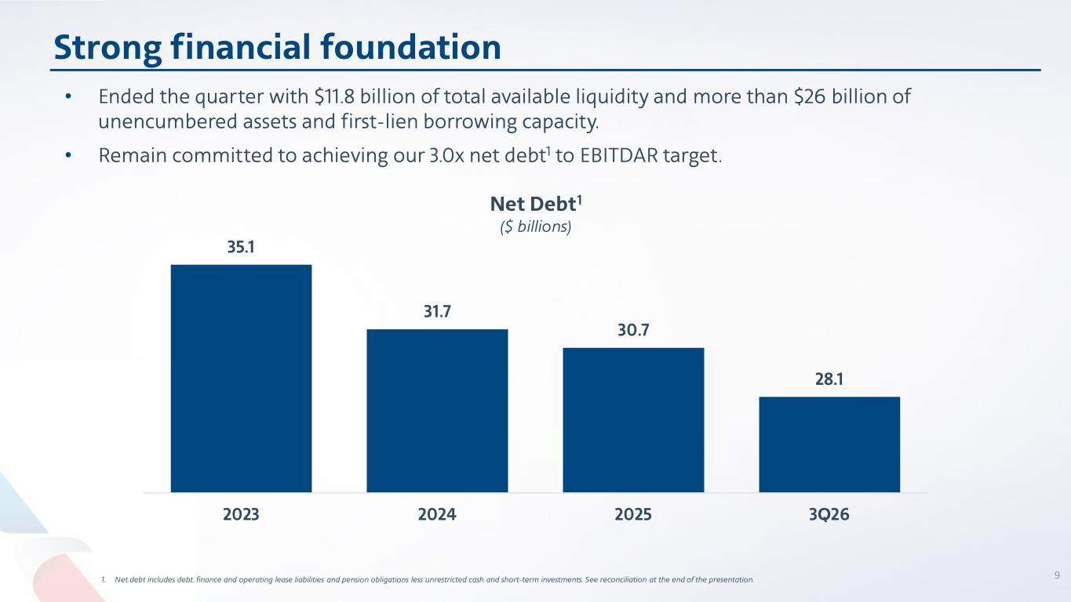
35.1 31.7 30.7 28.1 2023 2024 2025 3Q26 • Ended the quarter with $11.8 billion of total available liquidity and more than $26 billion of unencumbered assets and first-lien borrowing capacity. • Remain committed to achieving our 3.0x net debt1 to EBITDAR target. Strong financial foundation 91. Net debt includes debt, finance and operating lease liabilities and pension obligations less unrestricted cash and short-term investments. See reconciliation at the end of the presentation. Net Debt1 ($ billions)

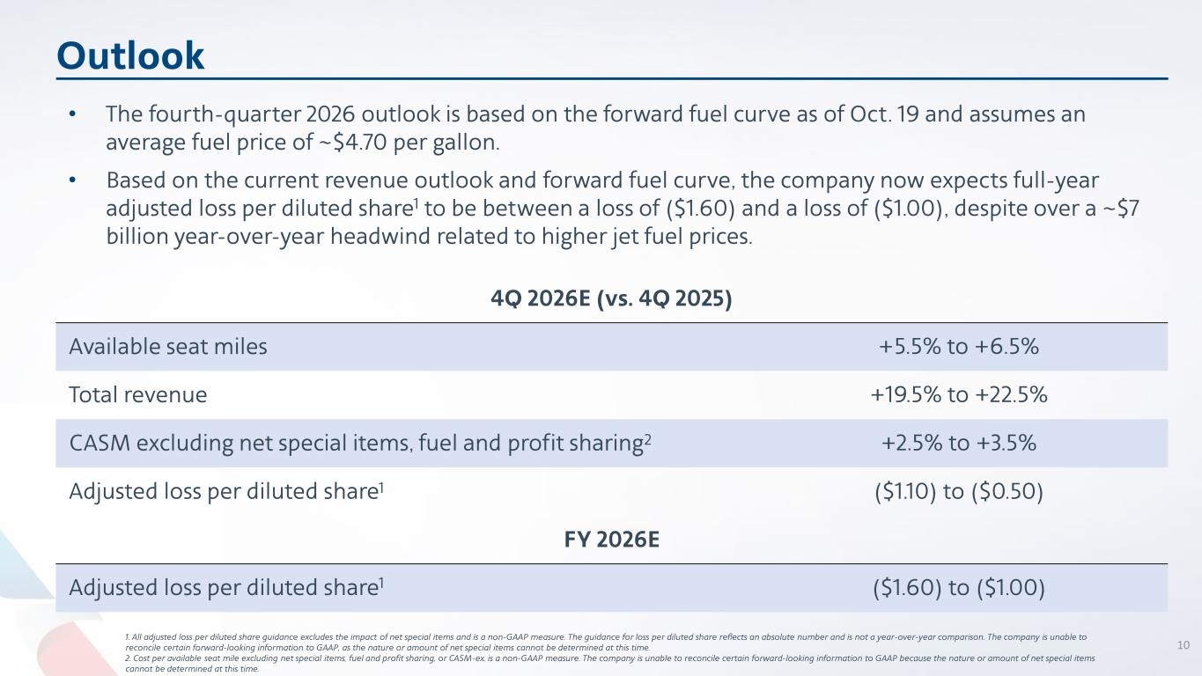
Outlook 1. All adjusted loss per diluted share guidance excludes the impact of net special items and is a non-GAAP measure. The guidance for loss per diluted share reflects an absolute number and is not a year-over-year comparison. The company is unable to reconcile certain forward-looking information to GAAP, as the nature or amount of net special items cannot be determined at this time. 2. Cost per available seat mile excluding net special items, fuel and profit sharing, or CASM-ex, is a non-GAAP measure. The company is unable to reconcile certain forward-looking information to GAAP because the nature or amount of net special items cannot be determined at this time. 4Q 2026E (vs. 4Q 2025) Available seat miles +5.5% to +6.5% Total revenue +19.5% to +22.5% CASM excluding net special items, fuel and profit sharing2 +2.5% to +3.5% Adjusted loss per diluted share1 ($1.10) to ($0.50) FY 2026E Adjusted loss per diluted share1 ($1.60) to ($1.00) • The fourth-quarter 2026 outlook is based on the forward fuel curve as of Oct. 19 and assumes an average fuel price of ~$4.70 per gallon. • Based on the current revenue outlook and forward fuel curve, the company now expects full-year adjusted loss per diluted share1 to be between a loss of ($1.60) and a loss of ($1.00), despite over a ~$7 billion year-over-year headwind related to higher jet fuel prices. 10

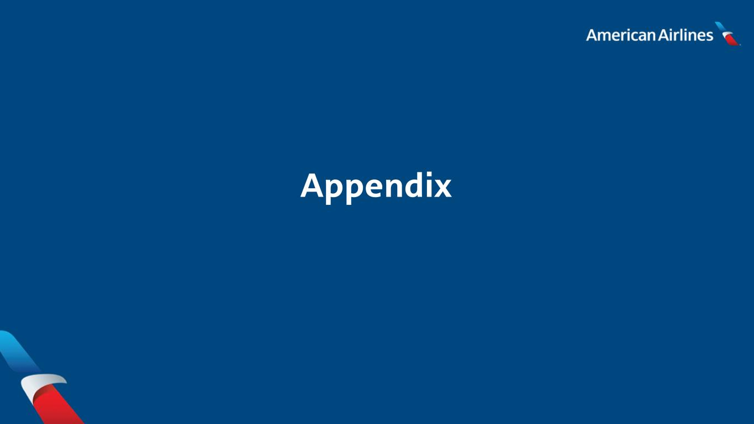
Appendix

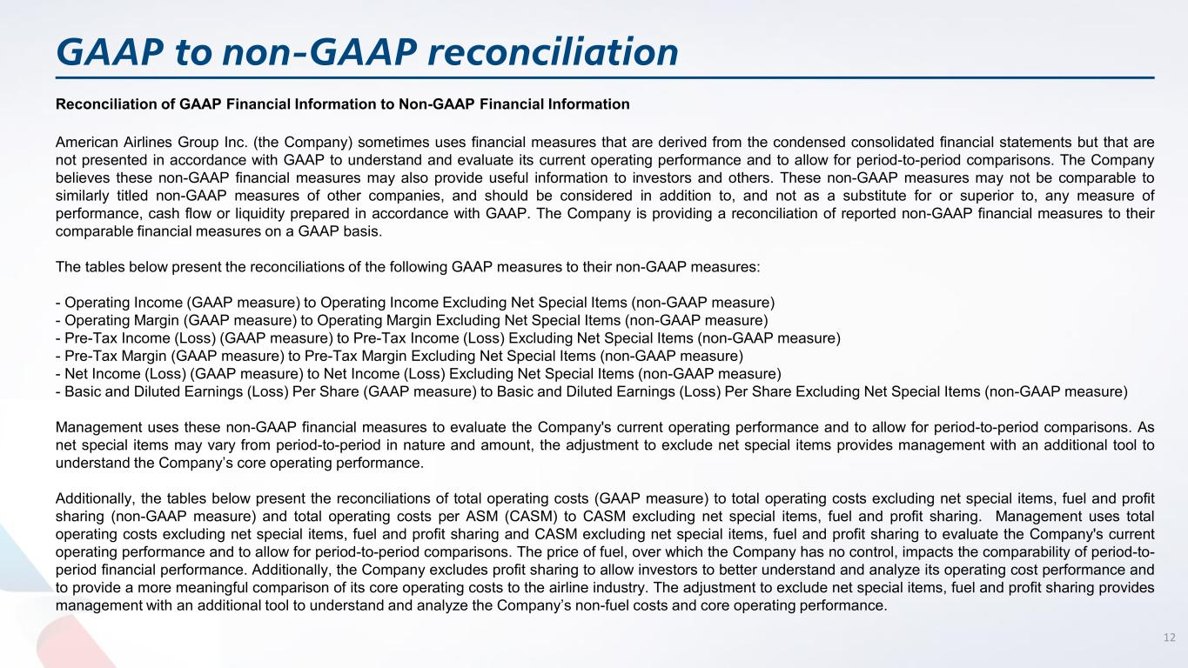
GAAP to non-GAAP reconciliation Reconciliation of GAAP Financial Information to Non-GAAP Financial Information American Airlines Group Inc. (the Company) sometimes uses financial measures that are derived from the condensed consolidated financial statements but that are not presented in accordance with GAAP to understand and evaluate its current operating performance and to allow for period-to-period comparisons. The Company believes these non-GAAP financial measures may also provide useful information to investors and others. These non-GAAP measures may not be comparable to similarly titled non-GAAP measures of other companies, and should be considered in addition to, and not as a substitute for or superior to, any measure of performance, cash flow or liquidity prepared in accordance with GAAP. The Company is providing a reconciliation of reported non-GAAP financial measures to their comparable financial measures on a GAAP basis. The tables below present the reconciliations of the following GAAP measures to their non-GAAP measures: - Operating Income (GAAP measure) to Operating Income Excluding Net Special Items (non-GAAP measure) - Operating Margin (GAAP measure) to Operating Margin Excluding Net Special Items (non-GAAP measure) - Pre-Tax Income (Loss) (GAAP measure) to Pre-Tax Income (Loss) Excluding Net Special Items (non-GAAP measure) - Pre-Tax Margin (GAAP measure) to Pre-Tax Margin Excluding Net Special Items (non-GAAP measure) - Net Income (Loss) (GAAP measure) to Net Income (Loss) Excluding Net Special Items (non-GAAP measure) - Basic and Diluted Earnings (Loss) Per Share (GAAP measure) to Basic and Diluted Earnings (Loss) Per Share Excluding Net Special Items (non-GAAP measure) Management uses these non-GAAP financial measures to evaluate the Company's current operating performance and to allow for period-to-period comparisons. As net special items may vary from period-to-period in nature and amount, the adjustment to exclude net special items provides management with an additional tool to understand the Company’s core operating performance. Additionally, the tables below present the reconciliations of total operating costs (GAAP measure) to total operating costs excluding net special items, fuel and profit sharing (non-GAAP measure) and total operating costs per ASM (CASM) to CASM excluding net special items, fuel and profit sharing. Management uses total operating costs excluding net special items, fuel and profit sharing and CASM excluding net special items, fuel and profit sharing to evaluate the Company's current operating performance and to allow for period-to-period comparisons. The price of fuel, over which the Company has no control, impacts the comparability of period-to- period financial performance. Additionally, the Company excludes profit sharing to allow investors to better understand and analyze its operating cost performance and to provide a more meaningful comparison of its core operating costs to the airline industry. The adjustment to exclude net special items, fuel and profit sharing provides management with an additional tool to understand and analyze the Company’s non-fuel costs and core operating performance. 12

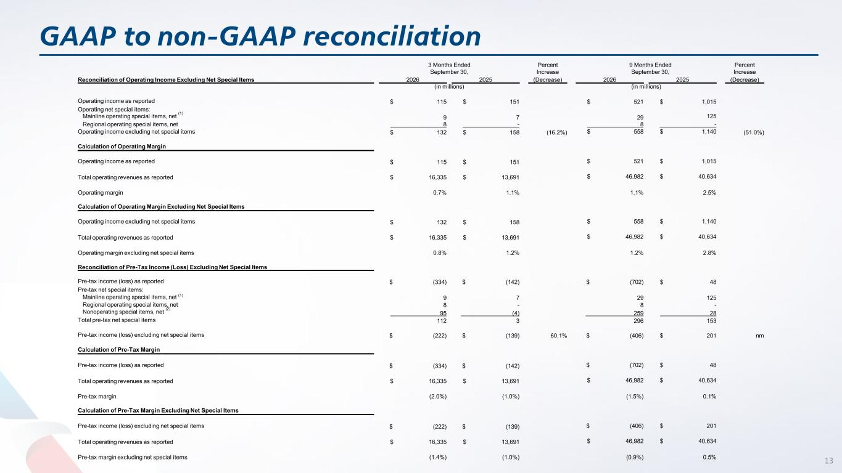
GAAP to non-GAAP reconciliation 13 Reconciliation of Operating Income Excluding Net Special Items 3 Months Ended September 30, Percent Increase 9 Months Ended September 30, Percent Increase 2026 2025 (Decrease) 2026 2025 (Decrease) (in millions) (in millions) Operating income as reported $ 115 $ 151 $ 521 $ 1,015 Operating net special items: Mainline operating special items, net (1) 9 7 29 125 Regional operating special items, net 8 - 8 - Operating income excluding net special items $ 132 $ 158 (16.2%) $ 558 $ 1,140 (51.0%) Calculation of Operating Margin Operating income as reported $ 115 $ 151 $ 521 $ 1,015 Total operating revenues as reported $ 16,335 $ 13,691 $ 46,982 $ 40,634 Operating margin 0.7% 1.1% 1.1% 2.5% Calculation of Operating Margin Excluding Net Special Items Operating income excluding net special items $ 132 $ 158 $ 558 $ 1,140 Total operating revenues as reported $ 16,335 $ 13,691 $ 46,982 $ 40,634 Operating margin excluding net special items 0.8% 1.2% 1.2% 2.8% Reconciliation of Pre-Tax Income (Loss) Excluding Net Special Items Pre-tax income (loss) as reported $ (334) $ (142) $ (702) $ 48 Pre-tax net special items: Mainline operating special items, net (1) 9 7 29 125 Regional operating special items, net 8 - 8 - Nonoperating special items, net (2) 95 (4) 259 28 Total pre-tax net special items 112 3 296 153 Pre-tax income (loss) excluding net special items $ (222) $ (139) 60.1% $ (406) $ 201 nm Calculation of Pre-Tax Margin Pre-tax income (loss) as reported $ (334) $ (142) $ (702) $ 48 Total operating revenues as reported $ 16,335 $ 13,691 $ 46,982 $ 40,634 Pre-tax margin (2.0%) (1.0%) (1.5%) 0.1% Calculation of Pre-Tax Margin Excluding Net Special Items Pre-tax income (loss) excluding net special items $ (222) $ (139) $ (406) $ 201 Total operating revenues as reported $ 16,335 $ 13,691 $ 46,982 $ 40,634 Pre-tax margin excluding net special items (1.4%) (1.0%) (0.9%) 0.5%

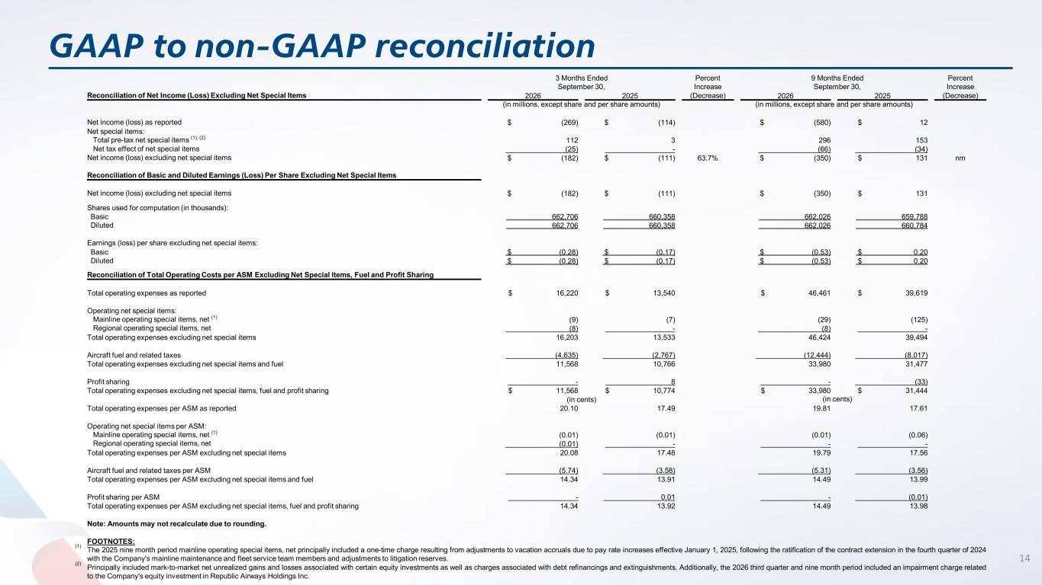
GAAP to non-GAAP reconciliation 14 3 Months Ended September 30, Percent Increase 9 Months Ended September 30, Percent Increase Reconciliation of Net Income (Loss) Excluding Net Special Items 2026 2025 (Decrease) 2026 2025 (Decrease) (in millions, except share and per share amounts) (in millions, except share and per share amounts) Net income (loss) as reported $ (269) $ (114) $ (580) $ 12 Net special items: Total pre-tax net special items (1), (2) 112 3 296 153 Net tax effect of net special items (25) - (66) (34) Net income (loss) excluding net special items $ (182) $ (111) 63.7% $ (350) $ 131 nm Reconciliation of Basic and Diluted Earnings (Loss) Per Share Excluding Net Special Items Net income (loss) excluding net special items $ (182) $ (111) $ (350) $ 131 Shares used for computation (in thousands): Basic 662,706 660,358 662,026 659,788 Diluted 662,706 660,358 662,026 660,784 Earnings (loss) per share excluding net special items: Basic $ (0.28) $ (0.17) $ (0.53) $ 0.20 Diluted $ (0.28) $ (0.17) $ (0.53) $ 0.20 Reconciliation of Total Operating Costs per ASM Excluding Net Special Items, Fuel and Profit Sharing Total operating expenses as reported $ 16,220 $ 13,540 $ 46,461 $ 39,619 Operating net special items: Mainline operating special items, net (1) (9) (7) (29) (125) Regional operating special items, net (8) - (8) - Total operating expenses excluding net special items 16,203 13,533 46,424 39,494 Aircraft fuel and related taxes (4,635) (2,767) (12,444) (8,017) Total operating expenses excluding net special items and fuel 11,568 10,766 33,980 31,477 Profit sharing - 8 - (33) Total operating expenses excluding net special items, fuel and profit sharing $ 11,568 $ 10,774 $ 33,980 $ 31,444 (in cents) (in cents) Total operating expenses per ASM as reported 20.10 17.49 19.81 17.61 Operating net special items per ASM: Mainline operating special items, net (1) (0.01) (0.01) (0.01) (0.06) Regional operating special items, net (0.01) - - - Total operating expenses per ASM excluding net special items 20.08 17.48 19.79 17.56 Aircraft fuel and related taxes per ASM (5.74) (3.58) (5.31) (3.56) Total operating expenses per ASM excluding net special items and fuel 14.34 13.91 14.49 13.99 Profit sharing per ASM - 0.01 - (0.01) Total operating expenses per ASM excluding net special items, fuel and profit sharing 14.34 13.92 14.49 13.98 Note: Amounts may not recalculate due to rounding. FOOTNOTES: (1) The 2025 nine month period mainline operating special items, net principally included a one-time charge resulting from adjustments to vacation accruals due to pay rate increases effective January 1, 2025, following the ratification of the contract extension in the fourth quarter of 2024 with the Company's mainline maintenance and fleet service team members and adjustments to litigation reserves. (2) Principally included mark-to-market net unrealized gains and losses associated with certain equity investments as well as charges associated with debt refinancings and extinguishments. Additionally, the 2026 third quarter and nine month period included an impairment charge related to the Company's equity investment in Republic Airways Holdings Inc.

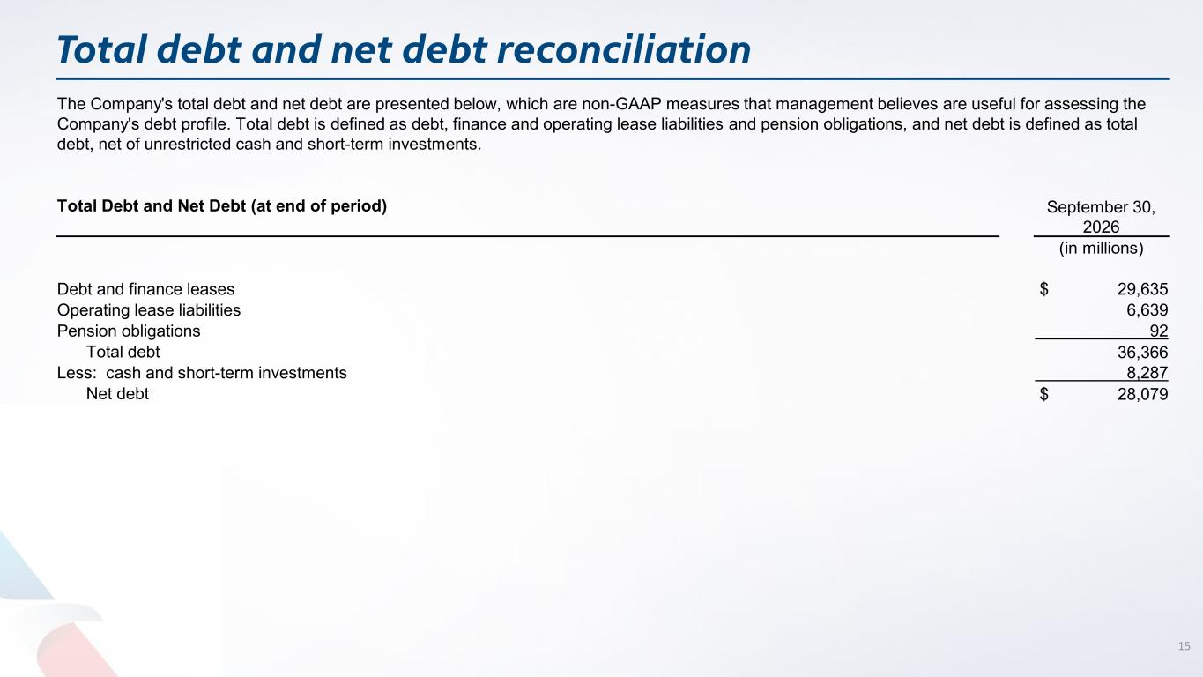
Total debt and net debt reconciliation 15 The Company's total debt and net debt are presented below, which are non-GAAP measures that management believes are useful for assessing the Company's debt profile. Total debt is defined as debt, finance and operating lease liabilities and pension obligations, and net debt is defined as total debt, net of unrestricted cash and short-term investments. Total Debt and Net Debt (at end of period) September 30, 2026 (in millions) Debt and finance leases $ 29,635 Operating lease liabilities 6,639 Pension obligations 92 Total debt 36,366 Less: cash and short-term investments 8,287 Net debt $ 28,079


16

