UNITED STATES

SECURITIES AND EXCHANGE COMMISSION

Washington, D.C. 20549

FORM 8-K

CURRENT REPORT

Pursuant to Section 13 or 15(d) of the Securities Exchange Act of 1934

Date of Report (Date of earliest event reported): April 24, 2025

AMERICAN AIRLINES GROUP INC.

AMERICAN AIRLINES, INC.

(Exact name of registrant as specified in its charter)

 | Delaware |  |  | 1-8400 |  |  |  | 75-1825172
 | Delaware |  |  | 1-2691 |  |  |  | 13-1502798
 | (State or other Jurisdiction of Incorporation) |  |  | (Commission File Number) |  |  |  | (IRS Employer Identification No.)
 | 1 Skyview Drive, |  | Fort Worth, | Texas |  |  |  | 76155
 | 1 Skyview Drive, |  | Fort Worth, | Texas |  |  |  | 76155
 | (Address of principal executive offices) |  |  |  |  |  |  | (Zip Code)

Registrant’s telephone number, including area code:

- 278-9000

- 278-9000

Check the appropriate box below if the Form 8-K filing is intended to simultaneously satisfy the filing obligation of the registrant under any of the following provisions:

- Written communications pursuant to Rule 425 under the Securities Act (17 CFR 230.425)

- Soliciting material pursuant to Rule 14a-12 under the Exchange Act (17 CFR 240.14a-12)

- Pre-commencement communications pursuant to Rule 14d-2(b) under the Exchange Act (17 CFR 240.14d-2(b))

- Pre-commencement communications pursuant to Rule 13e-4(c) under the Exchange Act (17 CFR 240.13e-4(c))

Securities registered pursuant to Section 12(b) of the Act:

Title of each class |  | Trading |  | Name of each exchange
Title of each class |  | Symbol(s) |  | on which registered
Common Stock, $0.01 par value per share |  | AAL |  | The Nasdaq Global Select Market
Preferred Stock Purchase Rights |  | — |  | (1)

- Attached to the Common Stock

Indicate by check mark whether the registrant is an emerging growth company as defined in Rule 405 of the Securities Act of 1933 or Rule 12b-2 of the Securities Exchange Act of 1934.

Emerging growth company ☐

If an emerging growth company, indicate by check mark if the registrant has elected not to use the extended transition period for complying with any new or revised financial accounting standards provided pursuant to Section 13(a) of the Exchange Act. ☐

ITEM 2.02. RESULTS OF OPERATIONS AND FINANCIAL CONDITION.

On April 24, 2025, American Airlines Group Inc. (the Company) issued a press release reporting financial results for the three months ended March 31, 2025. The press release is furnished as Exhibit 99.1 to this report.

ITEM 7.01. REGULATION FD DISCLOSURE.

On April 24, 2025, the Company provided a presentation to investors. This investor presentation is located on the Company’s website at www.aa.com under “Investor Relations” and is furnished as Exhibit 99.2 to this report.

Also on April 24, 2025, the Company provided an update for investors presenting information relating to its financial and operational outlook for the second quarter of 2025. This investor update is located on the Company’s website at www.aa.com under “Investor Relations” and is furnished as Exhibit 99.3 to this report.

The information in Items 2.02 and 7.01 of this Current Report on Form 8-K, including Exhibits 99.1, 99.2 and 99.3, is being furnished and shall not be deemed to be “filed” for purposes of Section 18 of the Securities Exchange Act of 1934, as amended, or otherwise subject to the liabilities of that Section and shall not be deemed incorporated by reference into any registration statement or other document filed pursuant to the Securities Act of 1933, as amended, except as shall be expressly set forth by specific reference in such filing.

ITEM 9.01. | FINANCIAL STATEMENTS AND EXHIBITS.
(d) Exhibits.
Exhibit No. |  | Description
99.1 |  | Press Release, dated April 24, 2025.
99.2 |  | Investor Presentation, dated April 24, 2025.
99.3 |  | Investor Update, dated April 24, 2025.
104.1 |  | Cover page interactive data file (embedded within the Inline XBRL document).

SIGNATURES

Pursuant to the requirements of the Securities Exchange Act of 1934, American Airlines Group Inc. has duly caused this report to be signed on its behalf by the undersigned hereunto duly authorized.

AMERICAN AIRLINES GROUP INC.

Date: April 24, 2025 By: /s/ Devon E. May

Devon E. May

Executive Vice President and

Chief Financial Officer

Pursuant to the requirements of the Securities Exchange Act of 1934, American Airlines, Inc. has duly caused this report to be signed on its behalf by the undersigned hereunto duly authorized.

AMERICAN AIRLINES, INC.

Date: April 24, 2025 By: /s/ Devon E. May

Devon E. May

Executive Vice President and

Chief Financial Officer

Exhibit 99.1


Corporate Communications

mediarelations@aa.com

Investor Relations

investor.relations@aa.com

FOR RELEASE: Thursday, April 24, 2025

AMERICAN AIRLINES REPORTS FIRST-QUARTER 2025 FINANCIAL RESULTS

FORT WORTH, Texas — American Airlines Group Inc. (NASDAQ: AAL) today reported its first-quarter 2025 financial results, including:

- First-quarter revenue of $12.6 billion

- First-quarter GAAP net loss of $473 million, or ($0.72) per diluted share

- Excluding net special items¹, first-quarter net loss of $386 million, or ($0.59) per diluted share
- Ended the quarter with $10.8 billion of total available liquidity

“The actions American has taken over the past several years to refresh our fleet, manage costs and strengthen our balance sheet position us well for the uncertainty our industry is facing,” said American’s CEO Robert Isom. “The resiliency of the American Airlines team, combined with the investments we have made to differentiate our network, product and customer experience, give us extreme confidence in our ability to navigate the current environment and deliver strong results for the long term.”

Revenue performance

American produced first-quarter revenue of $12.6 billion. Total unit revenue was up 0.7% versus the first-quarter of 2024, driven by continued strength in international unit revenue, which was up 2.9% year over year on 0.8% lower capacity year over year, and continued growth in premium and loyalty revenue. Throughout the quarter, American continued to restore revenue in indirect channels and remains on track to restore its revenue share from indirect channels to historical levels exiting the year. These efforts were offset by a number of factors, including economic uncertainty that pressured domestic leisure demand and the tragic accident of American Eagle Flight 5342.

AAdvantage® and Citi partnership
American and Citi continue to work toward the implementation of their exclusive and expanded partnership, which starts in 2026, and American remains on track to achieve the long-term growth targets the company previously outlined. In the first quarter, AAdvantage® enrollments were up 6% year over year with spending on the airline’s co-branded credit cards up 8% year over year, underscoring the continued value of American’s loyalty program.

Customer experience

American’s strong operational performance in recent years and its updated commercial strategy puts the airline in position to renew its focus on the customer experience to drive additional revenue growth. American has established a new Customer Experience organization to drive

American Airlines Reports First-Quarter Financial Results

April 24, 2025

Page 2

the strategy and coordinate the implementation of initiatives that define customers’ journeys with American. The company recently announced complimentary high-speed satellite Wi-Fi for AAdvantage® members beginning in January 2026, sponsored by AT&T. With this, American will offer free inflight connectivity on more aircraft than any other carrier.

Operational performance

In the first quarter, the American team continued to demonstrate its operational resilience and ability to quickly recover from disruptions. American continues to invest in its operation, team and technology to drive additional enhancements in operational reliability.

Financial performance

In the first quarter, the company produced an operating margin of (2.2%) on a GAAP basis. Excluding the impact of net special items¹, the company produced an adjusted operating margin of (1.6%) in the quarter.

Balance sheet and liquidity

American generated free cash flow2 of $1.7 billion in the first quarter, which enabled further strengthening of its balance sheet. In the quarter, American reduced its total debt3 by $1.2 billion, contributing to total debt reduction of $16.6 billion from peak levels in 2021. The airline has positioned its balance sheet well for the current environment and remains committed to reducing total debt to less than $35 billion by year-end 2027. The airline ended the first quarter with $10.8 billion of total available liquidity, comprised of cash and short-term investments plus undrawn capacity under revolving credit and other facilities. American has available borrowing capacity of more than $10 billion in unencumbered assets and more than $13 billion in additional first-lien borrowings allowable by its existing financing arrangements.

Guidance and investor update

Based on present demand trends, the current fuel price forecast and excluding the impact of special items, the company expects its second-quarter 2025 adjusted earnings per diluted share⁴ to be between $0.50 and $1.00. The company is withdrawing its full-year guidance at this time. American intends to provide a full-year update as the economic outlook becomes clearer.

For additional financial forecasting detail, please refer to the company’s investor update, furnished with this press release with the SEC on Form 8-K. This filing is also available at aa.com/investorrelations.

American Airlines Reports First-Quarter 2025 Financial Results

April 24, 2025

Page 3

Conference call and webcast details

The company will conduct a live audio webcast of its financial results conference call at 7:30 a.m. CT today. The call will be available to the public on a listen-only basis at aa.com/investorrelations. An archive of the webcast will be available through May 24.

Notes

See the accompanying notes in the financial tables section of this press release for further explanation, including a reconciliation of all GAAP to non-GAAP financial information and the calculation of free cash flow.

- The company recognized $87 million of net special items in the first quarter after the effect of taxes, which included operating net special items of $70 million. The first quarter net special items included a one-time charge resulting from pay rate increases effective Jan. 1, 2025, related to the ratification of the contract extension reached in the fourth quarter of 2024 with the company’s mainline maintenance and fleet service team members and an adjustment to litigation reserves, as well as nonoperating net special items of $48 million related to mark-to-market net unrealized losses associated with certain equity investments as well as charges associated with debt refinancings and extinguishments.

- Please see the accompanying notes for the company’s definition of free cash flow, a non-GAAP measure.
- All references to total debt include debt, finance and operating lease liabilities and pension obligations.

- Adjusted earnings per diluted share guidance excludes the impact of net special items. The company is unable to reconcile certain forward-looking information to GAAP as the nature or amount of net special items cannot be determined at this time.

About American Airlines Group

As a leading global airline, American Airlines offers thousands of flights per day to more than 350 destinations in more than 60 countries. The airline is a founding member of the oneworld® alliance, whose members serve more than 900 destinations around the globe. Shares of American Airlines Group Inc. trade on Nasdaq under the ticker symbol AAL. Learn more about what’s happening at American by visiting news.aa.com and connect with American @AmericanAir and at Facebook.com/AmericanAirlines. To Care for People on Life’s Journey®.

Cautionary statement regarding forward-looking statements and information

Certain of the statements contained in this report should be considered forward-looking statements within the meaning of the Securities Act of 1933, as amended, the Securities Exchange Act of 1934, as amended, and the Private Securities Litigation Reform Act of 1995. These forward-looking statements may be identified by words such as “may,” “will,” “expect,” “intend,” “anticipate,” “believe,” “estimate,” “plan,” “project,” “could,” “should,” “would,” “continue,” “seek,” “target,” “guidance,” “outlook,” “if current trends continue,” “optimistic,” “forecast” and other similar words. Such statements include, but are not limited to, statements about the company’s plans, objectives, expectations, intentions, estimates and strategies for the future, and other statements that are not historical facts. These forward-looking statements are based on the company’s current objectives, beliefs and expectations, and they are subject to significant risks and uncertainties that may cause actual results and financial position and timing of certain events to differ materially from the information in the forward-looking statements. These risks and uncertainties include, but are not limited to, downturns in economic conditions; our inability to obtain sufficient financing or other capital to operate successfully; our high level

American Airlines Reports First-Quarter 2025 Financial Results

April 24, 2025

Page 4

of debt and other obligations; our significant pension and other postretirement benefit funding obligations; any deterioration of our financial condition; any loss of key personnel, or our inability to attract, develop and retain additional qualified personnel; changing economic, geopolitical, commercial, regulatory and other conditions beyond our control, including the recently announced tariffs and other global events that affect travel behavior; changes in current legislation, regulations and economic conditions regarding federal governmental tariffs, the implementation of federal government budget cuts and the potential that any of the foregoing affects the demand for, or restricts the use of, travel by government employees and their families or private sector enterprises that contract or otherwise interface with the federal government; the intensely competitive and dynamic nature of the airline industry; union disputes, employee strikes and other labor-related disruptions; problems with any of our third-party regional operators or third-party service providers; any damage to our reputation or brand image; losses and adverse publicity stemming from any public incidents involving our company, our people or our brand; changes to our business model that may not be successful and may cause operational difficulties or decreased demand; our inability to protect our intellectual property rights, particularly our branding rights; litigation in the normal course of business or otherwise; our inability to use net operating losses and other carryforwards; any new U.S. and international tax legislation; any impairment of goodwill and intangible assets or long-lived assets; any inability of our commercial relationships with other companies to produce the returns or results we expect; our dependence on price and availability of aircraft fuel; extensive government regulation and compliance risks; economic and political instability outside of the U.S. where we have significant operations; ongoing security concerns due to conflicts, terrorist attacks or other acts of violence, domestically or abroad; climate change; environmental and social matters, and compliance risks with environmental, health and noise regulations; a shortage of pilots; our dependence on a limited number of suppliers for aircraft, aircraft engines and parts; any failure of technology and automated systems, including artificial intelligence, that we rely on to operate our business; evolving data privacy requirements, risks from cyberattacks and data privacy incidents, and compliance risks with regulations related therewith; any inability to effectively manage the costs, rights and functionality of third-party distribution channels; any inability to obtain and maintain adequate facilities and infrastructure throughout our system and, at some airports, adequate slots; interruptions or disruptions in service at one or more of our key facilities; increases in insurance costs or reductions in insurance coverage; heavy taxation in the airline industry; risks related to ownership of AAG common stock and convertible notes; and those set forth herein as well as in the company’s Annual Report on Form 10-K for the year ended December 31, 2024 (especially in Part I, Item 1A. Risk Factors) and in the company’s Quarterly Report on Form 10-Q for the quarter ended March 31, 2025 (especially in Part I, Item 2. Management’s Discussion and Analysis of Financial Condition and Results of Operations), and other risks and uncertainties listed from time to time in the company’s other filings with the Securities and Exchange Commission. Additionally, there may be other factors of which the company is not currently aware that may affect matters discussed in the forward-looking statements and may also cause actual results to differ materially from those discussed. The company does not assume any obligation to publicly update or supplement any forward-looking statement to reflect actual results, changes in assumptions or changes in other factors affecting these forward-looking statements other than as required by law. Any forward-looking statements speak only as of the date hereof or as of the dates indicated in the statement.

American Airlines Reports First-Quarter 2025 Financial Results

April 24, 2025

Page 5

American Airlines Group Inc.

Condensed Consolidated Statements of Operations

(In millions, except share and per share amounts)
(Unaudited)

 |  | 3 Months Ended |  |  |  |  | Percent
 |  | March 31, |  |  |  |  | Increase
 |  | 2025 |  |  | 2024 |  | (Decrease)
Operating revenues:
Passenger | $ | 11,391 |  | $ | 11,458 | (0.6)
Cargo |  | 189 |  |  | 187 | 1.1
Other |  | 971 |  |  | 925 | 5.0
Total operating revenues |  | 12,551 |  |  | 12,570 | (0.2)
Operating expenses:
Aircraft fuel and related taxes |  | 2,587 |  |  | 2,980 | (13.2)
Salaries, wages and benefits |  | 4,222 |  |  | 3,867 | 9.2
Regional expenses:
Regional operating expenses |  | 1,272 |  |  | 1,122 | 13.4
Regional depreciation and amortization |  | 79 |  |  | 79 | 0.2
Maintenance, materials and repairs |  | 922 |  |  | 884 | 4.2
Other rent and landing fees |  | 826 |  |  | 819 | 0.9
Aircraft rent |  | 297 |  |  | 328 | (9.4)
Selling expenses |  | 450 |  |  | 408 | 10.1
Depreciation and amortization |  | 468 |  |  | 470 | (0.4)
Special items, net |  | 70 |  |  | 70 | 0.6
Other |  | 1,628 |  |  | 1,536 | 6.0
Total operating expenses |  | 12,821 |  |  | 12,563 | 2.1
Operating income (loss) |  | (270) |  |  | 7 |  | _{nm} (1)
Nonoperating income (expense):
Interest income |  | 94 |  |  | 118 | (20.2)
Interest expense, net |  | (428) |  |  | (497) | (13.8)
Other expense, net |  | (44) |  |  | (41) | 7.7
Total nonoperating expense, net |  | (378) |  |  | (420) | (10.0)
Loss before income taxes |  | (648) |  |  | (413) | 56.9
Income tax benefit |  | (175) |  |  | (101) | 73.2
Net loss | $ | (473) |  | $ | (312) | 51.6
Loss per common share:
Basic and Diluted | $ | (0.72) |  | $ | (0.48)
Weighted average shares outstanding (in thousands):
Basic and Diluted |  | 658,880 |  |  | 655,847

Note: Percent change may not recalculate due to rounding.

- Not meaningful or greater than 100% change.

American Airlines Reports First-Quarter 2025 Financial Results

April 24, 2025

Page 6

American Airlines Group Inc.
Consolidated Operating Statistics ⁽¹⁾
(Unaudited)

 |  | 3 Months Ended
 |  | March 31, |  |  |  |  | Increase
 | 2025 |  |  | 2024 |  |  | (Decrease)
Revenue passenger miles (millions) |  | 56,356 |  |  | 57,473 | (1.9) %
Available seat miles (ASM) (millions) |  | 69,904 |  |  | 70,516 | (0.9) %
Passenger load factor (percent) |  | 80.6 |  |  | 81.5 |  | (0.9) pts
Yield (cents) |  | 20.21 |  |  | 19.94 | 1.4 %
Passenger revenue per ASM (cents) |  | 16.30 |  |  | 16.25 | 0.3 %
Total revenue per ASM (cents) |  | 17.95 |  |  | 17.83 | 0.7 %
Cargo ton miles (millions) |  | 483 |  |  | 484 | (0.2) %
Cargo yield per ton mile (cents) |  | 39.14 |  |  | 38.64 | 1.3 %
Fuel consumption (gallons in millions) |  | 1,042 |  |  | 1,042 | 0.1 %
Average aircraft fuel price including related taxes (dollars per gallon) |  | 2.48 |  |  | 2.86 | (13.3) %
Operating cost per ASM (cents) |  | 18.34 |  |  | 17.82 | 2.9 %
Operating cost per ASM excluding net special items (cents) |  | 18.24 |  |  | 17.72 | 3.0 %
Operating cost per ASM excluding net special items and fuel (cents) |  | 14.54 |  |  | 13.49 | 7.8 %
Passenger enplanements (thousands) |  | 51,034 |  |  | 52,766 | (3.3) %
Departures (thousands):
Mainline |  | 278 |  |  | 290 | (4.3) %
Regional |  | 250 |  |  | 219 | 14.3 %
Total |  | 528 |  |  | 509 | 3.7 %
Average stage length (miles):
Mainline |  | 1,176 |  |  | 1,156 | 1.8 %
Regional |  | 470 |  |  | 465 | 1.3 %
Total |  | 841 |  |  | 858 | (2.0) %
Aircraft at end of period:
Mainline |  | 985 |  |  | 967 | 1.9 %
Regional ⁽²⁾ |  | 567 |  |  | 550 | 3.1 %
Total |  | 1,552 |  |  | 1,517 | 2.3 %
Full-time equivalent employees at end of period:
Mainline |  | 102,400 |  |  | 103,600 | (1.2) %
Regional ⁽³⁾ |  | 30,700 |  |  | 29,200 | 5.1 %
Total |  | 133,100 |  |  | 132,800 | 0.2 %

Note: Amounts may not recalculate due to rounding.

- Unless otherwise noted, operating statistics include mainline and regional operations. Regional includes wholly-owned regional airline subsidiaries and operating results from capacity purchase carriers.

- Includes aircraft owned and leased by American as well as aircraft operated by third-party regional carriers under capacity purchase agreements. Excluded from the aircraft count above are six regional aircraft in temporary storage as of March 31, 2025 as follows: four Bombardier CRJ 900 and two Embraer 145.

- Regional full-time equivalent employees only include our wholly-owned regional airline subsidiaries.

American Airlines Reports First-Quarter 2025 Financial Results

April 24, 2025

Page 7

American Airlines Group Inc.

Consolidated Revenue Statistics by Region

(Unaudited)

 |  |  |  |  |  | 3 Months Ended |  |  |  |  | Increase
 |  |  |  |  |  | March 31, |  |  |  |  | Increase
2025 |  |  |  |  |  |  |  |  | 2024 |  | (Decrease)
Domestic ⁽¹⁾
Revenue passenger miles (millions) |  |  |  |  |  | 37,693 |  |  | 38,812 | (2.9) %
Available seat miles (ASM) (millions) |  |  |  |  |  | 46,669 |  |  | 47,102 | (0.9) %
Passenger load factor (percent) |  |  |  |  |  | 80.8 |  |  | 82.4 |  | (1.6) pts
Passenger revenue (dollars in millions) |  |  |  |  |  | 8,127 |  |  | 8,262 | (1.6) %
Yield (cents) |  |  |  |  |  | 21.56 |  |  | 21.29 | 1.3 %
Passenger revenue per ASM (cents) |  |  |  |  |  | 17.41 |  |  | 17.54 | (0.7) %
Latin America ⁽²⁾
Revenue passenger miles (millions) |  |  |  |  |  | 10,022 |  |  | 10,096 | (0.7) %
Available seat miles (millions) |  |  |  |  |  | 12,004 |  |  | 11,739 | 2.3 %
Passenger load factor (percent) |  |  |  |  |  | 83.5 |  |  | 86.0 |  | (2.5) pts
Passenger revenue (dollars in millions) |  |  |  |  |  | 1,906 |  |  | 1,902 | 0.2 %
Yield (cents) |  |  |  |  |  | 19.01 |  |  | 18.84 | 0.9 %
Passenger revenue per ASM (cents) |  |  |  |  |  | 15.88 |  |  | 16.20 | (2.0) %
Atlantic
Revenue passenger miles (millions) |  |  |  |  |  | 5,934 |  |  | 6,455 | (8.1) %
Available seat miles (millions) |  |  |  |  |  | 7,963 |  |  | 9,042 | (11.9) %
Passenger load factor (percent) |  |  |  |  |  | 74.5 |  |  | 71.4 |  | 3.1 pts
Passenger revenue (dollars in millions) |  |  |  |  |  | 965 |  |  | 992 | (2.7) %
Yield (cents) |  |  |  |  |  | 16.27 |  |  | 15.37 | 5.9 %
Passenger revenue per ASM (cents) |  |  |  |  |  | 12.12 |  |  | 10.97 | 10.5 %
Pacific
Revenue passenger miles (millions) |  |  |  |  |  | 2,707 |  |  | 2,110 | 28.3 %
Available seat miles (millions) |  |  |  |  |  | 3,268 |  |  | 2,633 | 24.1 %
Passenger load factor (percent) |  |  |  |  |  | 82.8 |  |  | 80.1 |  | 2.7 pts
Passenger revenue (dollars in millions) |  |  |  |  |  | 393 |  |  | 302 | 30.2 %
Yield (cents) |  |  |  |  |  | 14.51 |  |  | 14.30 | 1.5 %
Passenger revenue per ASM (cents) |  |  |  |  |  | 12.02 |  |  | 11.46 | 4.9 %
Total International
Revenue passenger miles (millions) |  |  |  |  |  | 18,663 |  |  | 18,661 |  | — %
Available seat miles (millions) |  |  |  |  |  | 23,235 |  |  | 23,414 | (0.8) %
Passenger load factor (percent) |  |  |  |  |  | 80.3 |  |  | 79.7 |  | 0.6 pts
Passenger revenue (dollars in millions) |  |  |  |  |  | 3,264 |  |  | 3,196 | 2.1 %
Yield (cents) |  |  |  |  |  | 17.49 |  |  | 17.13 | 2.1 %
Passenger revenue per ASM (cents) |  |  |  |  |  | 14.05 |  |  | 13.65 | 2.9 %

Note: Amounts may not recalculate due to rounding.

- Domestic results include Canada, Puerto Rico and U.S. Virgin Islands.

- Latin America results include the Caribbean.

American Airlines Reports First-Quarter 2025 Financial Results

April 24, 2025

Page 8

Reconciliation of GAAP Financial Information to Non-GAAP Financial Information

American Airlines Group Inc. (the Company) sometimes uses financial measures that are derived from the condensed consolidated financial statements but that are not presented in accordance with GAAP to understand and evaluate its current operating performance and to allow for period-to-period comparisons. The Company believes these non-GAAP financial measures may also provide useful information to investors and others. These non-GAAP measures may not be comparable to similarly titled non-GAAP measures of other companies, and should be considered in addition to, and not as a substitute for or superior to, any measure of performance, cash flow or liquidity prepared in accordance with GAAP. The Company is providing a reconciliation of reported non-GAAP financial measures to their comparable financial measures on a GAAP basis.

The tables below present the reconciliations of the following GAAP measures to their non-GAAP measures:

– Operating Income (Loss) (GAAP measure) to Operating Income (Loss) Excluding Net Special Items (non-GAAP measure)

– Operating Margin (GAAP measure) to Operating Margin Excluding Net Special Items (non-GAAP measure)
– Pre-Tax Loss (GAAP measure) to Pre-Tax Loss Excluding Net Special Items (non-GAAP measure)

– Pre-Tax Margin (GAAP measure) to Pre-Tax Margin Excluding Net Special Items (non-GAAP measure)

– Net Loss (GAAP measure) to Net Loss Excluding Net Special Items (non-GAAP measure)

– Basic and Diluted Loss Per Share (GAAP measure) to Basic and Diluted Loss Per Share Excluding Net Special Items (non-GAAP measure)

Management uses these non-GAAP financial measures to evaluate the Company's current operating performance and to allow for period-to-period comparisons. As net special items may vary from period-to-period in nature and amount, the adjustment to exclude net special items allows management an additional tool to understand the Company’s core operating performance.

Additionally, the tables below present the reconciliations of total operating costs (GAAP measure) to total operating costs excluding net special items and fuel (non-GAAP measure) and total operating costs per ASM (CASM) to CASM excluding net special items and fuel. Management uses total operating costs excluding net special items and fuel and CASM excluding net special items and fuel to evaluate the Company's current operating performance and for period-to-period comparisons. The price of fuel, over which the Company has no control, impacts the comparability of period-to-period financial performance. The adjustment to exclude fuel and net special items allows management an additional tool to understand and analyze the Company’s non-fuel costs and core operating performance.

 |  |  | 3 Months Ended |  |  |  |  | Percent
Reconciliation of Operating Income (Loss) Excluding Net Special Items |  |  | March 31, |  |  |  |  | Increase
 |  |  | 2025 |  |  | 2024 |  | (Decrease)
 |  |  | (in millions)
Operating income (loss) as reported | $ |  | (270) |  | $ | 7
Operating net special items:
Mainline operating special items, net ⁽¹⁾ |  |  | 70 |  |  | 70
Operating income (loss) excluding net special items | $ |  | (200) |  | $ | 77 |  | nm
Calculation of Operating Margin
Operating income (loss) as reported | $ |  | (270) |  | $ | 7
Total operating revenues as reported | $ |  | 12,551 |  | $ | 12,570
Operating margin |  |  | (2.2 %) |  |  | 0.1 %
Calculation of Operating Margin Excluding Net Special Items
Operating income (loss) excluding net special items | $ |  | (200) |  | $ | 77
Total operating revenues as reported | $ |  | 12,551 |  | $ | 12,570
Operating margin excluding net special items |  |  | (1.6 %) |  |  | 0.6 %
Reconciliation of Pre-Tax Loss Excluding Net Special Items
Pre-tax loss as reported | $ |  | (648) |  | $ | (413)
Pre-tax net special items:
Mainline operating special items, net ⁽¹⁾ |  |  | 70 |  |  | 70
Nonoperating special items, net ⁽²⁾ |  |  | 48 |  |  | 46
Total pre-tax net special items |  |  | 118 |  |  | 116
Pre-tax loss excluding net special items | $ |  | (530) |  | $ | (297) | 78.1%
Calculation of Pre-Tax Margin
Pre-tax loss as reported | $ |  | (648) |  | $ | (413)
Total operating revenues as reported | $ |  | 12,551 |  | $ | 12,570
Pre-tax margin |  |  | (5.2 %) |  |  | (3.3 %)
Calculation of Pre-Tax Margin Excluding Net Special Items
Pre-tax loss excluding net special items | $ |  | (530) |  | $ | (297)
Total operating revenues as reported | $ |  | 12,551 |  | $ | 12,570
Pre-tax margin excluding net special items |  |  | (4.2 %) |  |  | (2.4 %)

American Airlines Reports First-Quarter 2025 Financial Results

April 24, 2025

Page 9

 |  |  | 3 Months Ended |  |  |  |  | Percent
Reconciliation of Net Loss Excluding Net Special Items |  |  | March 31, |  |  |  |  | Increase
Reconciliation of Net Loss Excluding Net Special Items |  | 2025 |  |  | 2024 |  |  | (Decrease)
 |  | (in millions, except share and per share amounts)
Net loss as reported |  | $ | (473) |  | $ | (312)
Net special items:
Total pre-tax net special items ^{(1), (2)} |  |  | 118 |  |  | 116
Net tax effect of net special items |  |  | (31) |  |  | (30)
Net loss excluding net special items |  | $ | (386) |  | $ | (226) | 71.0%
Reconciliation of Basic and Diluted Loss Per Share Excluding Net Special Items
Net loss excluding net special items |  | $ | (386) |  | $ | (226)
Shares used for computation (in thousands):
Basic and diluted |  |  | 658,880 |  |  | 655,847
Loss per share excluding net special items:
Basic and diluted |  | $ | (0.59) |  | $ | (0.34)
Reconciliation of Total Operating Costs per ASM Excluding Net Special Items and Fuel
Total operating expenses as reported |  | $ | 12,821 |  | $ | 12,563
Operating net special items:
Mainline operating special items, net ⁽¹⁾ |  |  | (70) |  |  | (70)
Total operating expenses excluding net special items |  |  | 12,751 |  |  | 12,493
Aircraft fuel and related taxes |  |  | (2,587) |  |  | (2,980)
Total operating expenses excluding net special items and fuel |  | $ | 10,164 |  | $ | 9,513
 |  |  | (in cents)
Total operating expenses per ASM as reported |  |  | 18.34 |  |  | 17.82
Operating net special items per ASM:
Mainline operating special items, net ⁽¹⁾ |  |  | (0.10) |  |  | (0.10)
Total operating expenses per ASM excluding net special items |  |  | 18.24 |  |  | 17.72
Aircraft fuel and related taxes per ASM |  |  | (3.70) |  |  | (4.23)
Total operating expenses per ASM excluding net special items and fuel |  |  | 14.54 |  |  | 13.49

Note: Amounts may not recalculate due to rounding.

FOOTNOTES:

- The 2025 first quarter mainline operating special items, net included a one-time charge for adjustments to vacation accruals resulting from pay rate increases effective January 1, 2025, related to the ratification of the contract extension in the fourth quarter of 2024 with our mainline maintenance and fleet service team members and an adjustment to litigation reserves.

The 2024 first quarter mainline operating special items, net principally included $57 million of one-time charges resulting from the ratification of a new collective bargaining agreement with our mainline passenger service team members, including a one-time signing bonus.

- Principally included mark-to-market net unrealized gains and losses associated with certain equity investments as well as charges associated with debt refinancings and extinguishments.

American Airlines Reports First-Quarter 2025 Financial Results

April 24, 2025

Page 10

Net cash provided by operating activities

Cash flows from investing activities:

Capital expenditures and aircraft purchase deposits

Purchases of short-term investments

Sales of short-term investments

Decrease in restricted short-term investments

Other investing activities

Net cash used in investing activities

Cash flows from financing activities:

Payments on long-term debt and finance leases

Proceeds from issuance of long-term debt

Other financing activities

American Airlines Group Inc.

Condensed Consolidated Statements of Cash Flows

(In millions)(Unaudited)

3 Months Ended
March 31,

 | 2025 |  |  | 2024
$ | 2,456 |  | $ | 2,180
 | (824) |  |  | (824)
 | (1,806) |  |  | (3,287)
 | 1,349 |  |  | 2,585
 | 85 |  |  | 12
 | (8) |  |  | (2)
 | (1,204) |  |  | (1,516)
 | (1,362) |  |  | (873)
 | 325 |  |  | 248
 | (186) |  |  | (17)

Net cash used in financing activities |  |  | (1,223) |  |  | (642)
Net increase in cash and restricted cash |  |  | 29 |  |  | 22
Cash and restricted cash at beginning of period |  |  | 902 |  |  | 681
Cash and restricted cash at end of period ⁽¹⁾ |  | $ | 931 |  | $ | 703

- The following table provides a reconciliation of cash and restricted cash to amounts reported within the condensed consolidated balance sheets:

Cash | $ | 835 |  | $ | 604
Restricted cash included in restricted cash and short-term investments |  | 96 |  |  | 99
Total cash and restricted cash | $ | 931 |  | $ | 703

American Airlines Reports First-Quarter 2025 Financial Results

April 24, 2025

Page 11

Free Cash Flow

The Company's free cash flow summary is presented in the table below, which is a non-GAAP measure that management believes is useful information to investors and others in evaluating the Company's ability to generate cash from its core operating performance that is available for use to reinvest in the business or to reduce debt. The Company defines free cash flows as net cash provided by operating activities less net cash used in investing activities, adjusted for (1) net purchases of short-term investments and (2) change in restricted cash. We believe that calculating free cash flow as adjusted for these items is more useful for investors because short-term investment activity and restricted cash are not representative of activity core to our operations.

This non-GAAP measure may not be comparable to similarly titled non-GAAP measures of other companies, and should be considered in addition to, and not as a substitute for or superior to, any measure of performance, cash flow or liquidity prepared in accordance with GAAP. Our calculation of free cash flow is not intended, and should not be used, to measure the residual cash flow available for discretionary expenditures because, among other things, it excludes mandatory debt service requirements and certain other non-discretionary expenditures.

 |  |  | 3 Months Ended
 |  |  | March 31, 2025
 |  |  | (in millions)
Net cash provided by operating activities |  | $ | 2,456
Adjusted net cash used in investing activities ⁽¹⁾ |  |  | (745)
Free cash flow |  | $ | 1,711

- The following table provides a reconciliation of adjusted net cash used in investing activities for the three months ended March 31, 2025 (in millions):

Net cash used in investing activities | $ | (1,204)
Adjustments:
Net purchases of short-term investments |  | 457
Decrease in restricted cash |  | 2
Adjusted net cash used in investing activities | $ | (745)

American Airlines Reports First-Quarter 2025 Financial Results

April 24, 2025

Page 12

American Airlines Group Inc.

Condensed Consolidated Balance Sheets

(In millions, except shares)

 | March 31, 2025 |  |  |  | December 31, 2024
 | (unaudited)
Assets
Current assets
Cash | $ | 835 |  | $ | 804
Short-term investments |  | 6,631 |  |  | 6,180
Restricted cash and short-term investments |  | 647 |  |  | 732
Accounts receivable, net |  | 1,928 |  |  | 2,006
Aircraft fuel, spare parts and supplies, net |  | 2,653 |  |  | 2,638
Prepaid expenses and other |  | 909 |  |  | 794
Total current assets |  | 13,603 |  |  | 13,154
Operating property and equipment
Flight equipment |  | 43,738 |  |  | 43,521
Ground property and equipment |  | 10,306 |  |  | 10,202
Equipment purchase deposits |  | 1,063 |  |  | 1,012
Total property and equipment, at cost |  | 55,107 |  |  | 54,735
Less accumulated depreciation and amortization |  | (23,792) |  |  | (23,608)
Total property and equipment, net |  | 31,315 |  |  | 31,127
Operating lease right-of-use assets |  | 7,442 |  |  | 7,333
Other assets
Goodwill |  | 4,091 |  |  | 4,091
Intangibles, net |  | 2,042 |  |  | 2,044
Deferred tax asset |  | 2,655 |  |  | 2,485
Other assets |  | 1,461 |  |  | 1,549
Total other assets |  | 10,249 |  |  | 10,169
Total assets | $ | 62,609 |  | $ | 61,783
Liabilities and Stockholders’ Equity (Deficit)
Current liabilities
Current maturities of long-term debt and finance leases | $ | 4,729 |  | $ | 5,322
Accounts payable |  | 3,114 |  |  | 2,455
Accrued salaries and wages |  | 1,827 |  |  | 2,150
Air traffic liability |  | 8,932 |  |  | 6,759
Loyalty program liability |  | 3,663 |  |  | 3,556
Operating lease liabilities |  | 1,096 |  |  | 1,092
Other accrued liabilities |  | 2,751 |  |  | 2,961
Total current liabilities |  | 26,112 |  |  | 24,295
Noncurrent liabilities
Long-term debt and finance leases, net of current maturities |  | 24,713 |  |  | 25,154
Pension and postretirement benefits |  | 1,869 |  |  | 2,128
Loyalty program liability |  | 6,708 |  |  | 6,498
Operating lease liabilities |  | 6,062 |  |  | 5,976
Other liabilities |  | 1,653 |  |  | 1,709
Total noncurrent liabilities |  | 41,005 |  |  | 41,465
Stockholders' equity (deficit)
Common stock, 659,481,003 shares outstanding at March 31, 2025 |  | 7 |  |  | 7
Additional paid-in capital |  | 7,348 |  |  | 7,424
Accumulated other comprehensive loss |  | (4,547) |  |  | (4,565)
Retained deficit |  | (7,316) |  |  | (6,843)
Total stockholders' deficit |  | (4,508) |  |  | (3,977)
Total liabilities and stockholders’ equity (deficit) | $ | 62,609 |  | $ | 61,783

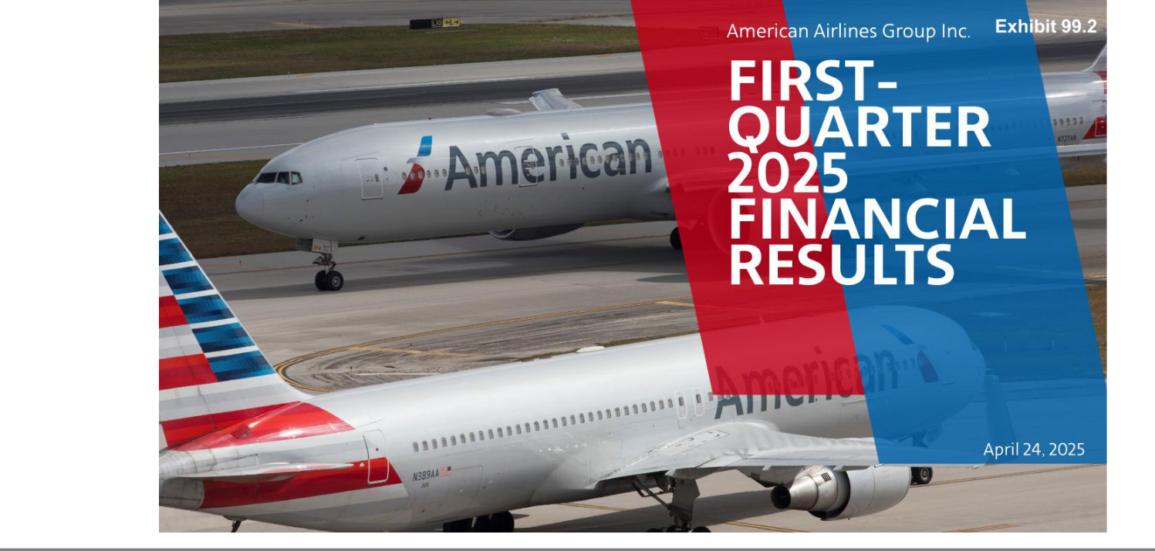

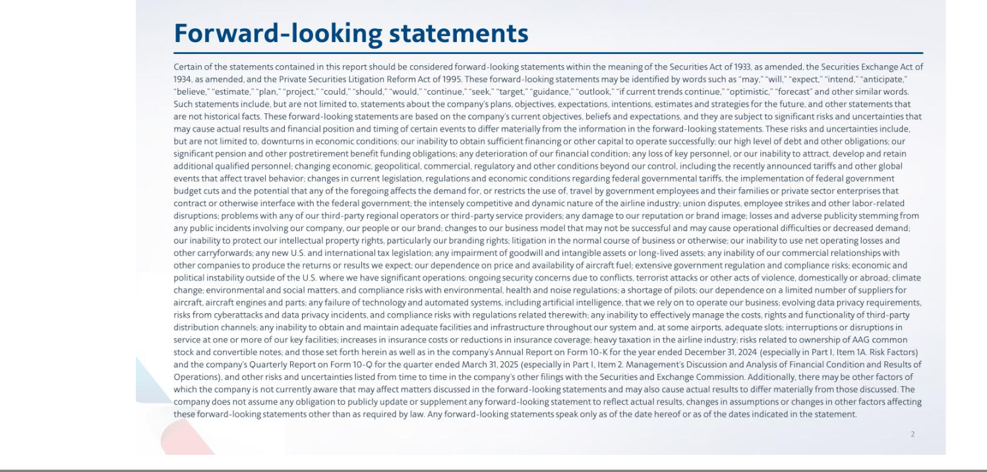

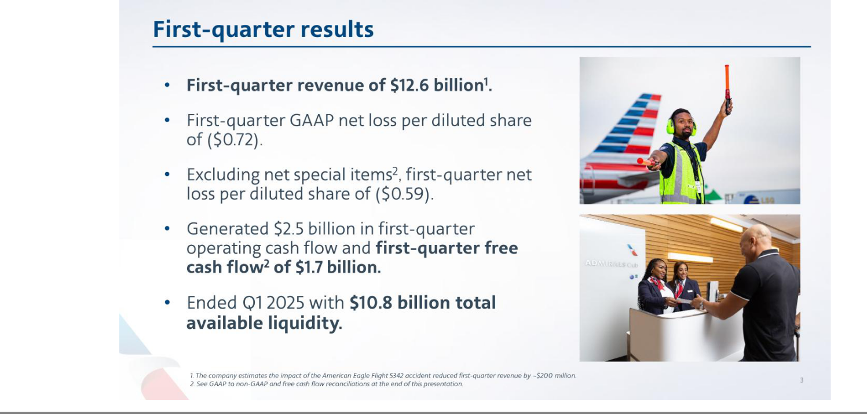

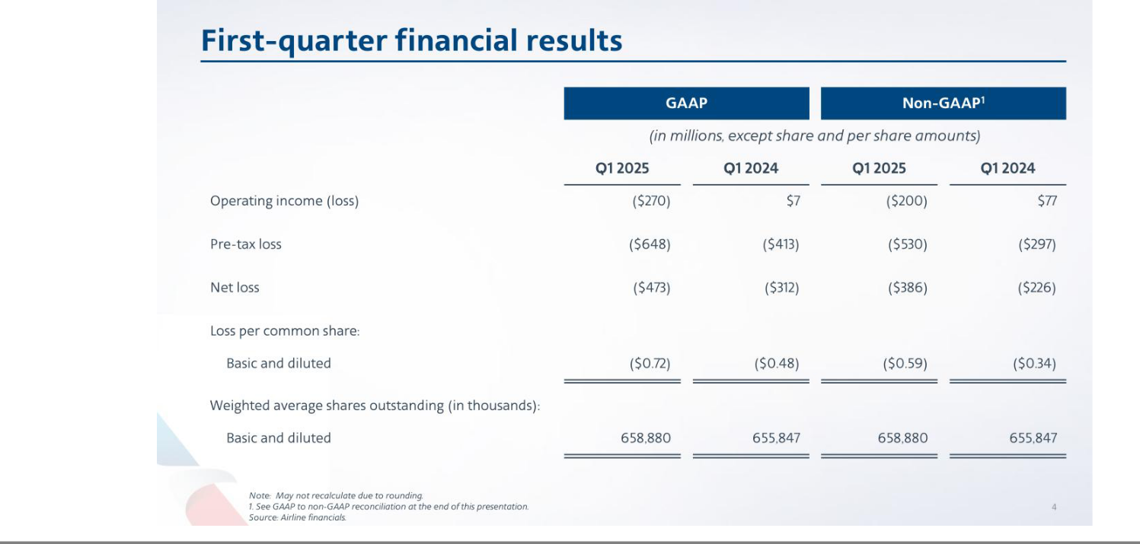

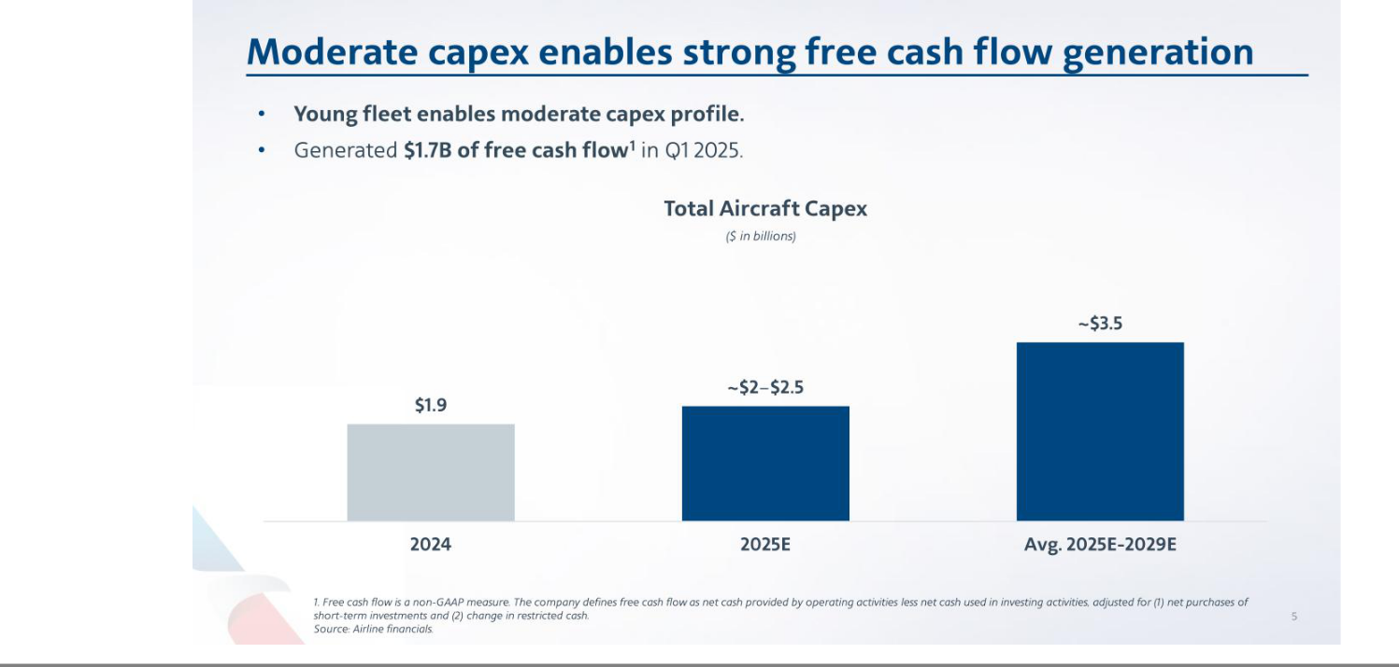

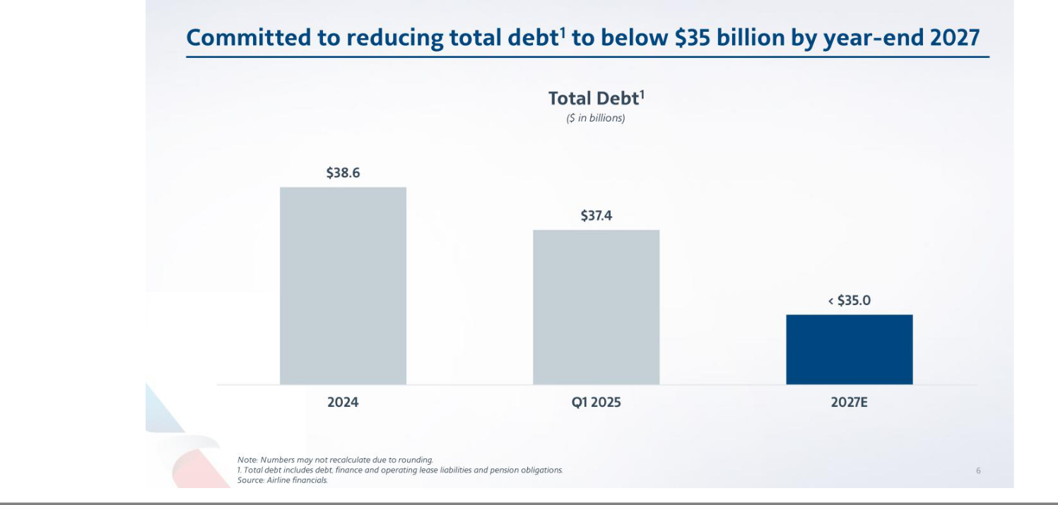



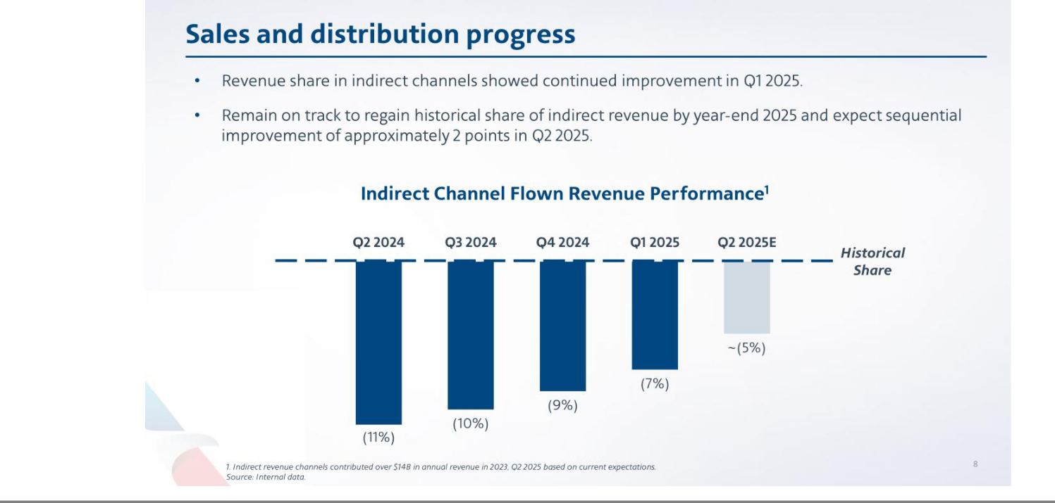

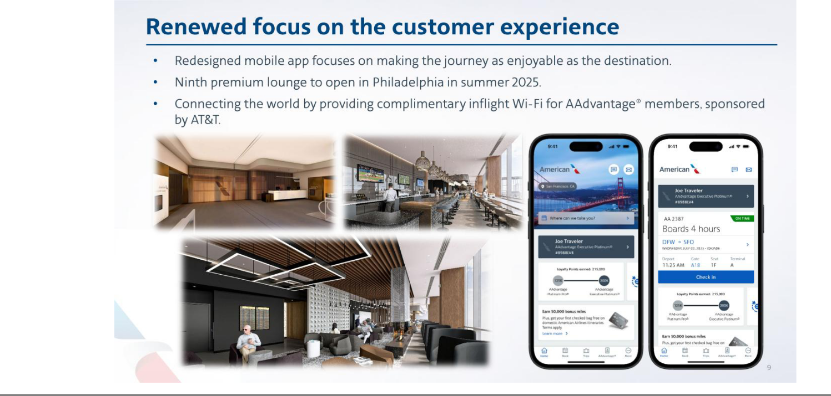

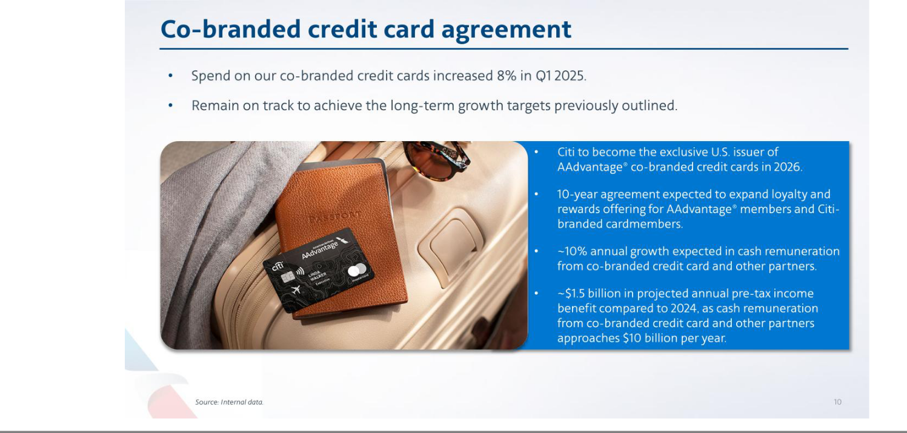

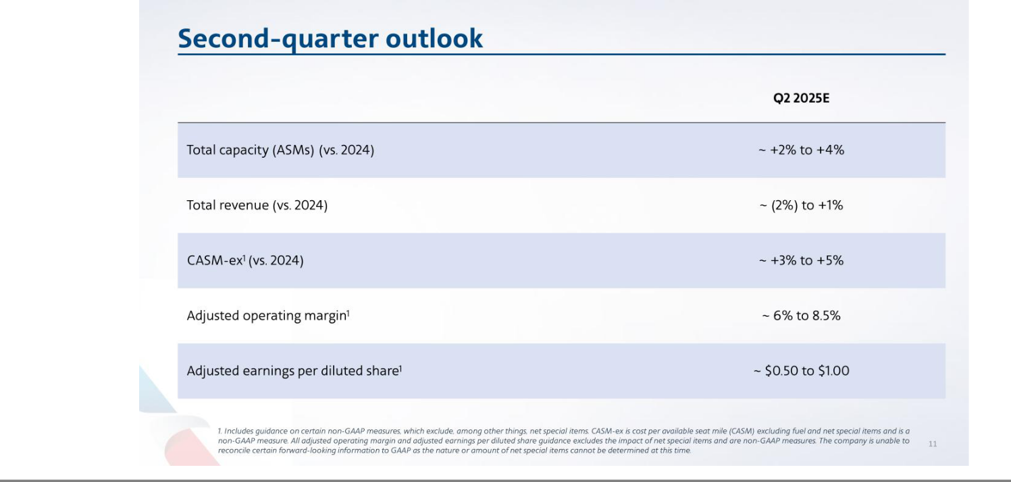



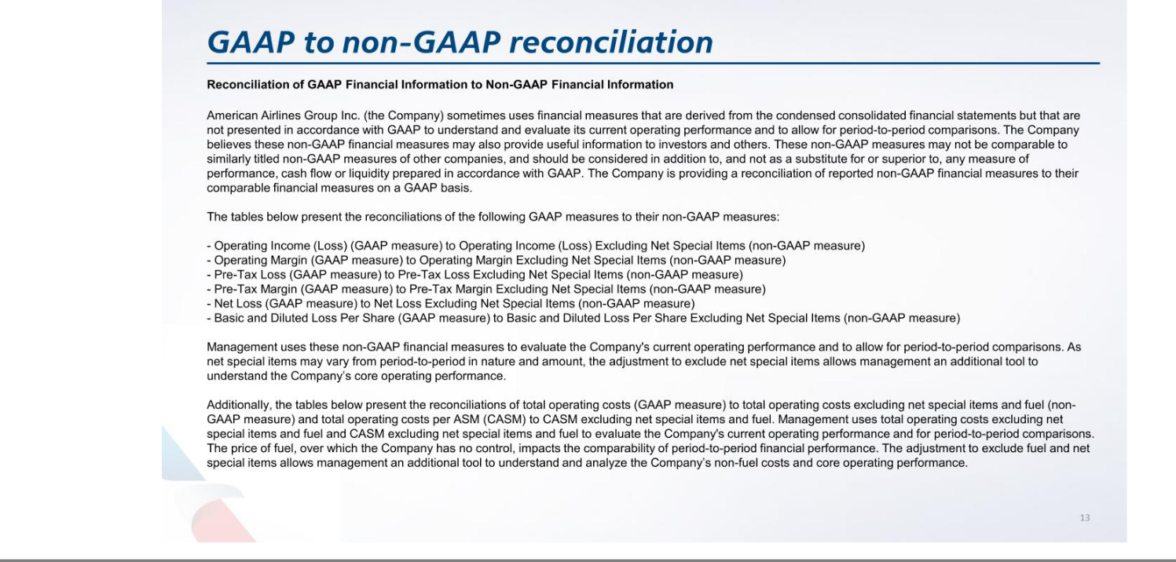

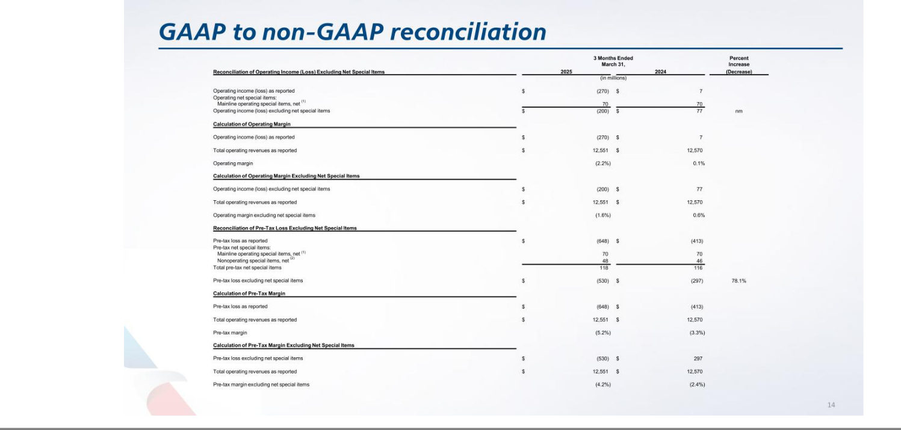

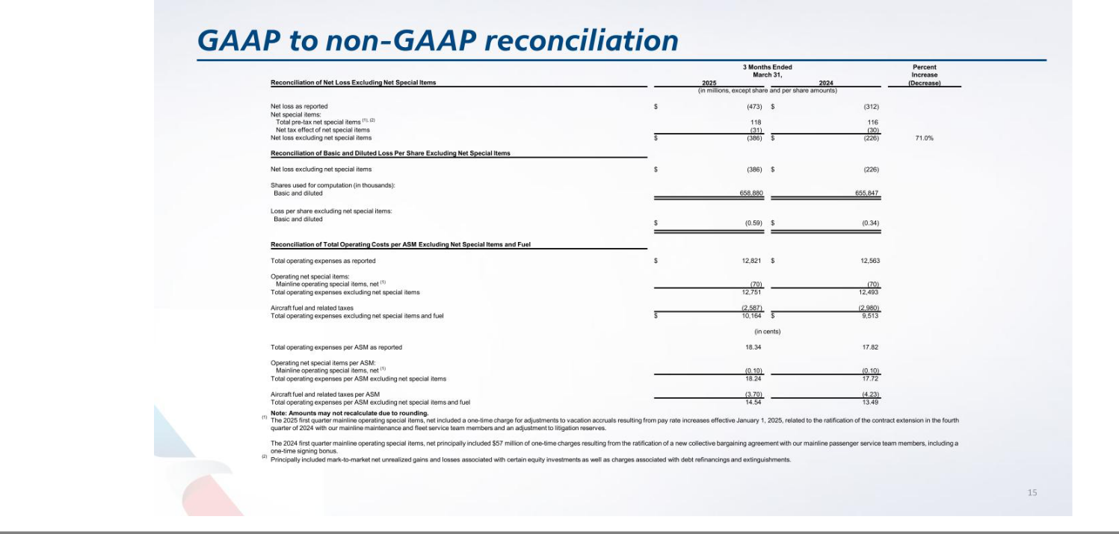

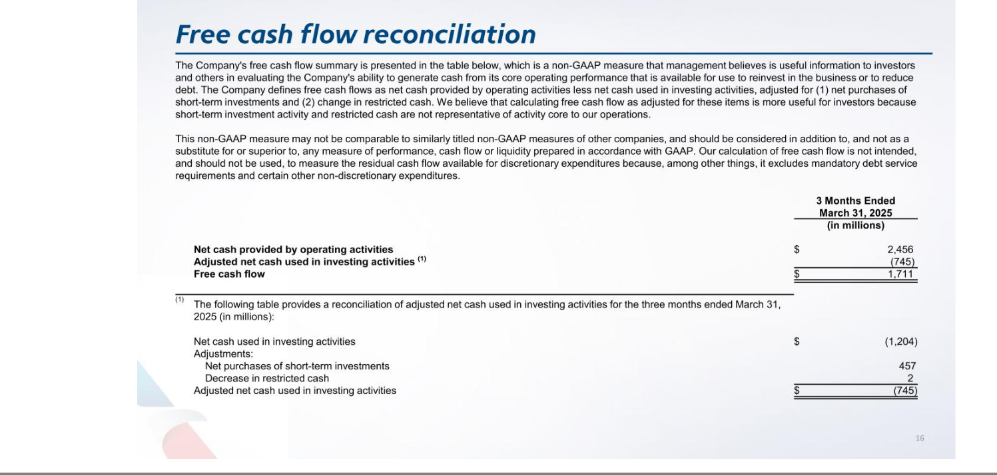

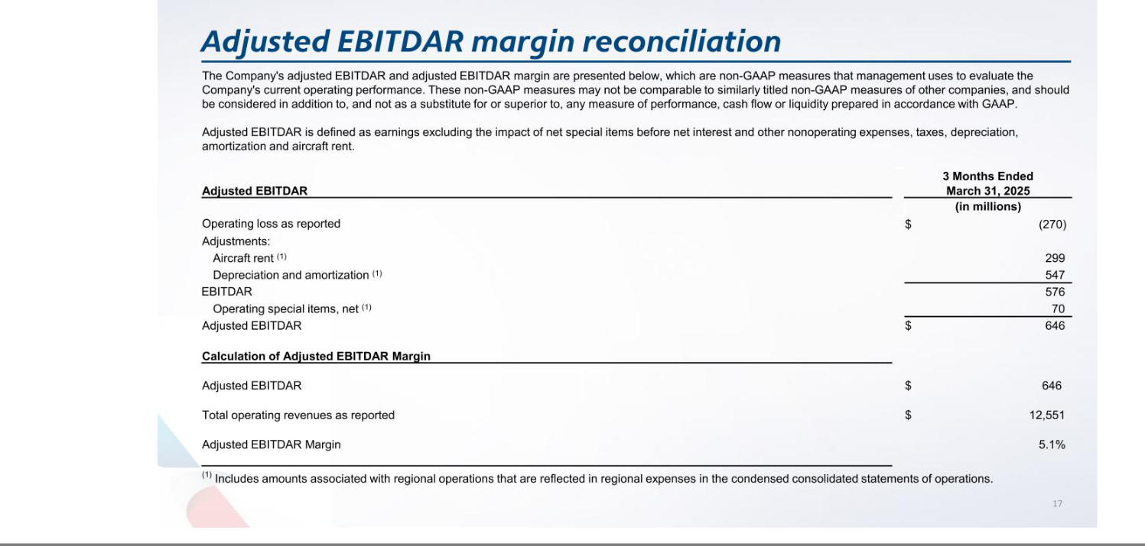

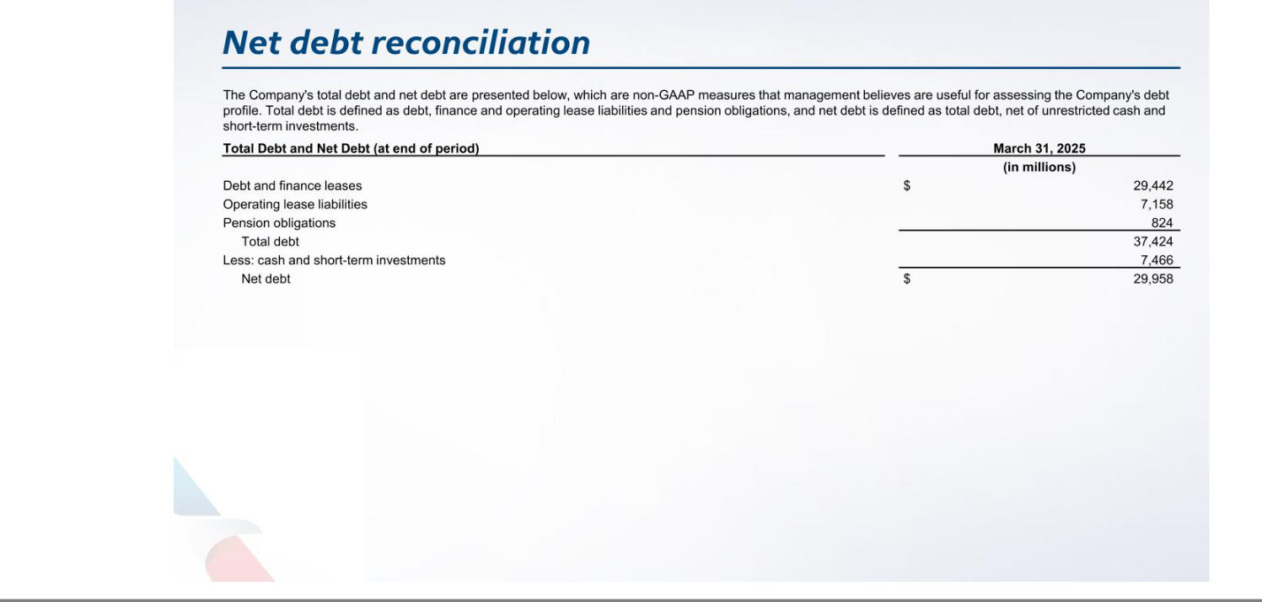




Exhibit 99.3

Financial Update

April 24, 2025

General Overview

- Capacity - The company expects its second-quarter capacity to be up approximately 2.0% to 4.0% versus the second quarter of 2024.

- Total revenue - Second-quarter total revenue is expected to be down approximately 2.0% to up approximately 1.0% versus the second quarter of 2024.

- CASM-ex¹ - The company expects its second-quarter CASM-ex to be up approximately 3.0% to 5.0% versus the second quarter of 2024.

- Adjusted operating margin¹ - Based on current assumptions, the company expects its second-quarter adjusted operating margin to be approximately 6.0% to 8.5%.

- Taxes - The company expects a provision for income taxes at an estimated effective tax rate of approximately 27% for the second quarter, which is expected to be substantially non-cash.

- Adjusted EPS¹ - Based on the assumptions outlined above, the company expects its second-quarter adjusted earnings per diluted share to be between $0.50 and $1.00 based on an expected share count of 660.4 million shares.

 | Q2 2025¹
Available seat miles (ASMs) |  | ~ +2.0% to +4.0% | (vs. Q2 24)
Total revenue |  | ~ -2.0% to +1.0% | (vs. Q2 24)
CASM excluding fuel and net special items |  | ~ +3.0% to +5.0% | (vs. Q2 24)
Adjusted operating margin |  | ~ 6.0% to 8.5%
Adjusted earnings per diluted share ($/share) |  | ~ $0.50 to $1.00
 | Q2 2025 Shares Forecast
 | Shares (mil)²
Earnings level ($ mil) | Basic |  | Diluted
Net income | 660.2 |  | 660.4
Net loss | 660.2 |  | 660.2

Notes:

- Includes guidance on certain non-GAAP measures, which exclude, among other things, net special items. CASM-ex is cost per available seat mile (CASM) excluding fuel and net special items and is a non-GAAP measure. All adjusted operating margin and adjusted earnings per diluted share guidance excludes the impact of net special items and are non-GAAP measures. The company is unable to reconcile certain forward-looking information to GAAP as the nature or amount of net special items cannot be determined at this time. Numbers may not recalculate due to rounding.

- Shares outstanding are based upon several estimates and assumptions, including average per share stock price and stock award activity. The number of shares in actual calculations of earnings per share will likely be different from those set forth above.

Please refer to the footnotes and the forward-looking statements page of this document for additional information.

Forward-Looking Statements

April 24, 2025

Cautionary Statement Regarding Forward-Looking Statements

Certain of the statements contained in this report should be considered forward-looking statements within the meaning of the Securities Act of 1933, as amended, the Securities Exchange Act of 1934, as amended, and the Private Securities Litigation Reform Act of 1995. These forward-looking statements may be identified by words such as “may,” “will,” “expect,” “intend,” “anticipate,” “believe,” “estimate,” “plan,” “project,” “could,” “should,” “would,” “continue,” “seek,” “target,” “guidance,” “outlook,” “if current trends continue,” “optimistic,” “forecast” and other similar words. Such statements include, but are not limited to, statements about the company’s plans, objectives, expectations, intentions, estimates and strategies for the future, and other statements that are not historical facts. These forward-looking statements are based on the company’s current objectives, beliefs and expectations, and they are subject to significant risks and uncertainties that may cause actual results and financial position and timing of certain events to differ materially from the information in the forward-looking statements. These risks and uncertainties include, but are not limited to, downturns in economic conditions; our inability to obtain sufficient financing or other capital to operate successfully; our high level of debt and other obligations; our significant pension and other postretirement benefit funding obligations; any deterioration of our financial condition; any loss of key personnel, or our inability to attract, develop and retain additional qualified personnel; changing economic, geopolitical, commercial, regulatory and other conditions beyond our control, including the recently announced tariffs and other global events that affect travel behavior; changes in current legislation, regulations and economic conditions regarding federal governmental tariffs, the implementation of federal government budget cuts and the potential that any of the foregoing affects the demand for, or restricts the use of, travel by government employees and their families or private sector enterprises that contract or otherwise interface with the federal government; the intensely competitive and dynamic nature of the airline industry; union disputes, employee strikes and other labor-related disruptions; problems with any of our third-party regional operators or third-party service providers; any damage to our reputation or brand image; losses and adverse publicity stemming from any public incidents involving our company, our people or our brand; changes to our business model that may not be successful and may cause operational difficulties or decreased demand; our inability to protect our intellectual property rights, particularly our branding rights; litigation in the normal course of business or otherwise; our inability to use net operating losses and other carryforwards; any new U.S. and international tax legislation; any impairment of goodwill and intangible assets or long-lived assets; any inability of our commercial relationships with other companies to produce the returns or results we expect; our dependence on price and availability of aircraft fuel; extensive government regulation and compliance risks; economic and political instability outside of the U.S. where we have significant operations; ongoing security concerns due to conflicts, terrorist attacks or other acts of violence, domestically or abroad; climate change; environmental and social matters, and compliance risks with environmental, health and noise regulations; a shortage of pilots; our dependence on a limited number of suppliers for aircraft, aircraft engines and parts; any failure of technology and automated systems, including artificial intelligence, that we rely on to operate our business; evolving data privacy requirements, risks from cyberattacks and data privacy incidents, and compliance risks with regulations related therewith; any inability to effectively manage the costs, rights and functionality of third-party distribution channels; any inability to obtain and maintain adequate facilities and infrastructure throughout our system and, at some airports, adequate slots; interruptions or disruptions in service at one or more of our key facilities; increases in insurance costs or reductions in insurance coverage; heavy taxation in the airline industry; risks related to ownership of AAG common stock and convertible notes; and those set forth herein as well as in the company’s Annual Report on Form 10-K for the year ended December 31, 2024 (especially in Part I, Item 1A. Risk Factors) and in the company’s Quarterly Report on Form 10-Q for the quarter ended March 31, 2025 (especially in Part I, Item 2. Management’s Discussion and Analysis of Financial Condition and Results of Operations), and other risks and uncertainties listed from time to time in the company’s other filings with the Securities and Exchange Commission. Additionally, there may be other factors of which the company is not currently aware that may affect matters discussed in the forward-looking statements and may also cause actual results to differ materially from those discussed. The company does not assume any obligation to publicly update or supplement any forward-looking statement to reflect actual results, changes in assumptions or changes in other factors affecting these forward-looking statements other than as required by law. Any forward-looking statements speak only as of the date hereof or as of the dates indicated in the statement.

Please refer to the footnotes and the forward-looking statements page of this document for additional information.

