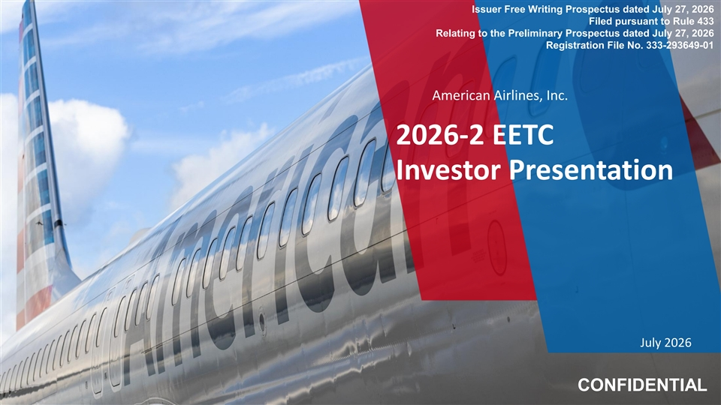
Issuer Free Writing Prospectus dated July 27, 2026 Filed pursuant to Rule 433 Relating to the Preliminary Prospectus dated July 27, 2026 Registration File No. 333-293649-01 American Airlines, Inc. 2026-2 EETC Investor Presentation July 2026 CONFIDENTIAL

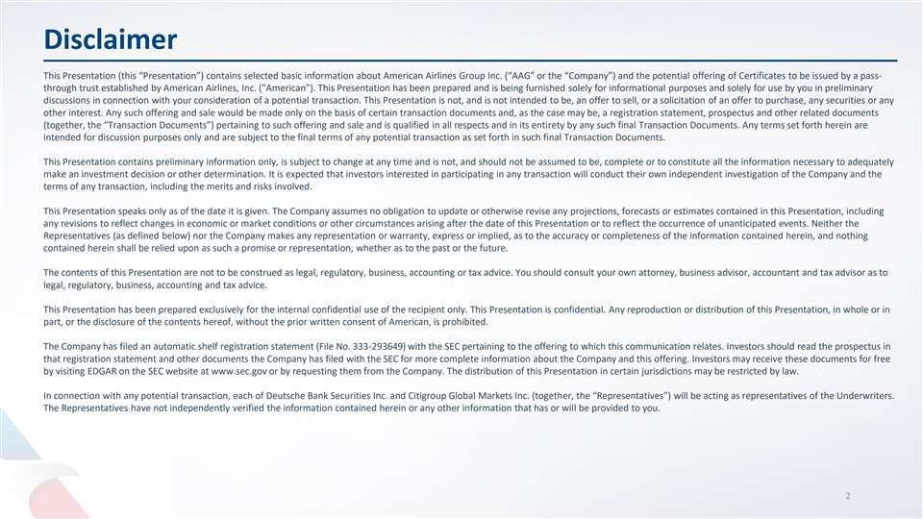
Disclaimer This Presentation (this “Presentation”) contains selected basic information about American Airlines Group Inc. (“AAG” or the “Company”) and the potential offering of Certificates to be issued by a pass- through trust established by American Airlines, Inc. ( American ). This Presentation has been prepared and is being furnished solely for informational purposes and solely for use by you in preliminary discussions in connection with your consideration of a potential transaction. This Presentation is not, and is not intended to be, an offer to sell, or a solicitation of an offer to purchase, any securities or any other interest. Any such offering and sale would be made only on the basis of certain transaction documents and, as the case may be, a registration statement, prospectus and other related documents (together, the “Transaction Documents”) pertaining to such offering and sale and is qualified in all respects and in its entirety by any such final Transaction Documents. Any terms set forth herein are intended for discussion purposes only and are subject to the final terms of any potential transaction as set forth in such final Transaction Documents. This Presentation contains preliminary information only, is subject to change at any time and is not, and should not be assumed to be, complete or to constitute all the information necessary to adequately make an investment decision or other determination. It is expected that investors interested in participating in any transaction will conduct their own independent investigation of the Company and the terms of any transaction, including the merits and risks involved. This Presentation speaks only as of the date it is given. The Company assumes no obligation to update or otherwise revise any projections, forecasts or estimates contained in this Presentation, including any revisions to reflect changes in economic or market conditions or other circumstances arising after the date of this Presentation or to reflect the occurrence of unanticipated events. Neither the Representatives (as defined below) nor the Company makes any representation or warranty, express or implied, as to the accuracy or completeness of the information contained herein, and nothing contained herein shall be relied upon as such a promise or representation, whether as to the past or the future. The contents of this Presentation are not to be construed as legal, regulatory, business, accounting or tax advice. You should consult your own attorney, business advisor, accountant and tax advisor as to legal, regulatory, business, accounting and tax advice. This Presentation has been prepared exclusively for the internal confidential use of the recipient only. This Presentation is confidential. Any reproduction or distribution of this Presentation, in whole or in part, or the disclosure of the contents hereof, without the prior written consent of American, is prohibited. The Company has filed an automatic shelf registration statement (File No. 333-293649) with the SEC pertaining to the offering to which this communication relates. Investors should read the prospectus in that registration statement and other documents the Company has filed with the SEC for more complete information about the Company and this offering. Investors may receive these documents for free by visiting EDGAR on the SEC website at www.sec.gov or by requesting them from the Company. The distribution of this Presentation in certain jurisdictions may be restricted by law. In connection with any potential transaction, each of Deutsche Bank Securities Inc. and Citigroup Global Markets Inc. (together, the “Representatives”) will be acting as representatives of the Underwriters. The Representatives have not independently verified the information contained herein or any other information that has or will be provided to you. 2


Forward-Looking Statements Certain of the statements contained in this report should be considered forward-looking statements within the meaning of the Securities Act of 1933, as amended, the Securities Exchange Act of 1934, as amended, and the Private Securities Litigation Reform Act of 1995. These forward-looking statements may be identified by words such as “may,” “will,” “expect,” “intend,” “anticipate,” “believe,” “estimate,” “plan,” “project,” “could,” “should,” “would,” “continue,” “seek,” “target,” “guidance,” “outlook,” “if current trends continue,” “optimistic,” “forecast” and other similar words. Such statements include, but are not limited to, statements about the company’s plans, objectives, expectations, intentions, estimates and strategies for the future, and other statements that are not historical facts. These forward-looking statements are based on the company’s current objectives, beliefs and expectations, and they are subject to significant risks and uncertainties that may cause actual results and financial position and timing of certain events to differ materially from the information in the forward-looking statements. These risks and uncertainties include, but are not limited to, downturns in economic conditions could adversely affect our business; we will need to obtain sufficient financing or other capital to operate successfully; our high level of debt and other obligations may limit our ability to fund general corporate requirements and obtain additional financing, may limit our flexibility in responding to competitive developments and may cause our business to be vulnerable to adverse economic and industry conditions; if our financial condition worsens, provisions in our credit card processing and other commercial agreements may adversely affect our liquidity; the loss of key personnel whom we depend on to operate our business, or the inability to attract, develop and retain additional qualified personnel could adversely affect our business; our business has been and will continue to be materially affected by many changing economic, geopolitical, commercial, regulatory and other conditions beyond our control, including global events that affect travel behavior; the airline industry is intensely competitive and dynamic; union disputes, employee strikes and other labor-related disruptions may adversely affect our operations and financial performance; if we encounter problems with any of our third-party regional operators or third-party service providers, our operations could be adversely affected by a resulting decline in revenue or negative public perception about our services; any damage to our reputation or brand image could adversely affect our business or financial results; risks of losses and adverse publicity from any public incidents involving our company, people or brand; changes to our business model that are designed to increase revenues and reduce costs may not be successful and may cause operational difficulties or decreased demand; our intellectual property rights, particularly our branding rights, are valuable, and any inability to protect them may adversely affect our business and financial results; we may be a party to litigation in the normal course of business or otherwise, which could affect our financial position and liquidity; we rely heavily on technology and automated systems, including artificial intelligence, to operate our business, and any failures could harm our business, results of operations and financial condition; evolving data privacy requirements could increase our costs, and any significant cybersecurity incident could disrupt our operations, harm our reputation, expose us to legal risks and otherwise materially adversely affect our business, results of operations and financial condition; we are exposed to risks from cyberattacks, and any cybersecurity incidents involving us, our third-party service providers, or one of our AAdvantage partners or other business partners; we have a significant amount of goodwill, which is assessed for impairment at least annually. We may never realize the full value of our intangible or long-lived assets, causing us to record material impairment charges; the commercial relationships that we have with other companies, including any related equity investments, may not produce the returns or results we expect; our business is very dependent on the price and availability of aircraft fuel. Continued periods of high volatility in fuel costs, increased fuel prices or significant disruptions in the supply of aircraft fuel could have a significant negative impact on consumer demand, our operating results and liquidity; our business is subject to extensive government regulation; we can be adversely affected by any prolonged partial or full U.S. Government shutdown; we operate a global business with international operations that are subject to economic and political instability and have been, and in the future may continue to be, adversely affected by numerous events, circumstances or government actions beyond our control; we may be adversely affected by conflicts overseas, terrorist attacks or other acts of violence, domestically or abroad; the travel industry continues to face ongoing security concerns; we are subject to risks associated with climate change, including increased regulation of our greenhouse gas emissions, changing consumer preferences and the potential for increased impacts of severe weather events on our operations and infrastructure; we are subject to various risks associated with environmental and social matters, and many forms of environmental and noise regulation; a shortage of pilots or other personnel could materially adversely affect our business; we depend on a limited number of suppliers for aircraft, aircraft engines and parts. Delays in scheduled aircraft deliveries, unexpected grounding of aircraft or aircraft engines whether by regulators or by us, or other loss of anticipated fleet capacity, and failure of new aircraft to receive regulatory approval, be produced or otherwise perform as and when expected, adversely impacts our business, results of operations and financial condition; we rely on third-party distribution channels and must effectively manage the costs, rights and functionality of these channels; if we are unable to obtain and maintain adequate facilities and infrastructure throughout our system and, at some airports, adequate slots, we may be unable to operate our existing flight schedule and to expand or change our route network in the future; interruptions or disruptions in service at one of our key facilities; increases in insurance costs or reductions in insurance coverage, and heavy taxation of the airline industry; risks related to ownership of AAG common stock; and other risks set forth herein as well as in the company’s latest annual report on Form 10-K for the year ended December 31, 2025 (especially in Part I, Item 1A. Risk Factors and Part II, Item 7. Management’s Discussion and Analysis of Financial Condition and Results of Operations) and subsequent quarterly reports on Form 10-Q (especially in Part I, Item 2. Management’s Discussion and Analysis of Financial Condition and Results of Operations and Part II, Item 1A. Risk Factors), and other risks and uncertainties listed from time to time in the company’s other filings with the Securities and Exchange Commission. Additionally, there may be other factors of which the company is not currently aware that may affect matters discussed in the forward-looking statements and may also cause actual results to differ materially from those discussed. The company does not assume any obligation to publicly update or supplement any forward-looking statement to reflect actual results, changes in assumptions or changes in other factors affecting these forward-looking statements other than as required by law. Any forward-looking statements speak only as of the date hereof or as of the dates indicated in the statement. 3

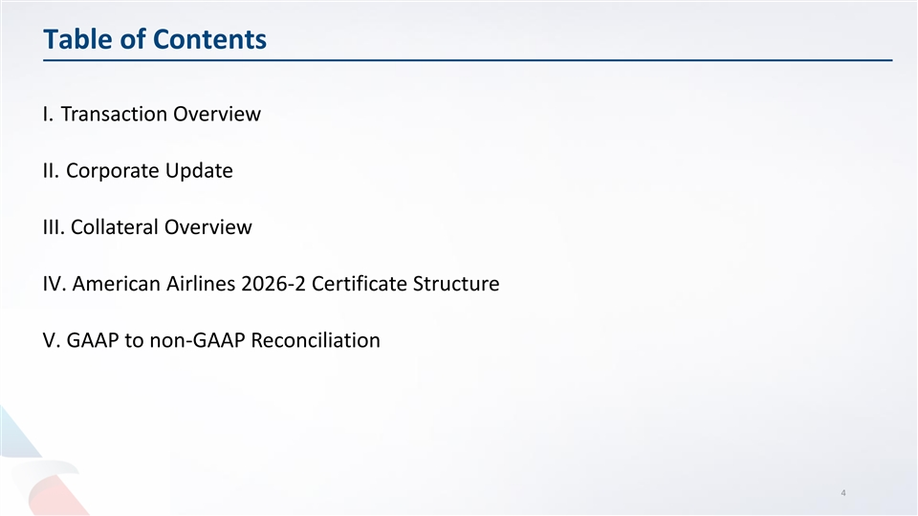
Table of Contents I. Transaction Overview II. Corporate Update III. Collateral Overview IV. American Airlines 2026-2 Certificate Structure V. GAAP to non-GAAP Reconciliation 4


Transaction Overview

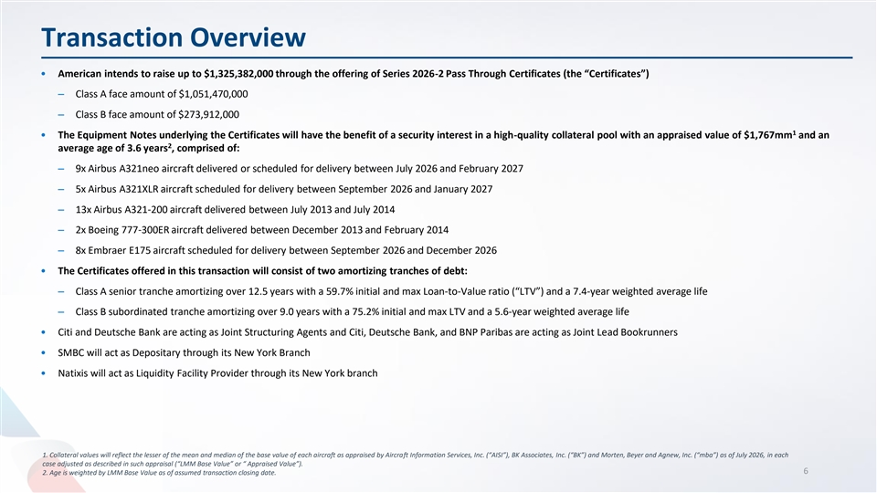
Transaction Overview • American intends to raise up to $1,325,382,000 through the offering of Series 2026-2 Pass Through Certificates (the “Certificates”) ‒ Class A face amount of $1,051,470,000 ‒ Class B face amount of $273,912,000 1 • The Equipment Notes underlying the Certificates will have the benefit of a security interest in a high-quality collateral pool with an appraised value of $1,767mm and an 2 average age of 3.6 years , comprised of: ‒ 9x Airbus A321neo aircraft delivered or scheduled for delivery between July 2026 and February 2027 ‒ 5x Airbus A321XLR aircraft scheduled for delivery between September 2026 and January 2027 ‒ 13x Airbus A321-200 aircraft delivered between July 2013 and July 2014 ‒ 2x Boeing 777-300ER aircraft delivered between December 2013 and February 2014 ‒ 8x Embraer E175 aircraft scheduled for delivery between September 2026 and December 2026 • The Certificates offered in this transaction will consist of two amortizing tranches of debt: ‒ Class A senior tranche amortizing over 12.5 years with a 59.7% initial and max Loan-to-Value ratio (“LTV”) and a 7.4-year weighted average life ‒ Class B subordinated tranche amortizing over 9.0 years with a 75.2% initial and max LTV and a 5.6-year weighted average life • Citi and Deutsche Bank are acting as Joint Structuring Agents and Citi, Deutsche Bank, and BNP Paribas are acting as Joint Lead Bookrunners • SMBC will act as Depositary through its New York Branch • Natixis will act as Liquidity Facility Provider through its New York branch 1. Collateral values will reflect the lesser of the mean and median of the base value of each aircraft as appraised by Aircraft Information Services, Inc. (“AISI”), BK Associates, Inc. (“BK”) and Morten, Beyer and Agnew, Inc. (“mba”) as of July 2026, in each case adjusted as described in such appraisal (“LMM Base Value” or “ Appraised Value”). 6 2. Age is weighted by LMM Base Value as of assumed transaction closing date.

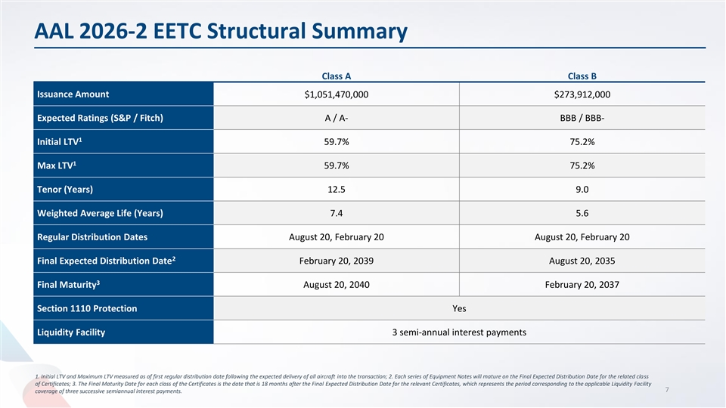
AAL 2026-2 EETC Structural Summary Class A Class B Issuance Amount $1,051,470,000 $273,912,000 Expected Ratings (S&P / Fitch) A / A- BBB / BBB- 1 Initial LTV 59.7% 75.2% 1 Max LTV 59.7% 75.2% Tenor (Years) 12.5 9.0 Weighted Average Life (Years) 7.4 5.6 Regular Distribution Dates August 20, February 20 August 20, February 20 2 Final Expected Distribution Date February 20, 2039 August 20, 2035 3 Final Maturity August 20, 2040 February 20, 2037 Section 1110 Protection Yes Liquidity Facility 3 semi-annual interest payments 1. Initial LTV and Maximum LTV measured as of first regular distribution date following the expected delivery of all aircraft into the transaction; 2. Each series of Equipment Notes will mature on the Final Expected Distribution Date for the related class of Certificates; 3. The Final Maturity Date for each class of the Certificates is the date that is 18 months after the Final Expected Distribution Date for the relevant Certificates, which represents the period corresponding to the applicable Liquidity Facility 7 coverage of three successive semiannual interest payments.

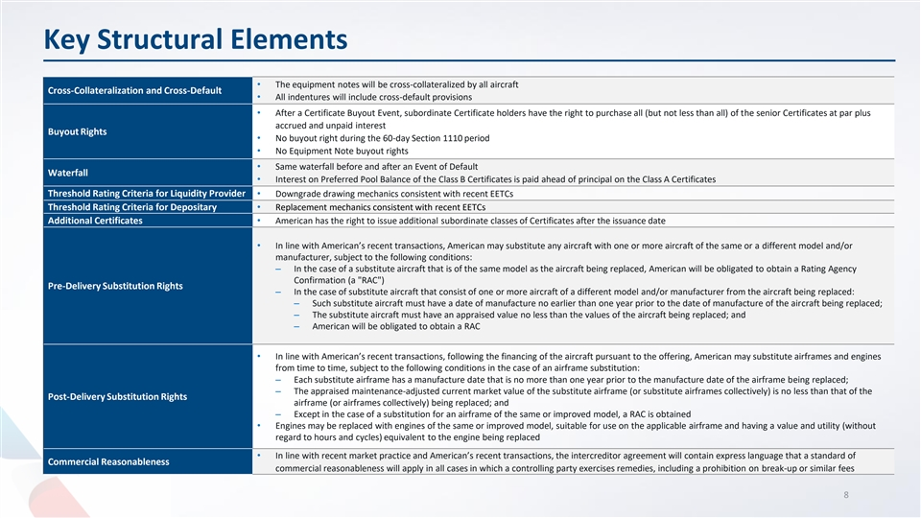
Key Structural Elements • The equipment notes will be cross-collateralized by all aircraft Cross-Collateralization and Cross-Default • All indentures will include cross-default provisions • After a Certificate Buyout Event, subordinate Certificate holders have the right to purchase all (but not less than all) of the senior Certificates at par plus accrued and unpaid interest Buyout Rights • No buyout right during the 60-day Section 1110 period • No Equipment Note buyout rights • Same waterfall before and after an Event of Default Waterfall • Interest on Preferred Pool Balance of the Class B Certificates is paid ahead of principal on the Class A Certificates Threshold Rating Criteria for Liquidity Provider• Downgrade drawing mechanics consistent with recent EETCs Threshold Rating Criteria for Depositary• Replacement mechanics consistent with recent EETCs Additional Certificates• American has the right to issue additional subordinate classes of Certificates after the issuance date • In line with American’s recent transactions, American may substitute any aircraft with one or more aircraft of the same or a different model and/or manufacturer, subject to the following conditions: ‒ In the case of a substitute aircraft that is of the same model as the aircraft being replaced, American will be obligated to obtain a Rating Agency Confirmation (a RAC ) Pre-Delivery Substitution Rights ‒ In the case of substitute aircraft that consist of one or more aircraft of a different model and/or manufacturer from the aircraft being replaced: ‒ Such substitute aircraft must have a date of manufacture no earlier than one year prior to the date of manufacture of the aircraft being replaced; ‒ The substitute aircraft must have an appraised value no less than the values of the aircraft being replaced; and ‒ American will be obligated to obtain a RAC • In line with American’s recent transactions, following the financing of the aircraft pursuant to the offering, American may substitute airframes and engines from time to time, subject to the following conditions in the case of an airframe substitution: ‒ Each substitute airframe has a manufacture date that is no more than one year prior to the manufacture date of the airframe being replaced; ‒ The appraised maintenance-adjusted current market value of the substitute airframe (or substitute airframes collectively) is no less than that of the Post-Delivery Substitution Rights airframe (or airframes collectively) being replaced; and ‒ Except in the case of a substitution for an airframe of the same or improved model, a RAC is obtained • Engines may be replaced with engines of the same or improved model, suitable for use on the applicable airframe and having a value and utility (without regard to hours and cycles) equivalent to the engine being replaced • In line with recent market practice and American’s recent transactions, the intercreditor agreement will contain express language that a standard of Commercial Reasonableness commercial reasonableness will apply in all cases in which a controlling party exercises remedies, including a prohibition on break-up or similar fees 8


Corporate Update

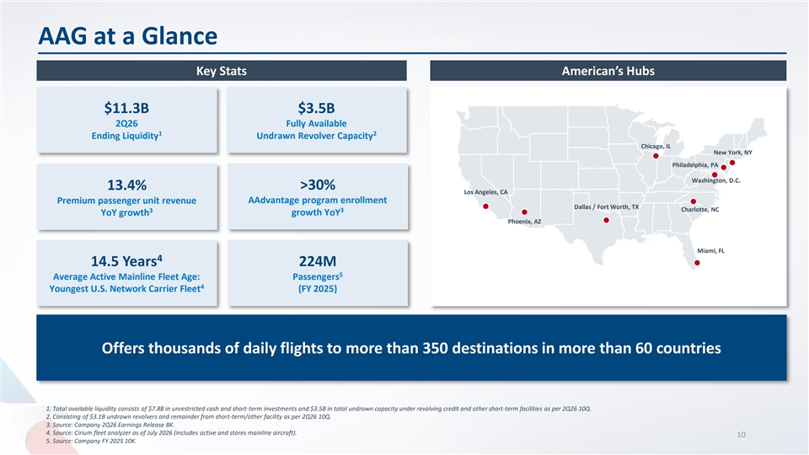
AAG at a Glance Key Stats American’s Hubs $11.3B $3.5B 2Q26 Fully Available 1 2 Ending Liquidity Undrawn Revolver Capacity Chicago, IL New York, NY Philadelphia, PA Washington, D.C. 13.4% >30% Los Angeles, CA Premium passenger unit revenue AAdvantage program enrollment Dallas / Fort Worth, TX Charlotte, NC 3 3 YoY growth growth YoY Phoenix, AZ Miami, FL 4 14.5 Years 224M 5 Average Active Mainline Fleet Age: Passengers 4 Youngest U.S. Network Carrier Fleet (FY 2025) Offers thousands of daily flights to more than 350 destinations in more than 60 countries 1. Total available liquidity consists of $7.8B in unrestricted cash and short-term investments and $3.5B in total undrawn capacity under revolving credit and other short-term facilities as per 2Q26 10Q. 2. Consisting of $3.1B undrawn revolvers and remainder from short-term/other facility as per 2Q26 10Q. 3. Source: Company 2Q26 Earnings Release 8K. 4. Source: Cirium fleet analyzer as of July 2026 (includes active and stores mainline aircraft). 10 5. Source: Company FY 2025 10K.

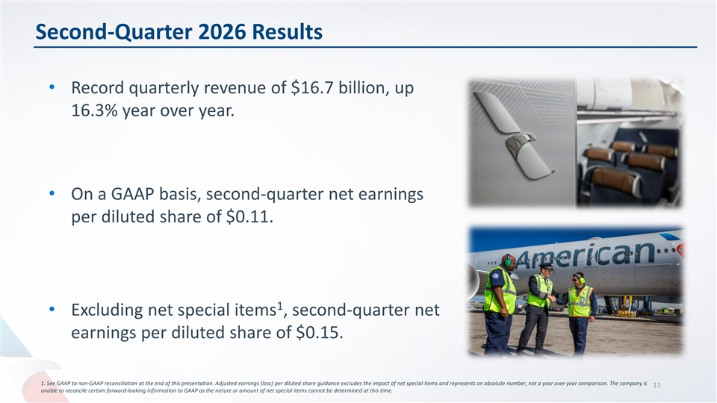
Second-Quarter 2026 Results • Record quarterly revenue of $16.7 billion, up 16.3% year over year. • On a GAAP basis, second-quarter net earnings per diluted share of $0.11. 1 • Excluding net special items , second-quarter net earnings per diluted share of $0.15. 1. See GAAP to non-GAAP reconciliation at the end of this presentation. Adjusted earnings (loss) per diluted share guidance excludes the impact of net special items and represents an absolute number, not a year over year comparison. The company is 11 unable to reconcile certain forward-looking information to GAAP as the nature or amount of net special items cannot be determined at this time.

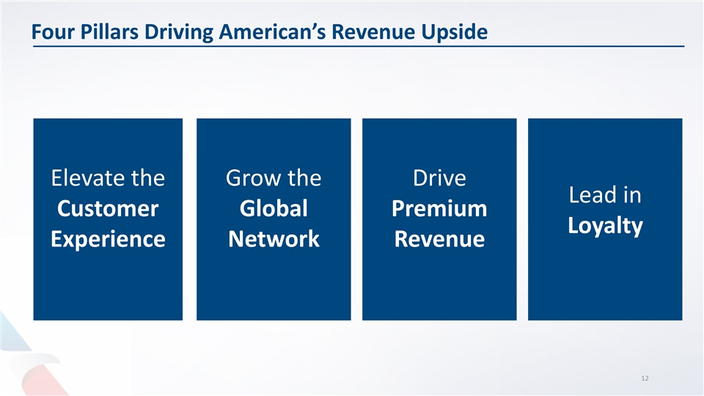
Four Pillars Driving American’s Revenue Upside Elevate the Grow the Drive Lead in Customer Global Premium Loyalty Experience Network Revenue 12

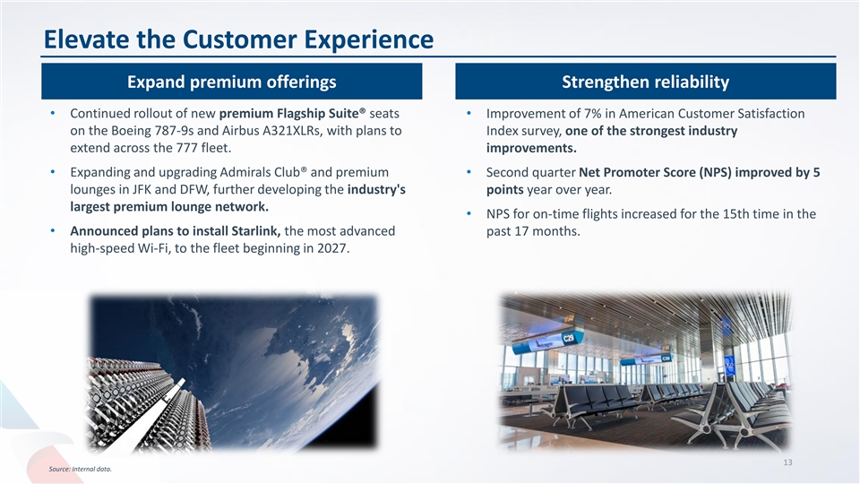
Elevate the Customer Experience Expand premium offerings Strengthen reliability • Continued rollout of new premium Flagship Suite® seats • Improvement of 7% in American Customer Satisfaction on the Boeing 787-9s and Airbus A321XLRs, with plans to Index survey, one of the strongest industry extend across the 777 fleet. improvements. • Expanding and upgrading Admirals Club® and premium • Second quarter Net Promoter Score (NPS) improved by 5 lounges in JFK and DFW, further developing the industry's points year over year. largest premium lounge network. • NPS for on-time flights increased for the 15th time in the • Announced plans to install Starlink, the most advanced past 17 months. high-speed Wi-Fi, to the fleet beginning in 2027. 13 Source: Internal data.

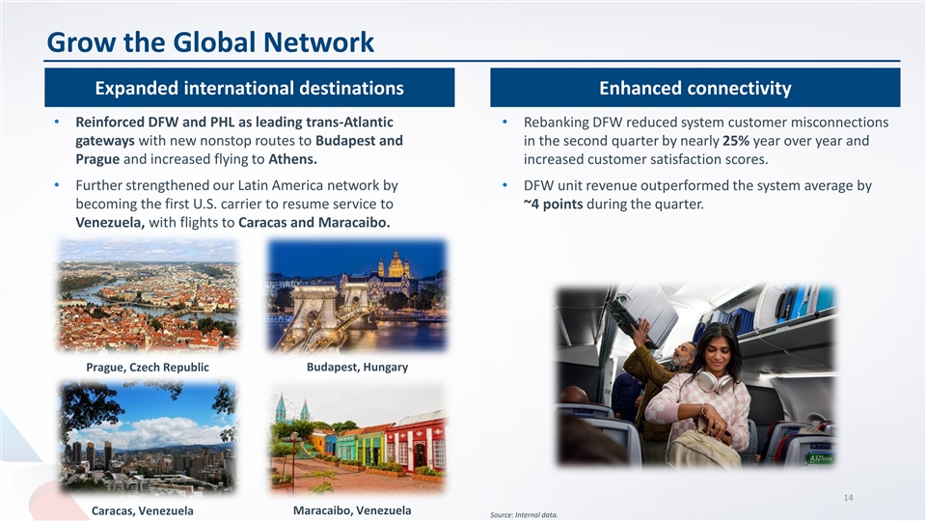
Grow the Global Network Expanded international destinations Enhanced connectivity • Reinforced DFW and PHL as leading trans-Atlantic • Rebanking DFW reduced system customer misconnections gateways with new nonstop routes to Budapest and in the second quarter by nearly 25% year over year and Prague and increased flying to Athens. increased customer satisfaction scores. • Further strengthened our Latin America network by • DFW unit revenue outperformed the system average by becoming the first U.S. carrier to resume service to ~4 points during the quarter. Venezuela, with flights to Caracas and Maracaibo. Prague, Czech Republic Budapest, Hungary 14 Caracas, Venezuela Maracaibo, Venezuela Source: Internal data.

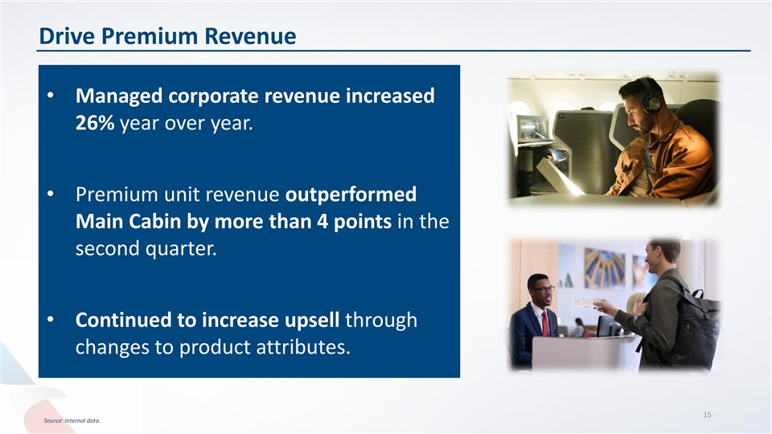
Drive Premium Revenue • Managed corporate revenue increased 26% year over year. • Premium unit revenue outperformed Main Cabin by more than 4 points in the second quarter. • Continued to increase upsell through changes to product attributes. 15 Source: Internal data.

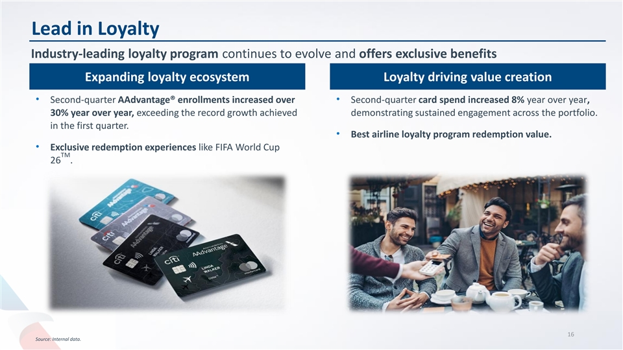
Lead in Loyalty Industry-leading loyalty program continues to evolve and offers exclusive benefits Expanding loyalty ecosystem Loyalty driving value creation • Second-quarter AAdvantage® enrollments increased over • Second-quarter card spend increased 8% year over year, 30% year over year, exceeding the record growth achieved demonstrating sustained engagement across the portfolio. in the first quarter. • Best airline loyalty program redemption value. • Exclusive redemption experiences like FIFA World Cup TM 26 . 16 Source: Internal data.

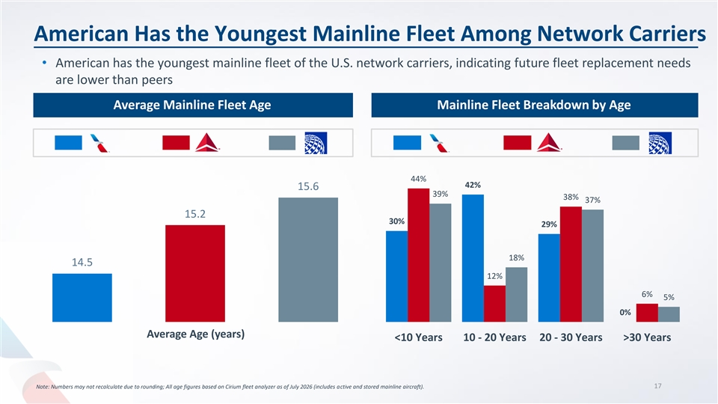
American Has the Youngest Mainline Fleet Among Network Carriers • American has the youngest mainline fleet of the U.S. network carriers, indicating future fleet replacement needs are lower than peers Average Mainline Fleet Age Mainline Fleet Breakdown by Age 44% 42% 15.6 39% 38% 37% 15.2 30% 29% 18% 14.5 12% 6% 5% 0% Average Age (years) <10 Years 10 - 20 Years 20 - 30 Years >30 Years 17 Note: Numbers may not recalculate due to rounding; All age figures based on Cirium fleet analyzer as of July 2026 (includes active and stored mainline aircraft).


Collateral Overview

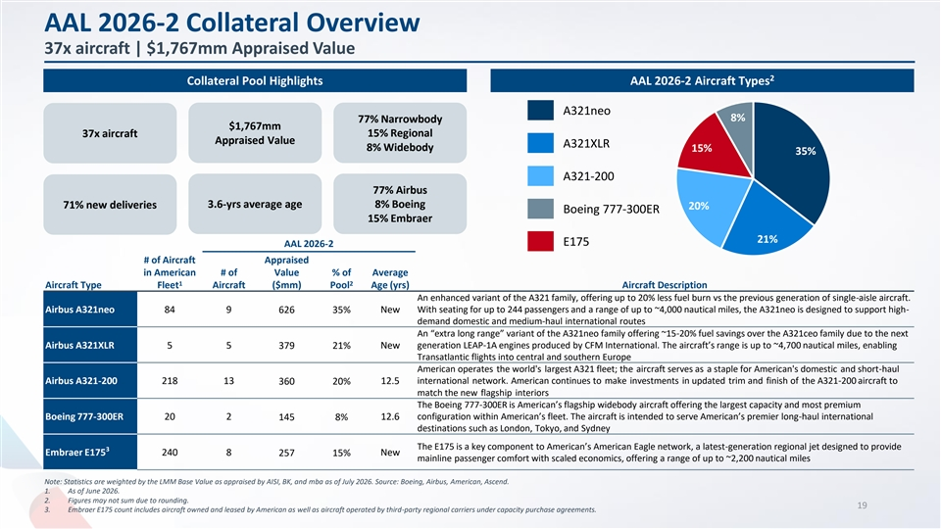
AAL 2026-2 Collateral Overview 37x aircraft | $1,767mm Appraised Value 2 Collateral Pool Highlights AAL 2026-2 Aircraft Types A321neo 8% 77% Narrowbody $1,767mm 37x aircraft 15% Regional Appraised Value A321XLR 8% Widebody 15% 35% A321-200 77% Airbus 3.6-yrs average age 8% Boeing 71% new deliveries 20% Boeing 777-300ER 15% Embraer 21% E175 AAL 2026-2 # of Aircraft Appraised in American # of Value % of Average 1 2 Aircraft Type Fleet Aircraft ($mm) Pool Age (yrs) Aircraft Description An enhanced variant of the A321 family, offering up to 20% less fuel burn vs the previous generation of single-aisle aircraft. With seating for up to 244 passengers and a range of up to ~4,000 nautical miles, the A321neo is designed to support high- Airbus A321neo 84 9 626 35% New demand domestic and medium-haul international routes An “extra long range” variant of the A321neo family offering ~15-20% fuel savings over the A321ceo family due to the next Airbus A321XLR 5 5 379 21% New generation LEAP-1A engines produced by CFM International. The aircraft’s range is up to ~4,700 nautical miles, enabling Transatlantic flights into central and southern Europe American operates the world's largest A321 fleet; the aircraft serves as a staple for American's domestic and short-haul Airbus A321-200 218 13 12.5 international network. American continues to make investments in updated trim and finish of the A321-200 aircraft to 360 20% match the new flagship interiors The Boeing 777-300ER is American’s flagship widebody aircraft offering the largest capacity and most premium Boeing 777-300ER 20 2 145 8% 12.6 configuration within American’s fleet. The aircraft is intended to serve American’s premier long-haul international destinations such as London, Tokyo, and Sydney The E175 is a key component to American’s American Eagle network, a latest-generation regional jet designed to provide 3 Embraer E175 240 8 257 15% New mainline passenger comfort with scaled economics, offering a range of up to ~2,200 nautical miles Note: Statistics are weighted by the LMM Base Value as appraised by AISI, BK, and mba as of July 2026. Source: Boeing, Airbus, American, Ascend. 1. As of June 2026. 2. Figures may not sum due to rounding. 19 3. Embraer E175 count includes aircraft owned and leased by American as well as aircraft operated by third-party regional carriers under capacity purchase agreements.

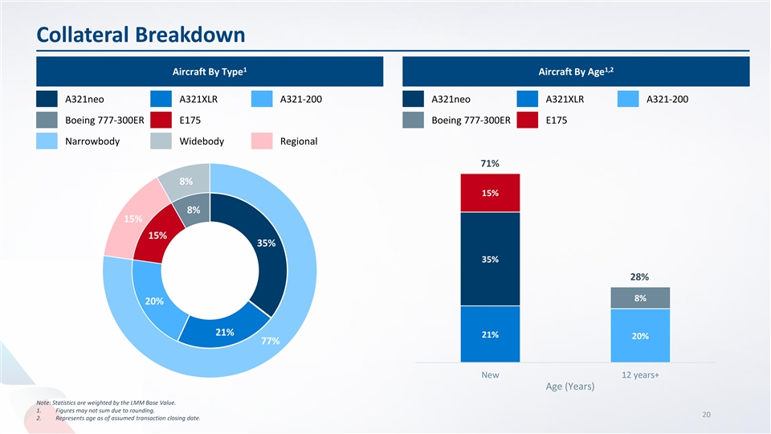
Collateral Breakdown 1 1,2 Aircraft By Type Aircraft By Age A321neo A321XLR A321-200 A321neo A321XLR A321-200 Boeing 777-300ER E175 Boeing 777-300ER E175 Narrowbody Widebody Regional 71% 8% 15% 8% 15% 15% 35% 35% 28% 8% 20% 21% 21% 20% 77% New 12 years+ Age (Years) Note: Statistics are weighted by the LMM Base Value. 1. Figures may not sum due to rounding. 20 2. Represents age as of assumed transaction closing date.

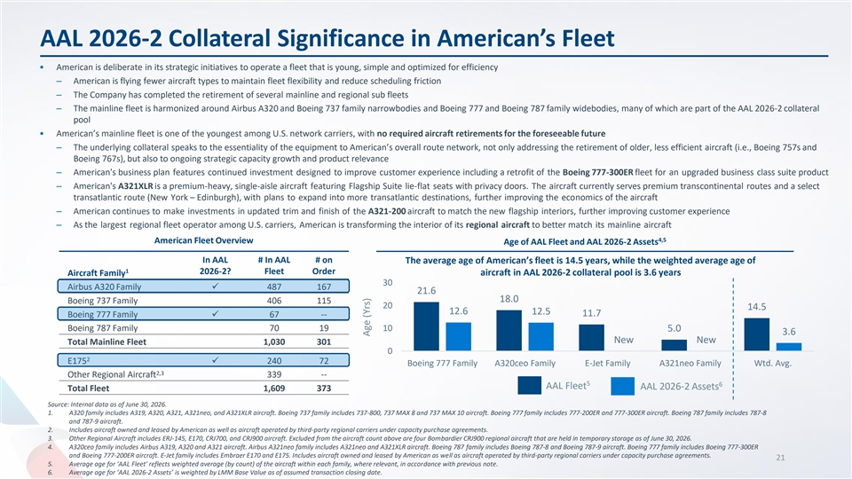
AAL 2026-2 Collateral Significance in American’s Fleet • American is deliberate in its strategic initiatives to operate a fleet that is young, simple and optimized for efficiency ‒ American is flying fewer aircraft types to maintain fleet flexibility and reduce scheduling friction ‒ The Company has completed the retirement of several mainline and regional sub fleets ‒ The mainline fleet is harmonized around Airbus A320 and Boeing 737 family narrowbodies and Boeing 777 and Boeing 787 family widebodies, many of which are part of the AAL 2026-2 collateral pool • American’s mainline fleet is one of the youngest among U.S. network carriers, with no required aircraft retirements for the foreseeable future ‒ The underlying collateral speaks to the essentiality of the equipment to American’s overall route network, not only addressing the retirement of older, less efficient aircraft (i.e., Boeing 757s and Boeing 767s), but also to ongoing strategic capacity growth and product relevance ‒ American's business plan features continued investment designed to improve customer experience including a retrofit of the Boeing 777-300ER fleet for an upgraded business class suite product ‒ American's A321XLR is a premium-heavy, single-aisle aircraft featuring Flagship Suite lie-flat seats with privacy doors. The aircraft currently serves premium transcontinental routes and a select transatlantic route (New York – Edinburgh), with plans to expand into more transatlantic destinations, further improving the economics of the aircraft ‒ American continues to make investments in updated trim and finish of the A321-200 aircraft to match the new flagship interiors, further improving customer experience ‒ As the largest regional fleet operator among U.S. carriers, American is transforming the interior of its regional aircraft to better match its mainline aircraft 4,5 American Fleet Overview Age of AAL Fleet and AAL 2026-2 Assets In AAL # In AAL # on The average age of American’s fleet is 14.5 years, while the weighted average age of 1 2026-2? Fleet Order aircraft in AAL 2026-2 collateral pool is 3.6 years Aircraft Family 30 Airbus A320 Family✓ 487 167 21.6 18.0 Boeing 737 Family 406 115 20 14.5 12.6 12.5 11.7 Boeing 777 Family✓ 67 -- Boeing 787 Family 70 19 10 5.0 3.6 New New Total Mainline Fleet 1,030 301 0 2 E175✓ 240 72 Boeing 777 Family A320ceo Family E-Jet Family A321neo Family Wtd. Avg. 2,3 Other Regional Aircraft 339 -- 5 6 AAL Fleet AAL 2026-2 Assets Total Fleet 1,609 373 Source: Internal data as of June 30, 2026. 1. A320 family includes A319, A320, A321, A321neo, and A321XLR aircraft. Boeing 737 family includes 737-800, 737 MAX 8 and 737 MAX 10 aircraft. Boeing 777 family includes 777-200ER and 777-300ER aircraft. Boeing 787 family includes 787-8 and 787-9 aircraft. 2. Includes aircraft owned and leased by American as well as aircraft operated by third-party regional carriers under capacity purchase agreements. 3. Other Regional Aircraft includes ERJ-145, E170, CRJ700, and CRJ900 aircraft. Excluded from the aircraft count above are four Bombardier CRJ900 regional aircraft that are held in temporary storage as of June 30, 2026. 4. A320ceo family includes Airbus A319, A320 and A321 aircraft. Airbus A321neo family includes A321neo and A321XLR aircraft. Boeing 787 family includes Boeing 787-8 and Boeing 787-9 aircraft. Boeing 777 family includes Boeing 777-300ER and Boeing 777-200ER aircraft. E-Jet family includes Embraer E170 and E175. Includes aircraft owned and leased by American as well as aircraft operated by third-party regional carriers under capacity purchase agreements. 21 5. Average age for ‘AAL Fleet’ reflects weighted average (by count) of the aircraft within each family, where relevant, in accordance with previous note. 6. Average age for ‘AAL 2026-2 Assets’ is weighted by LMM Base Value as of assumed transaction closing date. Age (Yrs)

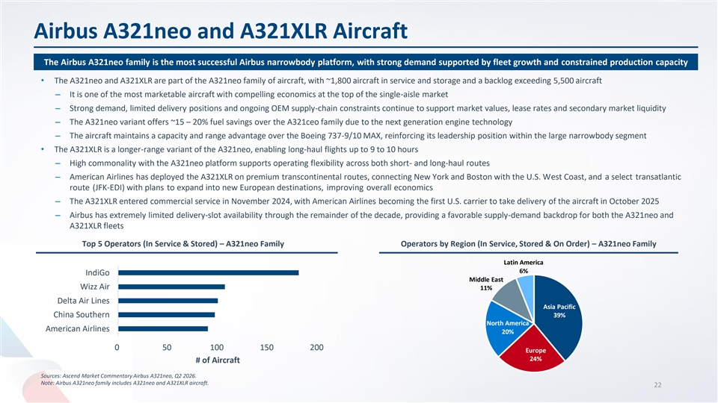
Airbus A321neo and A321XLR Aircraft The Airbus A321neo family is the most successful Airbus narrowbody platform, with strong demand supported by fleet growth and constrained production capacity • The A321neo and A321XLR are part of the A321neo family of aircraft, with ~1,800 aircraft in service and storage and a backlog exceeding 5,500 aircraft ‒ It is one of the most marketable aircraft with compelling economics at the top of the single-aisle market ‒ Strong demand, limited delivery positions and ongoing OEM supply-chain constraints continue to support market values, lease rates and secondary market liquidity ‒ The A321neo variant offers ~15 – 20% fuel savings over the A321ceo family due to the next generation engine technology ‒ The aircraft maintains a capacity and range advantage over the Boeing 737-9/10 MAX, reinforcing its leadership position within the large narrowbody segment • The A321XLR is a longer-range variant of the A321neo, enabling long-haul flights up to 9 to 10 hours ‒ High commonality with the A321neo platform supports operating flexibility across both short- and long-haul routes ‒ American Airlines has deployed the A321XLR on premium transcontinental routes, connecting New York and Boston with the U.S. West Coast, and a select transatlantic route (JFK-EDI) with plans to expand into new European destinations, improving overall economics ‒ The A321XLR entered commercial service in November 2024, with American Airlines becoming the first U.S. carrier to take delivery of the aircraft in October 2025 ‒ Airbus has extremely limited delivery-slot availability through the remainder of the decade, providing a favorable supply-demand backdrop for both the A321neo and A321XLR fleets Top 5 Operators (In Service & Stored) – A321neo Family Operators by Region (In Service, Stored & On Order) – A321neo Family Latin America 6% IndiGo Middle East Wizz Air 11% Delta Air Lines Asia Pacific China Southern 39% North America American Airlines 20% 0 50 100 150 200 Europe 24% # of Aircraft Sources: Ascend Market Commentary Airbus A321neo, Q2 2026. Note: Airbus A321neo family includes A321neo and A321XLR aircraft. 22

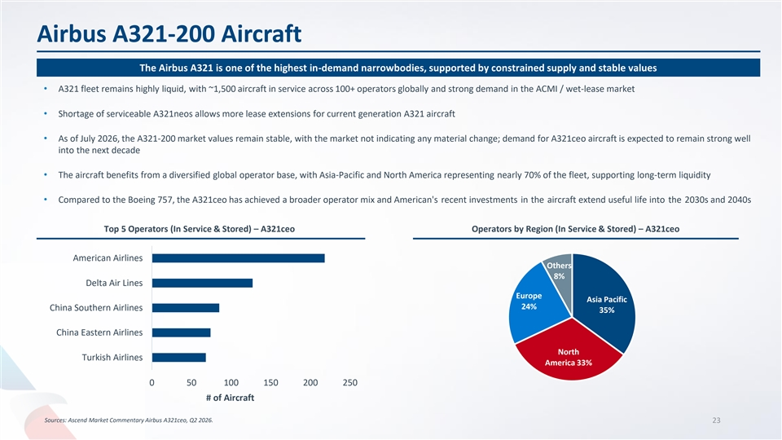
Airbus A321-200 Aircraft The Airbus A321 is one of the highest in-demand narrowbodies, supported by constrained supply and stable values • A321 fleet remains highly liquid, with ~1,500 aircraft in service across 100+ operators globally and strong demand in the ACMI / wet-lease market • Shortage of serviceable A321neos allows more lease extensions for current generation A321 aircraft • As of July 2026, the A321-200 market values remain stable, with the market not indicating any material change; demand for A321ceo aircraft is expected to remain strong well into the next decade • The aircraft benefits from a diversified global operator base, with Asia-Pacific and North America representing nearly 70% of the fleet, supporting long-term liquidity • Compared to the Boeing 757, the A321ceo has achieved a broader operator mix and American's recent investments in the aircraft extend useful life into the 2030s and 2040s Top 5 Operators (In Service & Stored) – A321ceo Operators by Region (In Service & Stored) – A321ceo American Airlines Others 8% Delta Air Lines Europe Asia Pacific 24% China Southern Airlines 35% China Eastern Airlines North Turkish Airlines America 33% 0 50 100 150 200 250 # of Aircraft Sources: Ascend Market Commentary Airbus A321ceo, Q2 2026. 23

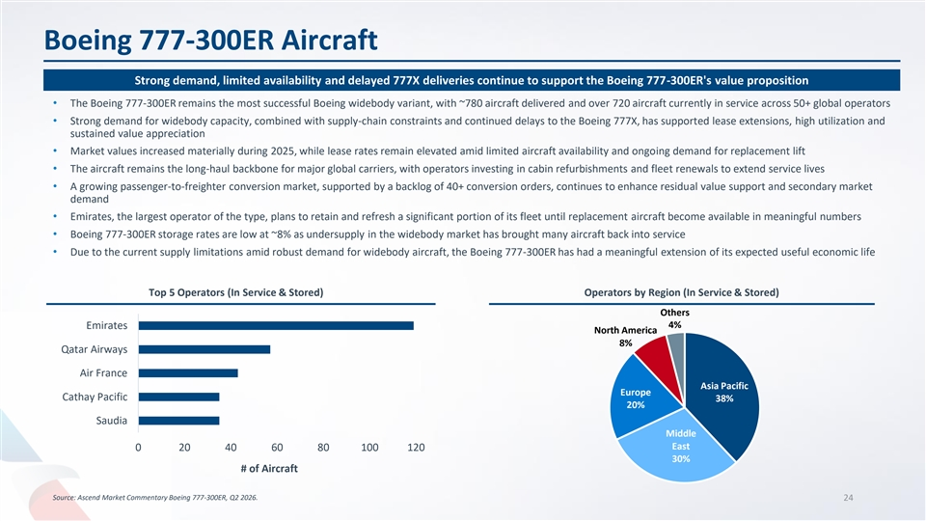
Boeing 777-300ER Aircraft Strong demand, limited availability and delayed 777X deliveries continue to support the Boeing 777-300ER's value proposition • The Boeing 777-300ER remains the most successful Boeing widebody variant, with ~780 aircraft delivered and over 720 aircraft currently in service across 50+ global operators • Strong demand for widebody capacity, combined with supply-chain constraints and continued delays to the Boeing 777X, has supported lease extensions, high utilization and sustained value appreciation • Market values increased materially during 2025, while lease rates remain elevated amid limited aircraft availability and ongoing demand for replacement lift • The aircraft remains the long-haul backbone for major global carriers, with operators investing in cabin refurbishments and fleet renewals to extend service lives • A growing passenger-to-freighter conversion market, supported by a backlog of 40+ conversion orders, continues to enhance residual value support and secondary market demand • Emirates, the largest operator of the type, plans to retain and refresh a significant portion of its fleet until replacement aircraft become available in meaningful numbers • Boeing 777-300ER storage rates are low at ~8% as undersupply in the widebody market has brought many aircraft back into service • Due to the current supply limitations amid robust demand for widebody aircraft, the Boeing 777-300ER has had a meaningful extension of its expected useful economic life Top 5 Operators (In Service & Stored) Operators by Region (In Service & Stored) Others 4% Emirates North America 8% Qatar Airways Air France Asia Pacific Europe Cathay Pacific 38% 20% Saudia Middle East 0 20 40 60 80 100 120 30% # of Aircraft Source: Ascend Market Commentary Boeing 777-300ER, Q2 2026. 24

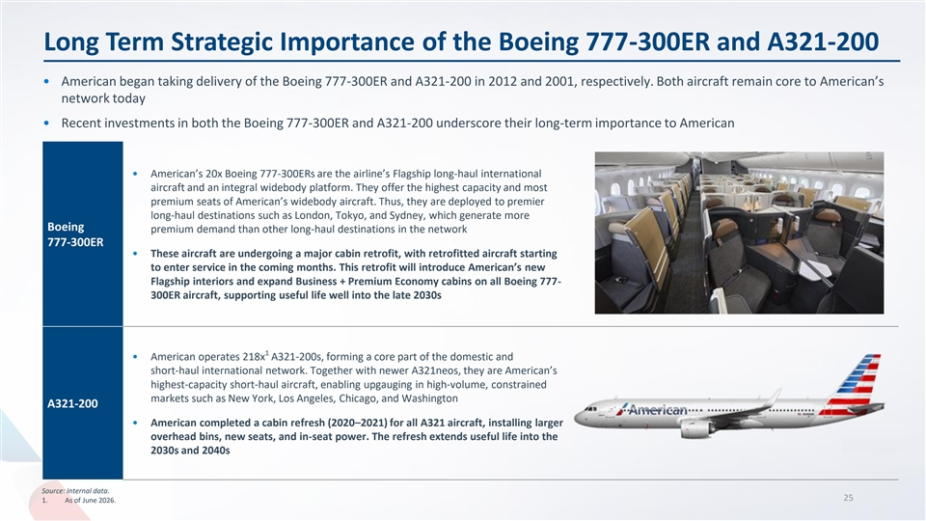
Long Term Strategic Importance of the Boeing 777-300ER and A321-200 • American began taking delivery of the Boeing 777-300ER and A321-200 in 2012 and 2001, respectively. Both aircraft remain core to American’s network today • Recent investments in both the Boeing 777-300ER and A321-200 underscore their long-term importance to American • American’s 20x Boeing 777-300ERs are the airline’s Flagship long-haul international aircraft and an integral widebody platform. They offer the highest capacity and most premium seats of American’s widebody aircraft. Thus, they are deployed to premier long-haul destinations such as London, Tokyo, and Sydney, which generate more Boeing premium demand than other long-haul destinations in the network 777-300ER • These aircraft are undergoing a major cabin retrofit, with retrofitted aircraft starting to enter service in the coming months. This retrofit will introduce American’s new Flagship interiors and expand Business + Premium Economy cabins on all Boeing 777- 300ER aircraft, supporting useful life well into the late 2030s 1 • American operates 218x A321-200s, forming a core part of the domestic and short-haul international network. Together with newer A321neos, they are American’s highest-capacity short-haul aircraft, enabling upgauging in high-volume, constrained markets such as New York, Los Angeles, Chicago, and Washington A321-200 • American completed a cabin refresh (2020–2021) for all A321 aircraft, installing larger overhead bins, new seats, and in-seat power. The refresh extends useful life into the 2030s and 2040s Source: Internal data. 25 1. As of June 2026.

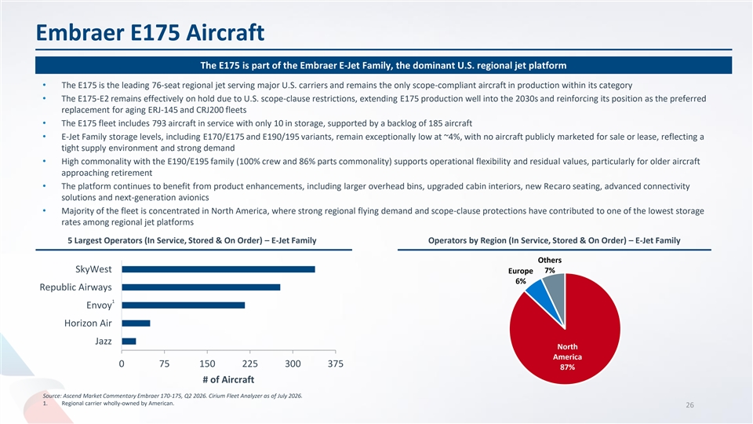
Embraer E175 Aircraft The E175 is part of the Embraer E-Jet Family, the dominant U.S. regional jet platform • The E175 is the leading 76-seat regional jet serving major U.S. carriers and remains the only scope-compliant aircraft in production within its category • The E175-E2 remains effectively on hold due to U.S. scope-clause restrictions, extending E175 production well into the 2030s and reinforcing its position as the preferred replacement for aging ERJ-145 and CRJ200 fleets • The E175 fleet includes 793 aircraft in service with only 10 in storage, supported by a backlog of 185 aircraft • E-Jet Family storage levels, including E170/E175 and E190/195 variants, remain exceptionally low at ~4%, with no aircraft publicly marketed for sale or lease, reflecting a tight supply environment and strong demand • High commonality with the E190/E195 family (100% crew and 86% parts commonality) supports operational flexibility and residual values, particularly for older aircraft approaching retirement • The platform continues to benefit from product enhancements, including larger overhead bins, upgraded cabin interiors, new Recaro seating, advanced connectivity solutions and next-generation avionics • Majority of the fleet is concentrated in North America, where strong regional flying demand and scope-clause protections have contributed to one of the lowest storage rates among regional jet platforms 5 Largest Operators (In Service, Stored & On Order) – E-Jet Family Operators by Region (In Service, Stored & On Order) – E-Jet Family Others SkyWest Europe 7% 6% Republic Airways 1 Envoy Horizon Air Jazz North America 0 75 150 225 300 375 87% # of Aircraft Source: Ascend Market Commentary Embraer 170-175, Q2 2026. Cirium Fleet Analyzer as of July 2026. 1. Regional carrier wholly-owned by American. 26

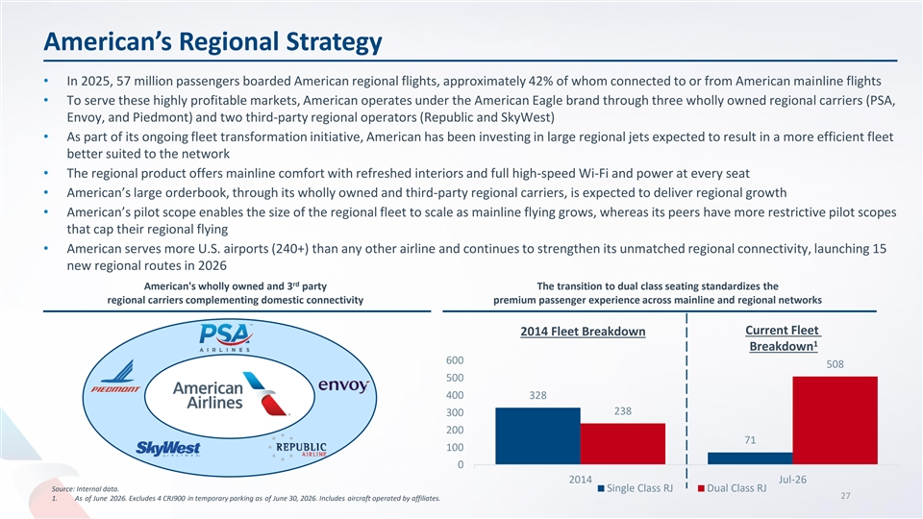
American’s Regional Strategy • In 2025, 57 million passengers boarded American regional flights, approximately 42% of whom connected to or from American mainline flights • To serve these highly profitable markets, American operates under the American Eagle brand through three wholly owned regional carriers (PSA, Envoy, and Piedmont) and two third-party regional operators (Republic and SkyWest) • As part of its ongoing fleet transformation initiative, American has been investing in large regional jets expected to result in a more efficient fleet better suited to the network • The regional product offers mainline comfort with refreshed interiors and full high-speed Wi-Fi and power at every seat • American’s large orderbook, through its wholly owned and third-party regional carriers, is expected to deliver regional growth • American’s pilot scope enables the size of the regional fleet to scale as mainline flying grows, whereas its peers have more restrictive pilot scopes that cap their regional flying • American serves more U.S. airports (240+) than any other airline and continues to strengthen its unmatched regional connectivity, launching 15 new regional routes in 2026 rd American's wholly owned and 3 party The transition to dual class seating standardizes the regional carriers complementing domestic connectivity premium passenger experience across mainline and regional networks Current Fleet 2014 Fleet Breakdown 1 Breakdown 600 508 500 400 328 238 300 200 71 100 0 2014 Jul-26 Source: Internal data. Single Class RJ Dual Class RJ 27 1. As of June 2026. Excludes 4 CRJ900 in temporary parking as of June 30, 2026. Includes aircraft operated by affiliates.

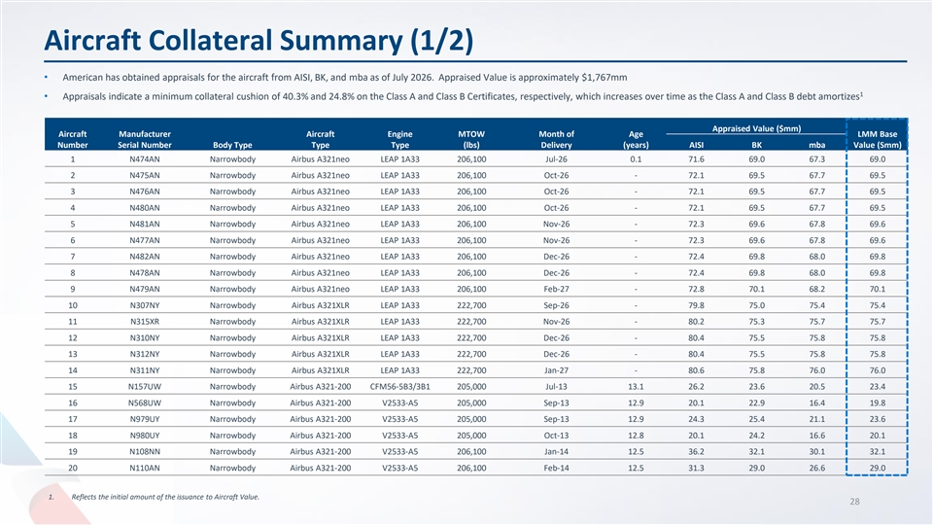
Aircraft Collateral Summary (1/2) • American has obtained appraisals for the aircraft from AISI, BK, and mba as of July 2026. Appraised Value is approximately $1,767mm 1 • Appraisals indicate a minimum collateral cushion of 40.3% and 24.8% on the Class A and Class B Certificates, respectively, which increases over time as the Class A and Class B debt amortizes Appraised Value ($mm) Aircraft Manufacturer Aircraft Engine MTOW Month of Age LMM Base Number Serial Number Body Type Type Type (lbs) Delivery (years) AISI BK mba Value (Smm) 1 N474AN Narrowbody Airbus A321neo LEAP 1A33 206,100 Jul-26 0.1 71.6 69.0 67.3 69.0 2 N475AN Narrowbody Airbus A321neo LEAP 1A33 206,100 Oct-26 - 72.1 69.5 67.7 69.5 3 N476AN Narrowbody Airbus A321neo LEAP 1A33 206,100 Oct-26 - 72.1 69.5 67.7 69.5 4 N480AN Narrowbody Airbus A321neo LEAP 1A33 206,100 Oct-26 - 72.1 69.5 67.7 69.5 5 N481AN Narrowbody Airbus A321neo LEAP 1A33 206,100 Nov-26 - 72.3 69.6 67.8 69.6 6 N477AN Narrowbody Airbus A321neo LEAP 1A33 206,100 Nov-26 - 72.3 69.6 67.8 69.6 7 N482AN Narrowbody Airbus A321neo LEAP 1A33 206,100 Dec-26 - 72.4 69.8 68.0 69.8 8 N478AN Narrowbody Airbus A321neo LEAP 1A33 206,100 Dec-26 - 72.4 69.8 68.0 69.8 9 N479AN Narrowbody Airbus A321neo LEAP 1A33 206,100 Feb-27 - 72.8 70.1 68.2 70.1 10 N307NY Narrowbody Airbus A321XLR LEAP 1A33 222,700 Sep-26 - 79.8 75.0 75.4 75.4 11 N315XR Narrowbody Airbus A321XLR LEAP 1A33 222,700 Nov-26 - 80.2 75.3 75.7 75.7 12 N310NY Narrowbody Airbus A321XLR LEAP 1A33 222,700 Dec-26 - 80.4 75.5 75.8 75.8 13 N312NY Narrowbody Airbus A321XLR LEAP 1A33 222,700 Dec-26 - 80.4 75.5 75.8 75.8 14 N311NY Narrowbody Airbus A321XLR LEAP 1A33 222,700 Jan-27 - 80.6 75.8 76.0 76.0 15 N157UW Narrowbody Airbus A321-200 CFM56-5B3/3B1 205,000 Jul-13 13.1 26.2 23.6 20.5 23.4 16 N568UW Narrowbody Airbus A321-200 V2533-A5 205,000 Sep-13 12.9 20.1 22.9 16.4 19.8 17 N979UY Narrowbody Airbus A321-200 V2533-A5 205,000 Sep-13 12.9 24.3 25.4 21.1 23.6 18 N980UY Narrowbody Airbus A321-200 V2533-A5 205,000 Oct-13 12.8 20.1 24.2 16.6 20.1 19 N108NN Narrowbody Airbus A321-200 V2533-A5 206,100 Jan-14 12.5 36.2 32.1 30.1 32.1 20 N110AN Narrowbody Airbus A321-200 V2533-A5 206,100 Feb-14 12.5 31.3 29.0 26.6 29.0 1. Reflects the initial amount of the issuance to Aircraft Value. 28

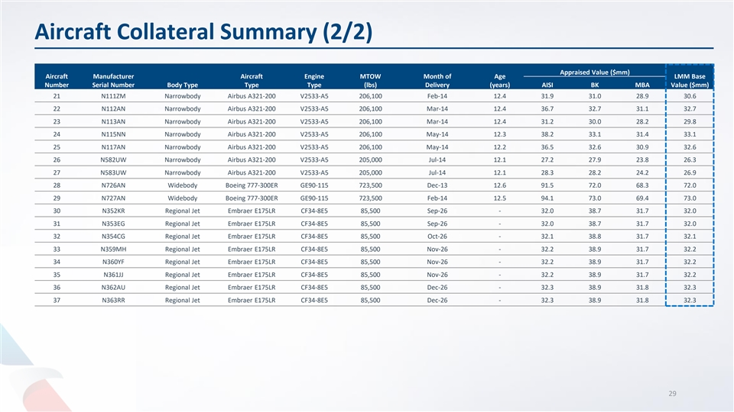
Aircraft Collateral Summary (2/2) Appraised Value ($mm) Aircraft Manufacturer Aircraft Engine MTOW Month of Age LMM Base Number Serial Number Body Type Type Type (lbs) Delivery (years) AISI BK MBA Value ($mm) 21 N111ZM Narrowbody Airbus A321-200 V2533-A5 206,100 Feb-14 12.4 31.9 31.0 28.9 30.6 22 N112AN Narrowbody Airbus A321-200 V2533-A5 206,100 Mar-14 12.4 36.7 32.7 31.1 32.7 23 N113AN Narrowbody Airbus A321-200 V2533-A5 206,100 Mar-14 12.4 31.2 30.0 28.2 29.8 24 N115NN Narrowbody Airbus A321-200 V2533-A5 206,100 May-14 12.3 38.2 33.1 31.4 33.1 25 N117AN Narrowbody Airbus A321-200 V2533-A5 206,100 May-14 12.2 36.5 32.6 30.9 32.6 26 N582UW Narrowbody Airbus A321-200 V2533-A5 205,000 Jul-14 12.1 27.2 27.9 23.8 26.3 27 N583UW Narrowbody Airbus A321-200 V2533-A5 205,000 Jul-14 12.1 28.3 28.2 24.2 26.9 28 N726AN Widebody Boeing 777-300ER GE90-115 723,500 Dec-13 12.6 91.5 72.0 68.3 72.0 29 N727AN Widebody Boeing 777-300ER GE90-115 723,500 Feb-14 12.5 94.1 73.0 69.4 73.0 30 N352KR Regional Jet Embraer E175LR CF34-8E5 85,500 Sep-26 - 32.0 38.7 31.7 32.0 31 N353EG Regional Jet Embraer E175LR CF34-8E5 85,500 Sep-26 - 32.0 38.7 31.7 32.0 32 N354CG Regional Jet Embraer E175LR CF34-8E5 85,500 Oct-26 - 32.1 38.8 31.7 32.1 33 N359MH Regional Jet Embraer E175LR CF34-8E5 85,500 Nov-26 - 32.2 38.9 31.7 32.2 34 N360YF Regional Jet Embraer E175LR CF34-8E5 85,500 Nov-26 - 32.2 38.9 31.7 32.2 35 N361JJ Regional Jet Embraer E175LR CF34-8E5 85,500 Nov-26 - 32.2 38.9 31.7 32.2 36 N362AU Regional Jet Embraer E175LR CF34-8E5 85,500 Dec-26 - 32.3 38.9 31.8 32.3 37 N363RR Regional Jet Embraer E175LR CF34-8E5 85,500 Dec-26 - 32.3 38.9 31.8 32.3 29


American Airlines 2026-2 Certificate Structure

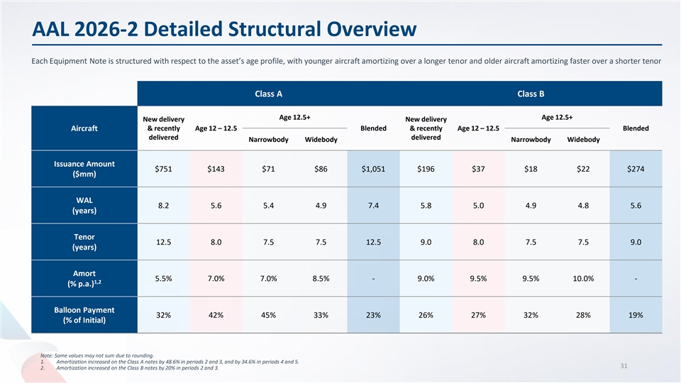
AAL 2026-2 Detailed Structural Overview Each Equipment Note is structured with respect to the asset’s age profile, with younger aircraft amortizing over a longer tenor and older aircraft amortizing faster over a shorter tenor Class A Class B Age 12.5+ Age 12.5+ New delivery New delivery & recently Age 12 – 12.5 Blended & recently Age 12 – 12.5 Blended Aircraft delivered delivered Narrowbody Widebody Narrowbody Widebody Issuance Amount $751 $143 $71 $86 $1,051 $196 $37 $18 $22 $274 ($mm) WAL 8.2 5.6 5.4 4.9 7.4 5.8 5.0 4.9 4.8 5.6 (years) Tenor 12.5 8.0 7.5 7.5 12.5 9.0 8.0 7.5 7.5 9.0 (years) Amort 5.5% 7.0% 7.0% 8.5% - 9.0% 9.5% 9.5% 10.0% - 1,2 (% p.a.) Balloon Payment 32% 42% 45% 33% 23% 26% 27% 32% 28% 19% (% of Initial) Note: Some values may not sum due to rounding. 1. Amortization increased on the Class A notes by 48.6% in periods 2 and 3, and by 34.6% in periods 4 and 5. 31 2. Amortization increased on the Class B notes by 20% in periods 2 and 3.

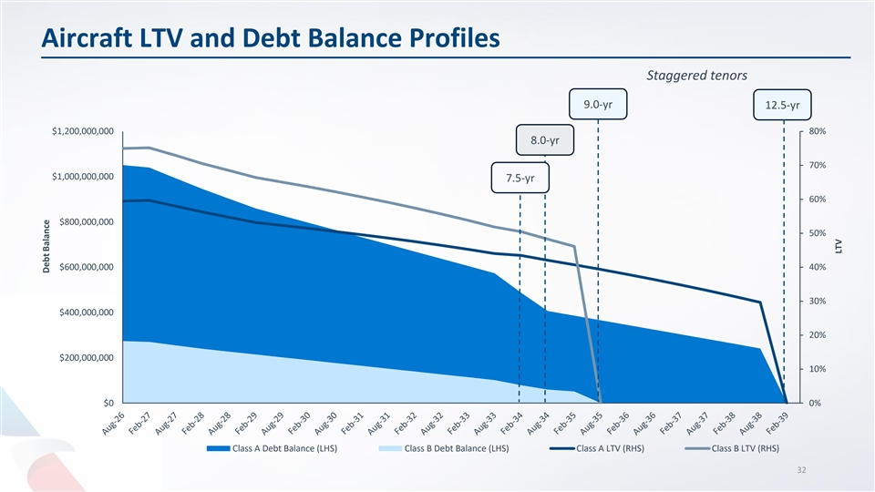
Aircraft LTV and Debt Balance Profiles Staggered tenors 9.0-yr 12.5-yr $1,200,000,000 80% 8.0-yr 70% $1,000,000,000 7.5-yr 60% $800,000,000 50% $600,000,000 40% 30% $400,000,000 20% $200,000,000 10% $0 0% Class A Debt Balance (LHS) Class B Debt Balance (LHS) Class A LTV (RHS) Class B LTV (RHS) 32 Debt Balance LTV

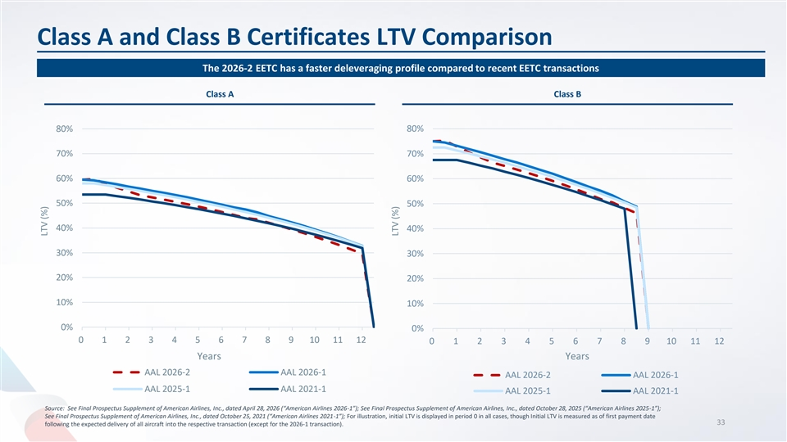
Class A and Class B Certificates LTV Comparison The 2026-2 EETC has a faster deleveraging profile compared to recent EETC transactions Class A Class B 80% 80% 70% 70% 60% 60% 50% 50% 40% 40% 30% 30% 20% 20% 10% 10% 0% 0% 0 1 2 3 4 5 6 7 8 9 10 11 12 0 1 2 3 4 5 6 7 8 9 10 11 12 Years Years AAL 2026-2 AAL 2026-1 AAL 2026-2 AAL 2026-1 AAL 2025-1 AAL 2021-1 AAL 2025-1 AAL 2021-1 Source: See Final Prospectus Supplement of American Airlines, Inc., dated April 28, 2026 (“American Airlines 2026-1”); See Final Prospectus Supplement of American Airlines, Inc., dated October 28, 2025 (“American Airlines 2025-1”); See Final Prospectus Supplement of American Airlines, Inc., dated October 25, 2021 (“American Airlines 2021-1”); For illustration, initial LTV is displayed in period 0 in all cases, though Initial LTV is measured as of first payment date 33 following the expected delivery of all aircraft into the respective transaction (except for the 2026-1 transaction). LTV (%) LTV (%)


GAAP to non-GAAP Reconciliation

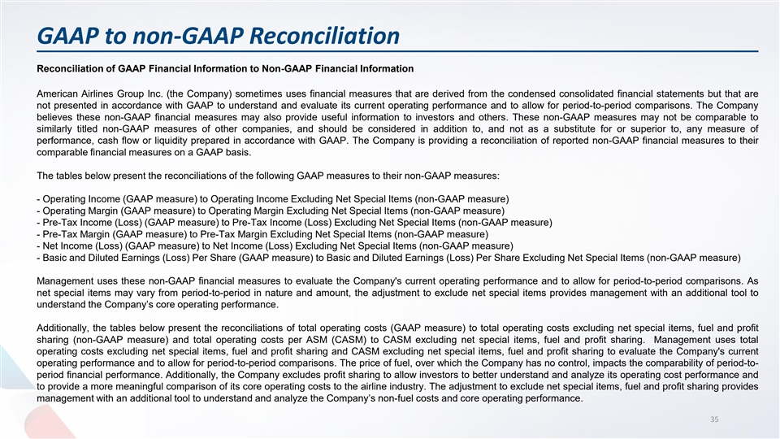
GAAP to non-GAAP Reconciliation Reconciliation of GAAP Financial Information to Non-GAAP Financial Information American Airlines Group Inc. (the Company) sometimes uses financial measures that are derived from the condensed consolidated financial statements but that are not presented in accordance with GAAP to understand and evaluate its current operating performance and to allow for period-to-period comparisons. The Company believes these non-GAAP financial measures may also provide useful information to investors and others. These non-GAAP measures may not be comparable to similarly titled non-GAAP measures of other companies, and should be considered in addition to, and not as a substitute for or superior to, any measure of performance, cash flow or liquidity prepared in accordance with GAAP. The Company is providing a reconciliation of reported non-GAAP financial measures to their comparable financial measures on a GAAP basis. The tables below present the reconciliations of the following GAAP measures to their non-GAAP measures: - Operating Income (GAAP measure) to Operating Income Excluding Net Special Items (non-GAAP measure) - Operating Margin (GAAP measure) to Operating Margin Excluding Net Special Items (non-GAAP measure) - Pre-Tax Income (Loss) (GAAP measure) to Pre-Tax Income (Loss) Excluding Net Special Items (non-GAAP measure) - Pre-Tax Margin (GAAP measure) to Pre-Tax Margin Excluding Net Special Items (non-GAAP measure) - Net Income (Loss) (GAAP measure) to Net Income (Loss) Excluding Net Special Items (non-GAAP measure) - Basic and Diluted Earnings (Loss) Per Share (GAAP measure) to Basic and Diluted Earnings (Loss) Per Share Excluding Net Special Items (non-GAAP measure) Management uses these non-GAAP financial measures to evaluate the Company's current operating performance and to allow for period-to-period comparisons. As net special items may vary from period-to-period in nature and amount, the adjustment to exclude net special items provides management with an additional tool to understand the Company’s core operating performance. Additionally, the tables below present the reconciliations of total operating costs (GAAP measure) to total operating costs excluding net special items, fuel and profit sharing (non-GAAP measure) and total operating costs per ASM (CASM) to CASM excluding net special items, fuel and profit sharing. Management uses total operating costs excluding net special items, fuel and profit sharing and CASM excluding net special items, fuel and profit sharing to evaluate the Company's current operating performance and to allow for period-to-period comparisons. The price of fuel, over which the Company has no control, impacts the comparability of period-to- period financial performance. Additionally, the Company excludes profit sharing to allow investors to better understand and analyze its operating cost performance and to provide a more meaningful comparison of its core operating costs to the airline industry. The adjustment to exclude net special items, fuel and profit sharing provides management with an additional tool to understand and analyze the Company’s non-fuel costs and core operating performance. 35

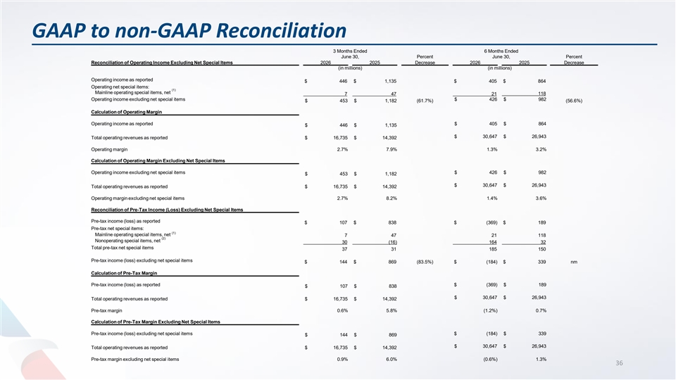
GAAP to non-GAAP Reconciliation 3 Months Ended 6 Months Ended June 30, Percent June 30, Percent Reconciliation of Operating Income Excluding Net Special Items 2026 2025 Decrease 2026 2025 Decrease (in millions) (in millions) Operating income as reported $ 446 $ 1,135 $ 405 $ 864 Operating net special items: (1) Mainline operating special items, net 7 47 21 118 Operating income excluding net special items $ 426 $ 982 $ 453 $ 1,182 (61.7%) (56.6%) Calculation of Operating Margin Operating income as reported $ 405 $ 864 $ 446 $ 1,135 $ 30,647 $ 26,943 Total operating revenues as reported $ 16,735 $ 14,392 Operating margin 2.7% 7.9% 1.3% 3.2% Calculation of Operating Margin Excluding Net Special Items Operating income excluding net special items $ 426 $ 982 $ 453 $ 1,182 $ 30,647 $ 26,943 Total operating revenues as reported $ 16,735 $ 14,392 Operating margin excluding net special items 2.7% 8.2% 1.4% 3.6% Reconciliation of Pre-Tax Income (Loss) Excluding Net Special Items Pre-tax income (loss) as reported $ 107 $ 838 $ (369) $ 189 Pre-tax net special items: (1) Mainline operating special items, net 7 47 21 118 (2) Nonoperating special items, net 30 (16) 164 32 Total pre-tax net special items 37 31 185 150 Pre-tax income (loss) excluding net special items $ 144 $ 869 (83.5%) $ (184) $ 339 nm Calculation of Pre-Tax Margin Pre-tax income (loss) as reported $ (369) $ 189 $ 107 $ 838 $ 30,647 $ 26,943 Total operating revenues as reported $ 16,735 $ 14,392 Pre-tax margin 0.6% 5.8% (1.2%) 0.7% Calculation of Pre-Tax Margin Excluding Net Special Items Pre-tax income (loss) excluding net special items $ (184) $ 339 $ 144 $ 869 $ 30,647 $ 26,943 Total operating revenues as reported $ 16,735 $ 14,392 Pre-tax margin excluding net special items 0.9% 6.0% (0.6%) 1.3% 36

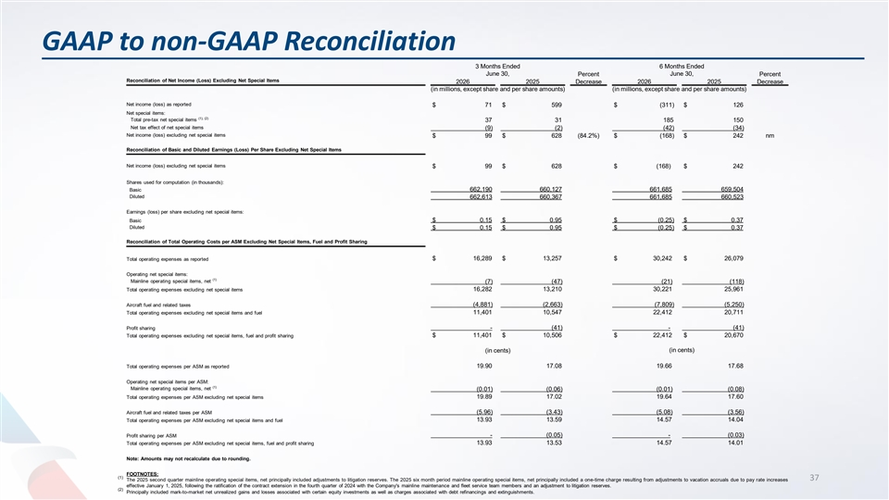
GAAP to non-GAAP Reconciliation 3 Months Ended 6 Months Ended June 30, Percent June 30, Percent Reconciliation of Net Income (Loss) Excluding Net Special Items 2026 2025 Decrease 2026 2025 Decrease (in millions, except share and per share amounts) (in millions, except share and per share amounts) Net income (loss) as reported $ 71 $ 599 $ (311) $ 126 Net special items: (1), (2) Total pre-tax net special items 37 31 185 150 Net tax effect of net special items (9) (2) (42) (34) Net income (loss) excluding net special items $ 99 $ 628 (84.2%) $ (168) $ 242 nm Reconciliation of Basic and Diluted Earnings (Loss) Per Share Excluding Net Special Items Net income (loss) excluding net special items $ 99 $ 628 $ (168) $ 242 Shares used for computation (in thousands): Basic 662,190 660,127 661,685 659,504 Diluted 662,613 660,367 661,685 660,523 Earnings (loss) per share excluding net special items: Basic $ 0.15 $ 0.95 $ (0.25) $ 0.37 Diluted $ 0.15 $ 0.95 $ (0.25) $ 0.37 Reconciliation of Total Operating Costs per ASM Excluding Net Special Items, Fuel and Profit Sharing Total operating expenses as reported $ 16,289 $ 13,257 $ 30,242 $ 26,079 Operating net special items: (1) Mainline operating special items, net (7) (47) (21) (118) Total operating expenses excluding net special items 16,282 13,210 30,221 25,961 Aircraft fuel and related taxes (4,881) (2,663) (7,809) (5,250) Total operating expenses excluding net special items and fuel 11,401 10,547 22,412 20,711 Profit sharing - (41) - (41) $ 11,401 $ 10,506 $ 22,412 $ 20,670 Total operating expenses excluding net special items, fuel and profit sharing (in cents) (in cents) 19.90 17.08 19.66 17.68 Total operating expenses per ASM as reported Operating net special items per ASM: (1) Mainline operating special items, net (0.01) (0.06) (0.01) (0.08) Total operating expenses per ASM excluding net special items 19.89 17.02 19.64 17.60 Aircraft fuel and related taxes per ASM (5.96) (3.43) (5.08) (3.56) Total operating expenses per ASM excluding net special items and fuel 13.93 13.59 14.57 14.04 Profit sharing per ASM - (0.05) - (0.03) 13.93 13.53 14.57 14.01 Total operating expenses per ASM excluding net special items, fuel and profit sharing Note: Amounts may not recalculate due to rounding. FOOTNOTES: (1) 37 The 2025 second quarter mainline operating special items, net principally included adjustments to litigation reserves. The 2025 six month period mainline operating special items, net principally included a one-time charge resulting from adjustments to vacation accruals due to pay rate increases effective January 1, 2025, following the ratification of the contract extension in the fourth quarter of 2024 with the Company's mainline maintenance and fleet service team members and an adjustment to litigation reserves. (2) Principally included mark-to-market net unrealized gains and losses associated with certain equity investments as well as charges associated with debt refinancings and extinguishments.



