UNITED STATES
SECURITIES AND EXCHANGE COMMISSION
Washington, D.C. 20549
FORM 8-K
CURRENT REPORT
Pursuant to Section 13 or 15(d) of the Securities Exchange Act of 1934
Date of Report (Date of earliest event reported): July 23, 2026
AMERICAN AIRLINES GROUP INC.
AMERICAN AIRLINES, INC.
(Exact name of registrant as specified in its charter)
Delaware |  |  |  |  |  | 1-8400 |  |  |  |  |  | 75-1825172
Delaware |  |  |  |  |  | 1-2691 |  |  |  |  |  | 13-1502798
(State or other Jurisdiction of Incorporation) |  |  |  |  |  | (Commission File Number) |  |  |  |  |  | (IRS Employer Identification No.)

1 Skyview Drive, |  |  | Fort Worth, |  |  | Texas |  |  |  |  |  |  |  |  | 76155
1 Skyview Drive, |  |  | Fort Worth, |  |  | Texas |  |  |  |  |  |  |  |  | 76155
(Address of principal executive offices) |  |  |  |  |  |  |  |  |  |  |  |  |  |  | (Zip Code)
Registrant’s telephone number, including area code:
(682) 278-9000
(682) 278-9000
Check the appropriate box below if the Form 8-K filing is intended to simultaneously satisfy the filing obligation of the registrant under any of the following provisions:
☐ |  |  | Written communications pursuant to Rule 425 under the Securities Act (17 CFR 230.425)
☐ |  |  | Soliciting material pursuant to Rule 14a-12 under the Exchange Act (17 CFR 240.14a-12)
☐ |  |  | Pre-commencement communications pursuant to Rule 14d-2(b) under the Exchange Act (17 CFR 240.14d-2(b))
☐ |  |  | Pre-commencement communications pursuant to Rule 13e-4(c) under the Exchange Act (17 CFR 240.13e-4(c))
Securities registered pursuant to Section 12(b) of the Act:
Title of each class |  |  |  |  |  | Trading  Symbol(s) |  |  |  |  |  | Name of each exchange  on which registered
Common Stock, $0.01 par value per share |  |  |  |  |  | AAL |  |  |  |  |  | The Nasdaq Global Select Market
Preferred Stock Purchase Rights |  |  |  |  |  | — |  |  |  |  |  | (1)
(1) Attached to the Common Stock
Indicate by check mark whether the registrant is an emerging growth company as defined in Rule 405 of the Securities Act of 1933 (§230.405 of this chapter) or Rule 12b-2 of the Securities Exchange Act of 1934 (§240.12b-2 of this chapter).
Emerging growth company |  |  | ☐

If an emerging growth company, indicate by check mark if the registrant has elected not to use the extended transition period for complying with any new or revised financial accounting standards provided pursuant to Section 13(a) of the Exchange Act. ☐

ITEM 2.02. |  |  | RESULTS OF OPERATIONS AND FINANCIAL CONDITION.
On July 23, 2026, American Airlines Group Inc. (the Company) issued a press release reporting financial results for the three and six months ended June 30, 2026. The press release is furnished as Exhibit 99.1 to this report.
ITEM 7.01. |  |  | REGULATION FD DISCLOSURE.
On July 23, 2026, the Company provided a presentation to investors. This investor presentation is located on the Company’s website at www.aa.com under “Investor Relations” and is furnished as Exhibit 99.2 to this report.
The information in Items 2.02 and 7.01 of this Current Report on Form 8-K, including Exhibits 99.1 and 99.2, is being furnished and shall not be deemed to be “filed” for purposes of Section 18 of the Securities Exchange Act of 1934, as amended, or otherwise subject to the liabilities of that Section and shall not be deemed incorporated by reference into any registration statement or other document filed pursuant to the Securities Act of 1933, as amended, except as shall be expressly set forth by specific reference in such filing.
ITEM 9.01. |  |  | FINANCIAL STATEMENTS AND EXHIBITS.
(d) Exhibits.
Exhibit No. |  |  |  |  |  | Description
99.1 |  |  |  |  |  | Press Release, dated July 23, 2026.
99.2 |  |  |  |  |  | Investor Presentation, dated July 23, 2026.
104.1 |  |  |  |  |  | Cover page interactive data file (embedded within the Inline XBRL document).

SIGNATURES
Pursuant to the requirements of the Securities Exchange Act of 1934, American Airlines Group Inc. has duly caused this report to be signed on its behalf by the undersigned hereunto duly authorized.
 |  |  | AMERICAN AIRLINES GROUP INC.
Date: July 23, 2026 |  |  | By: |  |  |  |  |  | /s/ Devon E. May
 |  |  |  |  |  |  |  |  | Devon E. May
Executive Vice President and
Chief Financial Officer
Pursuant to the requirements of the Securities Exchange Act of 1934, American Airlines, Inc. has duly caused this report to be signed on its behalf by the undersigned hereunto duly authorized.
 |  |  | AMERICAN AIRLINES, INC.
Date: July 23, 2026 |  |  | By: |  |  |  |  |  | /s/ Devon E. May
 |  |  |  |  |  |  |  |  | Devon E. May
Executive Vice President and
Chief Financial Officer

Exhibit 99.1

Corporate Communications
mediarelations@aa.com
Investor Relations
investor.relations@aa.com
FOR RELEASE: Thursday, July 23, 2026

American Airlines continues to execute on commercial priorities, delivering highest quarterly revenue in company history
FORT WORTH, Texas — American Airlines Group Inc. (NASDAQ: AAL) today reported its second-quarter 2026 financial results, including record quarterly revenue, driven by strong demand for American’s product and solid commercial execution.
Second-quarter highlights:

•Record revenue of $16.7 billion, up 16.3% year over year, the highest quarterly revenue in company history, driven by strong performance across American’s four commercial pillars.
•Strong demand and execution that offset nearly 50% of the over $2.2 billion year-over-year fuel expense increase.
•GAAP net income of $71 million, or $0.11 per diluted share.
•Adjusted net income of $99 million1, or $0.15 per diluted share.

“American delivered year-over-year revenue growth of more than 16% in the second quarter, exceeding our initial expectations and continuing the momentum we’ve built across the business,” said American’s CEO Robert Isom. “This performance reflects the strength of our commercial strategy, driven by our four pillars: elevate the customer experience, grow the global network, drive premium revenue and lead in loyalty. Revenue growth was strong across all entities and cabins, with premium, Main Cabin, domestic and international all up meaningfully year over year. These results demonstrate that our revenue performance and efficiency efforts will continue to drive improved results, and I’m excited about the remainder of 2026 and what’s ahead in 2027 and beyond. Thank you to the American Airlines team for their outstanding execution on our commercial and operational objectives during the quarter.”

The strength of American’s revenue performance and continued efficiency efforts helped to offset a challenging fuel environment. Fuel expense increased by over $2.2 billion, or 83% year over year. American was able to offset nearly 50% of this fuel headwind in the second quarter through higher fares. Fuel prices have remained volatile in recent weeks. Based on the forward fuel curve as of July 21, American expects third-quarter fuel expense to be up $1.7 billion year over year. The company is focused on mitigating the impact of higher fuel expense through robust demand for American’s product and the continued execution of its four-pillar strategy.
American Airlines Reports Second-Quarter 2026 Financial Results

July 23, 2026
Page 2

Revenue performance
The company’s second-quarter results were driven by strong revenue performance across all entities and cabins:

•Premium continued to outperform with passenger unit revenue up 13.4%, while Main Cabin also performed well with passenger unit revenue up 8.8% compared to the second quarter of 2025.
•Domestic demand rebounded nicely year over year with passenger unit revenue growth of 10.6%.
•International demand was strong across all entities, with passenger unit revenue for the Atlantic entity up 8.9%, the Pacific entity up 15.1% and the Latin America entity up 6.6% compared to the second quarter of 2025.
•Demand for business travel also remained strong in the second quarter, with managed corporate revenue increasing 26% year over year.
Elevate the customer experience
American continues to invest in the customer experience, resulting in a 5-point year-over-year improvement in its Net Promoter Score (NPS) in the second quarter. For on-time flights, American saw its NPS increase for the 15th time in the past 17 months. In May, the company announced plans to install Starlink high-speed Wi-Fi on its fleet beginning in 2027, further advancing onboard connectivity and the overall customer experience.

The company continues to expand and enhance its Admirals Club® and premium lounge network to deliver a more premium experience across the customer journey, including new and upgraded amenities in key locations such as New York (JFK) and Dallas-Fort Worth (DFW), in addition to previously announced plans for Charlotte, North Carolina (CLT), and Miami (MIA).
Grow the global network
American remains focused on optimizing its network to drive profitable growth, supported by continued expansion in high-demand international markets. In the second quarter, the company launched new nonstop routes to Europe, including service to Budapest, Hungary, and Prague from Philadelphia (PHL) and to Athens, Greece, from DFW, further strengthening its position in the premium trans-Atlantic market. American was also the first U.S. carrier to return to Venezuela, with service from MIA to Caracas, reinforcing its leading position in Latin America.

Across its domestic network, the airline continues to enhance connectivity and efficiency through investments in its hubs. These initiatives include the successful rebanking of DFW, which improved customer connectivity and operational performance at its largest hub. This effort reduced system misconnections in the quarter by nearly 25% year over year, improving customer satisfaction scores. This initiative also supported better financial performance at DFW, where unit revenue increased 4 points above the system average in the second quarter. The company also continues to bolster its key hubs at Chicago (ORD), MIA, PHL and Phoenix (PHX).

The company’s capacity grew 5.4% year over year in the second quarter, and the operation remained resilient throughout the quarter, with on-time arrival performance improving 2.8 points year over year.
American Airlines Reports Second-Quarter 2026 Financial Results

July 23, 2026
Page 3

Drive premium revenue
American continues to see momentum in its premium revenue performance, supported by strength in both corporate and premium leisure demand. The airline is adding premium seats with deliveries of new Boeing 787-9 and Airbus A321XLR aircraft and retrofits of its 777-300ER, 777-200ER, A319 and A320 aircraft. This summer, American will offer more premium seats than any other airline.

Managed corporate revenue increased 26% year over year in the second quarter, with sequential improvements each month. This marks the fifth consecutive quarter of double-digit growth in managed corporate revenue for American.

The company is also taking disciplined actions to maximize revenue, including updates to its checked bag fee structure and Basic Economy offerings. These initiatives contributed to a 5-point increase in the upsell rate from Basic Economy to Main Cabin for tickets sold during the second quarter.
Lead in loyalty
The industry-leading AAdvantage® program remains a key driver of customer engagement and revenue. The program continues to benefit from strong member activity and ongoing enhancements to the co-branded credit card program, reinforcing its role as a powerful contributor to both loyalty and premium demand. Enrollments in the AAdvantage® program grew more than 30% year over year in the second quarter. American’s co-branded credit card partnership with Citi is a clear example of the strength of its loyalty ecosystem with year-over-year second-quarter card spend growing 8%.
Efficiency and cost performance
American continues to benefit from long-term investments to build a more efficient and resilient airline.

“Over the past several years, we’ve made focused investments in procurement, technology and continued efforts to reengineer the business to run the airline as efficiently as possible while enhancing the customer experience,” said American’s Chief Financial Officer Devon May. “Those efforts are enabling more efficient capacity production and are reflected in our CASM-ex2 performance, which was up approximately 3% year over year.”

Balance sheet and liquidity
The company continues to strengthen its financial foundation and ended the second quarter with $11.3 billion of total available liquidity. During the quarter, the company completed several financings that bolstered liquidity and addressed its only meaningful maturity in 2027. The company remains committed to reducing debt, lowering interest expense and achieving its leverage objectives.

Outlook and financial guidance
Revenue momentum is expected to continue into the second half of the year, supported by strong demand for American’s products. The company remains focused on expanding margins over time through continued revenue execution and the benefits of its multiyear efficiency initiatives.

American Airlines Reports Second-Quarter 2026 Financial Results

July 23, 2026
Page 4

In the third quarter, the company expects year-over-year revenue growth to be between 16.0% and 19.0%. Based on the forward fuel curve as of July 21, American anticipates an average fuel price of approximately $3.75 per gallon for the third quarter and expects CASM-ex2 to increase 2.5% to 4.5% year over year. Given the recent increase in the cost of fuel, the company is now expecting full-year adjusted earnings (loss) per diluted share3 to be between ($0.65) and $0.65.

Q3 2026E (vs. Q3 2025)
Available seat miles |  |  | +3.0% – +5.0%
Total revenue |  |  | +16.0% – +19.0%
CASM excluding net special items, fuel and profit sharing2 |  |  | +2.5% – +4.5%
Adjusted earnings (loss) per diluted share3 |  |  | ($0.70) – ($0.10)
FY 2026E
Adjusted earnings (loss) per diluted share3 |  |  | ($0.65) – $0.65

Conference call and webcast
American will host a conference call at 7:30 a.m. CT today. A live webcast and replay will be available at aa.com/investorrelations.
Notes
See the accompanying notes in the financial tables section of this press release for further explanation, including reconciliations of certain GAAP to non-GAAP financial information.

1.Adjusted net income is a non-GAAP financial measure and includes $28 million of net special items after the effect of taxes that the company recognized in the second quarter.
2.Cost per available seat mile (CASM) excluding net special items, fuel and profit sharing (CASM-ex) is a non-GAAP measure. The company is unable to reconcile certain forward-looking information to GAAP as the nature or amount of net special items cannot be determined at this time.
3.Adjusted earnings (loss) per diluted share guidance excludes the impact of net special items and represents an absolute number, not a year-over-year comparison. The company is unable to reconcile certain forward-looking information to GAAP as the nature or amount of net special items cannot be determined at this time.

About American Airlines Group (NASDAQ: AAL)
American Airlines is a premium global airline connecting more of the U.S. to the world. With roots tracing back to an air mail carrier in the Midwestern United States in 1926, American now operates more than 6,000 daily flights to more than 350 destinations in more than 60 countries and serves more than 200 million customers annually. Powered by a proud and talented team of 130,000 aviation professionals, American’s team lives out the airline’s purpose of caring for people on life’s journey every day.

The world’s largest airline proudly celebrates its centennial year in 2026, reaching a milestone that reflects a century of innovation and the Forever ForwardSM spirit that changed the industry and the world. American introduced the first scheduled air cargo service, the first airport lounge and the first airline loyalty program and continues to reinvent the customer experience today. The airline is also a founding member of the oneworld alliance, whose members serve more than 900 destinations around the globe.
American Airlines Reports Second-Quarter 2026 Financial Results

July 23, 2026
Page 5

Get the latest about American at news.aa.com and @AmericanAir.
Use of websites and social media to disclose information
American routinely uses the investor relations section of its website as well as its social media pages, including on Facebook and X, and its newsroom at news.aa.com, to disclose important information about American Airlines Group Inc. and its subsidiaries and to comply with its disclosure obligations under Regulation Fair Disclosure. The information contained on, or that may be accessed through, the company’s website, social media channels or newsroom is not incorporated by reference into, and is not a part of, this document, and all website addresses in this document are intended to be inactive textual references only.

Cautionary statement regarding forward-looking statements and information
Certain of the statements contained in this report should be considered forward-looking statements within the meaning of the Securities Act of 1933, as amended, the Securities Exchange Act of 1934, as amended, and the Private Securities Litigation Reform Act of 1995. These forward-looking statements may be identified by words such as “may,” “will,” “expect,” “intend,” “anticipate,” “believe,” “estimate,” “plan,” “project,” “could,” “should,” “would,” “continue,” “seek,” “target,” “guidance,” “outlook,” “if current trends continue,” “optimistic,” “forecast” and other similar words. Such statements include, but are not limited to, statements about the company’s plans, objectives, expectations, intentions, estimates and strategies for the future, and other statements that are not historical facts. These forward-looking statements are based on the company’s current objectives, beliefs and expectations, and they are subject to significant risks and uncertainties that may cause actual results and financial position and timing of certain events to differ materially from the information in the forward-looking statements. These risks and uncertainties include, but are not limited to, downturns in economic conditions could adversely affect our business; we will need to obtain sufficient financing or other capital to operate successfully; our high level of debt and other obligations may limit our ability to fund general corporate requirements and obtain additional financing, may limit our flexibility in responding to competitive developments and may cause our business to be vulnerable to adverse economic and industry conditions; if our financial condition worsens, provisions in our credit card processing and other commercial agreements may adversely affect our liquidity; the loss of key personnel whom we depend on to operate our business, or the inability to attract, develop and retain additional qualified personnel could adversely affect our business; our business has been and will continue to be materially affected by many changing economic, geopolitical, commercial, regulatory and other conditions beyond our control, including global events that affect travel behavior; the airline industry is intensely competitive and dynamic; union disputes, employee strikes and other labor-related disruptions may adversely affect our operations and financial performance; if we encounter problems with any of our third-party regional operators or third-party service providers, our operations could be adversely affected by a resulting decline in revenue or negative public perception about our services; any damage to our reputation or brand image could adversely affect our business or financial results; risks of losses and adverse publicity from any public incidents involving our company, people or brand; changes to our business model that are designed to increase revenues and reduce costs may not be successful and may cause operational difficulties or decreased demand; our intellectual property rights, particularly our branding rights, are valuable, and any inability to protect them may adversely affect our business and financial results; we may be a party to litigation in the normal course of business or otherwise, which could affect our financial position and liquidity; we rely heavily on technology and automated systems, including artificial intelligence, to operate our business, and any failures could harm our business, results of operations and financial
American Airlines Reports Second-Quarter 2026 Financial Results

July 23, 2026
Page 6

condition; evolving data privacy requirements could increase our costs, and any significant cybersecurity incident could disrupt our operations, harm our reputation, expose us to legal risks and otherwise materially adversely affect our business, results of operations and financial condition; we are exposed to risks from cyberattacks, and any cybersecurity incidents involving us, our third-party service providers, or one of our AAdvantage partners or other business partners; we have a significant amount of goodwill, which is assessed for impairment at least annually. We may never realize the full value of our intangible or long-lived assets, causing us to record material impairment charges; the commercial relationships that we have with other companies, including any related equity investments, may not produce the returns or results we expect; our business is very dependent on the price and availability of aircraft fuel. Continued periods of high volatility in fuel costs, increased fuel prices or significant disruptions in the supply of aircraft fuel could have a significant negative impact on consumer demand, our operating results and liquidity; our business is subject to extensive government regulation; we can be adversely affected by any prolonged partial or full U.S. Government shutdown; we operate a global business with international operations that are subject to economic and political instability and have been, and in the future may continue to be, adversely affected by numerous events, circumstances or government actions beyond our control; we may be adversely affected by conflicts overseas, terrorist attacks or other acts of violence, domestically or abroad; the travel industry continues to face ongoing security concerns; we are subject to risks associated with climate change, including increased regulation of our greenhouse gas emissions, changing consumer preferences and the potential for increased impacts of severe weather events on our operations and infrastructure; we are subject to various risks associated with environmental and social matters, and many forms of environmental and noise regulation; a shortage of pilots or other personnel could materially adversely affect our business; we depend on a limited number of suppliers for aircraft, aircraft engines and parts. Delays in scheduled aircraft deliveries, unexpected grounding of aircraft or aircraft engines whether by regulators or by us, or other loss of anticipated fleet capacity, and failure of new aircraft to receive regulatory approval, be produced or otherwise perform as and when expected, adversely impacts our business, results of operations and financial condition; we rely on third-party distribution channels and must effectively manage the costs, rights and functionality of these channels; if we are unable to obtain and maintain adequate facilities and infrastructure throughout our system and, at some airports, adequate slots, we may be unable to operate our existing flight schedule and to expand or change our route network in the future; interruptions or disruptions in service at one of our key facilities; increases in insurance costs or reductions in insurance coverage, and heavy taxation of the airline industry; risks related to ownership of AAG common stock; and other risks set forth herein as well as in the company’s latest annual report on Form 10-K for the year ended December 31, 2025 (especially in Part I, Item 1A. Risk Factors and Part II, Item 7. Management’s Discussion and Analysis of Financial Condition and Results of Operations) and subsequent quarterly reports on Form 10-Q (especially in Part I, Item 2. Management’s Discussion and Analysis of Financial Condition and Results of Operations and Part II, Item 1A. Risk Factors), and other risks and uncertainties listed from time to time in the company’s other filings with the Securities and Exchange Commission. Additionally, there may be other factors of which the company is not currently aware that may affect matters discussed in the forward-looking statements and may also cause actual results to differ materially from those discussed. The company does not assume any obligation to publicly update or supplement any forward-looking statement to reflect actual results, changes in assumptions or changes in other factors affecting these forward-looking statements other than as required by law. Any forward-looking statements speak only as of the date hereof or as of the dates indicated in the statement.

American Airlines Reports Second-Quarter 2026 Financial Results

July 23, 2026
Page 7

American Airlines Group Inc.
Condensed Consolidated Statements of Operations
(In millions, except share and per share amounts)
(Unaudited)
 |  |  | 3 Months Ended  June 30, |  |  |  |  |  |  |  |  |  |  |  | Percent  Increase  (Decrease) |  |  |  |  |  | 6 Months Ended  June 30, |  |  |  |  |  |  |  |  |  |  |  | Percent  Increase  (Decrease)
 |  |  | 2026 |  |  |  |  |  | 2025 |  |  |  |  |  |  |  |  |  |  |  | 2026 |  |  |  |  |  | 2025
Operating revenues:
Passenger |  |  | $ | 15,214 |  |  |  |  | $ | 13,123 |  |  |  |  | 15.9 |  |  |  |  |  | $ | 27,709 |  |  |  |  | $ | 24,514 |  |  |  |  | 13.0
Cargo |  |  | 273 |  |  |  |  |  | 211 |  |  |  |  |  | 29.7 |  |  |  |  |  | 487 |  |  |  |  |  | 400 |  |  |  |  |  | 21.7
Other |  |  | 1,248 |  |  |  |  |  | 1,058 |  |  |  |  |  | 17.9 |  |  |  |  |  | 2,451 |  |  |  |  |  | 2,029 |  |  |  |  |  | 20.8
Total operating revenues |  |  | 16,735 |  |  |  |  |  | 14,392 |  |  |  |  |  | 16.3 |  |  |  |  |  | 30,647 |  |  |  |  |  | 26,943 |  |  |  |  |  | 13.7
Operating expenses:
Aircraft fuel and related taxes |  |  | 4,881 |  |  |  |  |  | 2,663 |  |  |  |  |  | 83.3 |  |  |  |  |  | 7,809 |  |  |  |  |  | 5,250 |  |  |  |  |  | 48.7
Salaries, wages and benefits |  |  | 4,639 |  |  |  |  |  | 4,382 |  |  |  |  |  | 5.9 |  |  |  |  |  | 9,314 |  |  |  |  |  | 8,604 |  |  |  |  |  | 8.2
Regional expenses:
Regional operating expenses |  |  | 1,344 |  |  |  |  |  | 1,250 |  |  |  |  |  | 7.5 |  |  |  |  |  | 2,656 |  |  |  |  |  | 2,523 |  |  |  |  |  | 5.3
Regional depreciation and amortization |  |  | 91 |  |  |  |  |  | 81 |  |  |  |  |  | 13.1 |  |  |  |  |  | 183 |  |  |  |  |  | 160 |  |  |  |  |  | 14.3
Maintenance, materials and repairs |  |  | 1,027 |  |  |  |  |  | 927 |  |  |  |  |  | 10.8 |  |  |  |  |  | 2,008 |  |  |  |  |  | 1,848 |  |  |  |  |  | 8.7
Other rent and landing fees |  |  | 976 |  |  |  |  |  | 894 |  |  |  |  |  | 9.2 |  |  |  |  |  | 1,867 |  |  |  |  |  | 1,720 |  |  |  |  |  | 8.5
Aircraft rent |  |  | 308 |  |  |  |  |  | 303 |  |  |  |  |  | 1.8 |  |  |  |  |  | 617 |  |  |  |  |  | 600 |  |  |  |  |  | 2.9
Selling expenses |  |  | 603 |  |  |  |  |  | 535 |  |  |  |  |  | 12.7 |  |  |  |  |  | 1,110 |  |  |  |  |  | 985 |  |  |  |  |  | 12.7
Depreciation and amortization |  |  | 478 |  |  |  |  |  | 476 |  |  |  |  |  | 0.4 |  |  |  |  |  | 953 |  |  |  |  |  | 944 |  |  |  |  |  | 1.0
Special items, net |  |  | 7 |  |  |  |  |  | 47 |  |  |  |  |  | (85.1) |  |  |  |  |  | 21 |  |  |  |  |  | 118 |  |  |  |  |  | (82.4)
Other |  |  | 1,935 |  |  |  |  |  | 1,699 |  |  |  |  |  | 13.8 |  |  |  |  |  | 3,704 |  |  |  |  |  | 3,327 |  |  |  |  |  | 11.3
Total operating expenses |  |  | 16,289 |  |  |  |  |  | 13,257 |  |  |  |  |  | 22.9 |  |  |  |  |  | 30,242 |  |  |  |  |  | 26,079 |  |  |  |  |  | 16.0
Operating income |  |  | 446 |  |  |  |  |  | 1,135 |  |  |  |  |  | (60.7) |  |  |  |  |  | 405 |  |  |  |  |  | 864 |  |  |  |  |  | (53.1)
Nonoperating income (expense):
Interest income |  |  | 74 |  |  |  |  |  | 100 |  |  |  |  |  | (25.8) |  |  |  |  |  | 130 |  |  |  |  |  | 194 |  |  |  |  |  | (33.3)
Interest expense, net |  |  | (409) |  |  |  |  |  | (433) |  |  |  |  |  | (5.5) |  |  |  |  |  | (807) |  |  |  |  |  | (861) |  |  |  |  |  | (6.4)
Other income (expense), net |  |  | (4) |  |  |  |  |  | 36 |  |  |  |  |  | nm |  |  | (1) |  |  | (97) |  |  |  |  |  | (8) |  |  |  |  |  | nm
Total nonoperating expense, net |  |  | (339) |  |  |  |  |  | (297) |  |  |  |  |  | 14.2 |  |  |  |  |  | (774) |  |  |  |  |  | (675) |  |  |  |  |  | 14.7
Income (loss) before income taxes |  |  | 107 |  |  |  |  |  | 838 |  |  |  |  |  | (87.2) |  |  |  |  |  | (369) |  |  |  |  |  | 189 |  |  |  |  |  | nm
Income tax provision (benefit) |  |  | 36 |  |  |  |  |  | 239 |  |  |  |  |  | (84.9) |  |  |  |  |  | (58) |  |  |  |  |  | 63 |  |  |  |  |  | nm
Net income (loss) |  |  | $ | 71 |  |  |  |  | $ | 599 |  |  |  |  | (88.2) |  |  |  |  |  | $ | (311) |  |  |  |  | $ | 126 |  |  |  |  | nm
Earnings (loss) per common share:
Basic |  |  | $ | 0.11 |  |  |  |  | $ | 0.91 |  |  |  |  |  |  |  |  |  |  | $ | (0.47) |  |  |  |  | $ | 0.19
Diluted |  |  | $ | 0.11 |  |  |  |  | $ | 0.91 |  |  |  |  |  |  |  |  |  |  | $ | (0.47) |  |  |  |  | $ | 0.19
Weighted average shares outstanding (in thousands):
Basic |  |  | 662,190 |  |  |  |  |  | 660,127 |  |  |  |  |  |  |  |  |  |  |  | 661,685 |  |  |  |  |  | 659,504
Diluted |  |  | 662,613 |  |  |  |  |  | 660,367 |  |  |  |  |  |  |  |  |  |  |  | 661,685 |  |  |  |  |  | 660,523
Note: Percent change may not recalculate due to rounding.
(1)Not meaningful or greater than 100% change.

American Airlines Reports Second-Quarter 2026 Financial Results

July 23, 2026
Page 8

American Airlines Group Inc.
Consolidated Operating Statistics (1)
(Unaudited)
 |  |  | 3 Months Ended  June 30, |  |  |  |  |  |  |  |  |  |  |  | Increase  (Decrease) |  |  |  |  |  | 6 Months Ended  June 30, |  |  |  |  |  |  |  |  |  |  |  | Increase  (Decrease)
 |  |  | 2026 |  |  |  |  |  | 2025 |  |  |  |  |  |  |  |  |  |  |  | 2026 |  |  |  |  |  | 2025
Revenue passenger miles (millions) |  |  | 68,118 |  |  |  |  |  | 65,762 |  |  |  |  |  | 3.6 % |  |  |  |  |  | 126,669 |  |  |  |  |  | 122,118 |  |  |  |  |  | 3.7 %
Available seat miles (ASM) (millions) |  |  | 81,843 |  |  |  |  |  | 77,636 |  |  |  |  |  | 5.4 % |  |  |  |  |  | 153,852 |  |  |  |  |  | 147,539 |  |  |  |  |  | 4.3 %
Passenger load factor (percent) |  |  | 83.2 |  |  |  |  |  | 84.7 |  |  |  |  |  | (1.5) pts |  |  |  |  |  | 82.3 |  |  |  |  |  | 82.8 |  |  |  |  |  | (0.5) pts
Yield (cents) |  |  | 22.33 |  |  |  |  |  | 19.96 |  |  |  |  |  | 11.9 % |  |  |  |  |  | 21.88 |  |  |  |  |  | 20.07 |  |  |  |  |  | 9.0 %
Passenger revenue per ASM (cents) |  |  | 18.59 |  |  |  |  |  | 16.90 |  |  |  |  |  | 10.0 % |  |  |  |  |  | 18.01 |  |  |  |  |  | 16.62 |  |  |  |  |  | 8.4 %
Total revenue per ASM (cents) |  |  | 20.45 |  |  |  |  |  | 18.54 |  |  |  |  |  | 10.3 % |  |  |  |  |  | 19.92 |  |  |  |  |  | 18.26 |  |  |  |  |  | 9.1 %
Cargo ton miles (millions) |  |  | 638 |  |  |  |  |  | 521 |  |  |  |  |  | 22.5 % |  |  |  |  |  | 1,165 |  |  |  |  |  | 1,004 |  |  |  |  |  | 16.0 %
Cargo yield per ton mile (cents) |  |  | 42.84 |  |  |  |  |  | 40.48 |  |  |  |  |  | 5.8 % |  |  |  |  |  | 41.81 |  |  |  |  |  | 39.84 |  |  |  |  |  | 4.9 %
Fuel consumption (gallons in millions) |  |  | 1,204 |  |  |  |  |  | 1,163 |  |  |  |  |  | 3.5 % |  |  |  |  |  | 2,270 |  |  |  |  |  | 2,206 |  |  |  |  |  | 2.9 %
Average aircraft fuel price including related taxes (dollars per gallon) |  |  | 4.05 |  |  |  |  |  | 2.29 |  |  |  |  |  | 77.1 % |  |  |  |  |  | 3.44 |  |  |  |  |  | 2.38 |  |  |  |  |  | 44.5 %
Operating cost per ASM (cents) |  |  | 19.90 |  |  |  |  |  | 17.08 |  |  |  |  |  | 16.5 % |  |  |  |  |  | 19.66 |  |  |  |  |  | 17.68 |  |  |  |  |  | 11.2 %
Operating cost per ASM excluding net special items (cents) |  |  | 19.89 |  |  |  |  |  | 17.02 |  |  |  |  |  | 16.9 % |  |  |  |  |  | 19.64 |  |  |  |  |  | 17.60 |  |  |  |  |  | 11.6 %
Operating cost per ASM excluding net special items and fuel (cents) |  |  | 13.93 |  |  |  |  |  | 13.59 |  |  |  |  |  | 2.5 % |  |  |  |  |  | 14.57 |  |  |  |  |  | 14.04 |  |  |  |  |  | 3.8 %
Operating cost per ASM excluding net special items, fuel and profit sharing (cents) |  |  | 13.93 |  |  |  |  |  | 13.53 |  |  |  |  |  | 2.9 % |  |  |  |  |  | 14.57 |  |  |  |  |  | 14.01 |  |  |  |  |  | 4.0 %
Passenger enplanements (thousands) |  |  | 59,101 |  |  |  |  |  | 58,711 |  |  |  |  |  | 0.7 % |  |  |  |  |  | 110,871 |  |  |  |  |  | 109,746 |  |  |  |  |  | 1.0 %
Departures (thousands):
Mainline |  |  | 312 |  |  |  |  |  | 306 |  |  |  |  |  | 2.2 % |  |  |  |  |  | 592 |  |  |  |  |  | 583 |  |  |  |  |  | 1.4 %
Regional |  |  | 285 |  |  |  |  |  | 270 |  |  |  |  |  | 5.5 % |  |  |  |  |  | 539 |  |  |  |  |  | 520 |  |  |  |  |  | 3.6 %
Total |  |  | 597 |  |  |  |  |  | 576 |  |  |  |  |  | 3.7 % |  |  |  |  |  | 1,131 |  |  |  |  |  | 1,103 |  |  |  |  |  | 2.5 %
Average stage length (miles):
Mainline |  |  | 1,214 |  |  |  |  |  | 1,185 |  |  |  |  |  | 2.4 % |  |  |  |  |  | 1,207 |  |  |  |  |  | 1,181 |  |  |  |  |  | 2.2 %
Regional |  |  | 471 |  |  |  |  |  | 460 |  |  |  |  |  | 2.5 % |  |  |  |  |  | 474 |  |  |  |  |  | 465 |  |  |  |  |  | 2.1 %
Total |  |  | 860 |  |  |  |  |  | 845 |  |  |  |  |  | 1.7 % |  |  |  |  |  | 858 |  |  |  |  |  | 843 |  |  |  |  |  | 1.7 %
Aircraft at end of period:
Mainline |  |  | 1,030 |  |  |  |  |  | 992 |  |  |  |  |  | 3.8 % |  |  |  |  |  | 1,030 |  |  |  |  |  | 992 |  |  |  |  |  | 3.8 %
Regional (2) |  |  | 579 |  |  |  |  |  | 547 |  |  |  |  |  | 5.9 % |  |  |  |  |  | 579 |  |  |  |  |  | 547 |  |  |  |  |  | 5.9 %
Total |  |  | 1,609 |  |  |  |  |  | 1,539 |  |  |  |  |  | 4.5 % |  |  |  |  |  | 1,609 |  |  |  |  |  | 1,539 |  |  |  |  |  | 4.5 %
Full-time equivalent employees at end of period:
Mainline |  |  | 109,700 |  |  |  |  |  | 106,100 |  |  |  |  |  | 3.4 % |  |  |  |  |  | 109,700 |  |  |  |  |  | 106,100 |  |  |  |  |  | 3.4 %
Regional (3) |  |  | 33,700 |  |  |  |  |  | 32,000 |  |  |  |  |  | 5.3 % |  |  |  |  |  | 33,700 |  |  |  |  |  | 32,000 |  |  |  |  |  | 5.3 %
Total |  |  | 143,400 |  |  |  |  |  | 138,100 |  |  |  |  |  | 3.8 % |  |  |  |  |  | 143,400 |  |  |  |  |  | 138,100 |  |  |  |  |  | 3.8 %
Note: Amounts may not recalculate due to rounding.
(1)Unless otherwise noted, operating statistics include mainline and regional operations. Regional includes wholly-owned regional airline subsidiaries and operating results from capacity purchase carriers.
(2)Includes aircraft owned and leased by American as well as aircraft operated by third-party regional carriers under capacity purchase agreements. Excluded from the aircraft count above are four Bombardier CRJ900 regional aircraft that are held in temporary storage as of June 30, 2026.
(3)Regional full-time equivalent employees only include our wholly-owned regional airline subsidiaries.

American Airlines Reports Second-Quarter 2026 Financial Results

July 23, 2026
Page 9

American Airlines Group Inc.
Consolidated Revenue Statistics by Region
(Unaudited)
 |  |  | 3 Months Ended  June 30, |  |  |  |  |  |  |  |  |  |  |  | Increase  (Decrease) |  |  |  |  |  | 6 Months Ended  June 30, |  |  |  |  |  |  |  |  |  |  |  | Increase  (Decrease)
 |  |  | 2026 |  |  |  |  |  | 2025 |  |  |  |  |  |  |  |  |  |  |  | 2026 |  |  |  |  |  | 2025
Domestic (1)
Revenue passenger miles (millions) |  |  | 45,321 |  |  |  |  |  | 43,772 |  |  |  |  |  | 3.5 % |  |  |  |  |  | 84,488 |  |  |  |  |  | 81,465 |  |  |  |  |  | 3.7 %
Available seat miles (ASM) (millions) |  |  | 55,068 |  |  |  |  |  | 51,988 |  |  |  |  |  | 5.9 % |  |  |  |  |  | 103,482 |  |  |  |  |  | 98,657 |  |  |  |  |  | 4.9 %
Passenger load factor (percent) |  |  | 82.3 |  |  |  |  |  | 84.2 |  |  |  |  |  | (1.9) pts |  |  |  |  |  | 81.6 |  |  |  |  |  | 82.6 |  |  |  |  |  | (1.0) pts
Passenger revenue (dollars in millions) |  |  | 10,726 |  |  |  |  |  | 9,159 |  |  |  |  |  | 17.1 % |  |  |  |  |  | 19,716 |  |  |  |  |  | 17,286 |  |  |  |  |  | 14.1 %
Yield (cents) |  |  | 23.67 |  |  |  |  |  | 20.93 |  |  |  |  |  | 13.1 % |  |  |  |  |  | 23.34 |  |  |  |  |  | 21.22 |  |  |  |  |  | 10.0 %
Passenger revenue per ASM (cents) |  |  | 19.48 |  |  |  |  |  | 17.62 |  |  |  |  |  | 10.6 % |  |  |  |  |  | 19.05 |  |  |  |  |  | 17.52 |  |  |  |  |  | 8.7 %
Latin America (2)
Revenue passenger miles (millions) |  |  | 8,617 |  |  |  |  |  | 8,358 |  |  |  |  |  | 3.1 % |  |  |  |  |  | 18,906 |  |  |  |  |  | 18,380 |  |  |  |  |  | 2.9 %
Available seat miles (millions) |  |  | 10,169 |  |  |  |  |  | 9,725 |  |  |  |  |  | 4.6 % |  |  |  |  |  | 22,572 |  |  |  |  |  | 21,728 |  |  |  |  |  | 3.9 %
Passenger load factor (percent) |  |  | 84.7 |  |  |  |  |  | 85.9 |  |  |  |  |  | (1.2) pts |  |  |  |  |  | 83.8 |  |  |  |  |  | 84.6 |  |  |  |  |  | (0.8) pts
Passenger revenue (dollars in millions) |  |  | 1,726 |  |  |  |  |  | 1,550 |  |  |  |  |  | 11.4 % |  |  |  |  |  | 3,689 |  |  |  |  |  | 3,455 |  |  |  |  |  | 6.8 %
Yield (cents) |  |  | 20.04 |  |  |  |  |  | 18.54 |  |  |  |  |  | 8.1 % |  |  |  |  |  | 19.51 |  |  |  |  |  | 18.80 |  |  |  |  |  | 3.8 %
Passenger revenue per ASM (cents) |  |  | 16.98 |  |  |  |  |  | 15.94 |  |  |  |  |  | 6.6 % |  |  |  |  |  | 16.34 |  |  |  |  |  | 15.90 |  |  |  |  |  | 2.8 %
Atlantic
Revenue passenger miles (millions) |  |  | 11,844 |  |  |  |  |  | 11,432 |  |  |  |  |  | 3.6 % |  |  |  |  |  | 18,057 |  |  |  |  |  | 17,366 |  |  |  |  |  | 4.0 %
Available seat miles (millions) |  |  | 13,891 |  |  |  |  |  | 13,414 |  |  |  |  |  | 3.6 % |  |  |  |  |  | 21,685 |  |  |  |  |  | 21,377 |  |  |  |  |  | 1.4 %
Passenger load factor (percent) |  |  | 85.3 |  |  |  |  |  | 85.2 |  |  |  |  |  | 0.1 pts |  |  |  |  |  | 83.3 |  |  |  |  |  | 81.2 |  |  |  |  |  | 2.1 pts
Passenger revenue (dollars in millions) |  |  | 2,353 |  |  |  |  |  | 2,086 |  |  |  |  |  | 12.8 % |  |  |  |  |  | 3,455 |  |  |  |  |  | 3,052 |  |  |  |  |  | 13.2 %
Yield (cents) |  |  | 19.87 |  |  |  |  |  | 18.25 |  |  |  |  |  | 8.9 % |  |  |  |  |  | 19.14 |  |  |  |  |  | 17.57 |  |  |  |  |  | 8.9 %
Passenger revenue per ASM (cents) |  |  | 16.94 |  |  |  |  |  | 15.55 |  |  |  |  |  | 8.9 % |  |  |  |  |  | 15.93 |  |  |  |  |  | 14.28 |  |  |  |  |  | 11.6 %
Pacific
Revenue passenger miles (millions) |  |  | 2,336 |  |  |  |  |  | 2,200 |  |  |  |  |  | 6.2 % |  |  |  |  |  | 5,218 |  |  |  |  |  | 4,907 |  |  |  |  |  | 6.3 %
Available seat miles (millions) |  |  | 2,715 |  |  |  |  |  | 2,509 |  |  |  |  |  | 8.2 % |  |  |  |  |  | 6,113 |  |  |  |  |  | 5,777 |  |  |  |  |  | 5.8 %
Passenger load factor (percent) |  |  | 86.0 |  |  |  |  |  | 87.7 |  |  |  |  |  | (1.7) pts |  |  |  |  |  | 85.4 |  |  |  |  |  | 84.9 |  |  |  |  |  | 0.5 pts
Passenger revenue (dollars in millions) |  |  | 409 |  |  |  |  |  | 328 |  |  |  |  |  | 24.6 % |  |  |  |  |  | 849 |  |  |  |  |  | 721 |  |  |  |  |  | 17.8 %
Yield (cents) |  |  | 17.50 |  |  |  |  |  | 14.92 |  |  |  |  |  | 17.3 % |  |  |  |  |  | 16.27 |  |  |  |  |  | 14.69 |  |  |  |  |  | 10.7 %
Passenger revenue per ASM (cents) |  |  | 15.05 |  |  |  |  |  | 13.08 |  |  |  |  |  | 15.1 % |  |  |  |  |  | 13.89 |  |  |  |  |  | 12.48 |  |  |  |  |  | 11.3 %
Total International
Revenue passenger miles (millions) |  |  | 22,797 |  |  |  |  |  | 21,990 |  |  |  |  |  | 3.7 % |  |  |  |  |  | 42,181 |  |  |  |  |  | 40,653 |  |  |  |  |  | 3.8 %
Available seat miles (millions) |  |  | 26,775 |  |  |  |  |  | 25,648 |  |  |  |  |  | 4.4 % |  |  |  |  |  | 50,370 |  |  |  |  |  | 48,882 |  |  |  |  |  | 3.0 %
Passenger load factor (percent) |  |  | 85.1 |  |  |  |  |  | 85.7 |  |  |  |  |  | (0.6) pts |  |  |  |  |  | 83.7 |  |  |  |  |  | 83.2 |  |  |  |  |  | 0.5 pts
Passenger revenue (dollars in millions) |  |  | 4,488 |  |  |  |  |  | 3,964 |  |  |  |  |  | 13.2 % |  |  |  |  |  | 7,993 |  |  |  |  |  | 7,228 |  |  |  |  |  | 10.6 %
Yield (cents) |  |  | 19.69 |  |  |  |  |  | 18.03 |  |  |  |  |  | 9.2 % |  |  |  |  |  | 18.95 |  |  |  |  |  | 17.78 |  |  |  |  |  | 6.6 %
Passenger revenue per ASM (cents) |  |  | 16.76 |  |  |  |  |  | 15.46 |  |  |  |  |  | 8.5 % |  |  |  |  |  | 15.87 |  |  |  |  |  | 14.79 |  |  |  |  |  | 7.3 %
Note: Amounts may not recalculate due to rounding.
(1)Domestic results include Canada, Puerto Rico and U.S. Virgin Islands.
(2)Latin America results include the Caribbean.

American Airlines Reports Second-Quarter 2026 Financial Results

July 23, 2026
Page 10

Reconciliation of GAAP Financial Information to Non-GAAP Financial Information
American Airlines Group Inc. (the Company) sometimes uses financial measures that are derived from the condensed consolidated financial statements but that are not presented in accordance with GAAP to understand and evaluate its current operating performance and to allow for period-to-period comparisons. The Company believes these non-GAAP financial measures may also provide useful information to investors and others. These non-GAAP measures may not be comparable to similarly titled non-GAAP measures of other companies, and should be considered in addition to, and not as a substitute for or superior to, any measure of performance, cash flow or liquidity prepared in accordance with GAAP. The Company is providing a reconciliation of reported non-GAAP financial measures to their comparable financial measures on a GAAP basis.
The tables below present the reconciliations of the following GAAP measures to their non-GAAP measures:
- Operating Income (GAAP measure) to Operating Income Excluding Net Special Items (non-GAAP measure)
- Operating Margin (GAAP measure) to Operating Margin Excluding Net Special Items (non-GAAP measure)
- Pre-Tax Income (Loss) (GAAP measure) to Pre-Tax Income (Loss) Excluding Net Special Items (non-GAAP measure)
- Pre-Tax Margin (GAAP measure) to Pre-Tax Margin Excluding Net Special Items (non-GAAP measure)
- Net Income (Loss) (GAAP measure) to Net Income (Loss) Excluding Net Special Items (non-GAAP measure)
- Basic and Diluted Earnings (Loss) Per Share (GAAP measure) to Basic and Diluted Earnings (Loss) Per Share Excluding Net Special Items (non-GAAP measure)
Management uses these non-GAAP financial measures to evaluate the Company’s current operating performance and to allow for period-to-period comparisons. As net special items may vary from period-to-period in nature and amount, the adjustment to exclude net special items provides management with an additional tool to understand the Company’s core operating performance.
Additionally, the tables below present the reconciliations of total operating costs (GAAP measure) to total operating costs excluding net special items, fuel and profit sharing (non-GAAP measure) and total operating costs per ASM (CASM) to CASM excluding net special items, fuel and profit sharing. Management uses total operating costs excluding net special items, fuel and profit sharing and CASM excluding net special items, fuel and profit sharing to evaluate the Company’s current operating performance and to allow for period-to-period comparisons. The price of fuel, over which the Company has no control, impacts the comparability of period-to-period financial performance. Additionally, the Company excludes profit sharing to allow investors to better understand and analyze its operating cost performance and to provide a more meaningful comparison of its core operating costs to the airline industry. The adjustment to exclude net special items, fuel and profit sharing provides management with an additional tool to understand and analyze the Company’s non-fuel costs and core operating performance.
Reconciliation of Operating Income Excluding Net Special Items |  |  |  |  |  | 3 Months Ended  June 30, |  |  |  |  |  |  |  |  |  |  |  | Percent  Decrease |  |  |  |  |  | 6 Months Ended  June 30, |  |  |  |  |  |  |  |  |  |  |  | Percent  Decrease
 |  |  |  |  |  | 2026 |  |  |  |  |  | 2025 |  |  |  |  |  |  |  |  |  |  |  | 2026 |  |  |  |  |  | 2025
 |  |  | (in millions) |  |  |  |  |  |  |  |  |  |  |  |  |  |  |  |  |  | (in millions)
Operating income as reported |  |  |  |  |  | $ | 446 |  |  |  |  | $ | 1,135 |  |  |  |  |  |  |  |  |  |  | $ | 405 |  |  |  |  | $ | 864
Operating net special items:
Mainline operating special items, net (1) |  |  |  |  |  | 7 |  |  |  |  |  | 47 |  |  |  |  |  |  |  |  |  |  |  | 21 |  |  |  |  |  | 118
Operating income excluding net special items |  |  |  |  |  | $ | 453 |  |  |  |  | $ | 1,182 |  |  |  |  | (61.7%) |  |  |  |  |  | $ | 426 |  |  |  |  | $ | 982 |  |  |  |  | (56.6%)
Calculation of Operating Margin
Operating income as reported |  |  |  |  |  | $ | 446 |  |  |  |  | $ | 1,135 |  |  |  |  |  |  |  |  |  |  | $ | 405 |  |  |  |  | $ | 864
Total operating revenues as reported |  |  |  |  |  | $ | 16,735 |  |  |  |  | $ | 14,392 |  |  |  |  |  |  |  |  |  |  | $ | 30,647 |  |  |  |  | $ | 26,943
Operating margin |  |  |  |  |  | 2.7 |  | % |  |  |  | 7.9 |  | % |  |  |  |  |  |  |  |  |  | 1.3 |  | % |  |  |  | 3.2 |  | %
Calculation of Operating Margin Excluding Net Special Items
Operating income excluding net special items |  |  |  |  |  | $ | 453 |  |  |  |  | $ | 1,182 |  |  |  |  |  |  |  |  |  |  | $ | 426 |  |  |  |  | $ | 982
Total operating revenues as reported |  |  |  |  |  | $ | 16,735 |  |  |  |  | $ | 14,392 |  |  |  |  |  |  |  |  |  |  | $ | 30,647 |  |  |  |  | $ | 26,943
Operating margin excluding net special items |  |  |  |  |  | 2.7 |  | % |  |  |  | 8.2 |  | % |  |  |  |  |  |  |  |  |  | 1.4 |  | % |  |  |  | 3.6 |  | %
Reconciliation of Pre-Tax Income (Loss) Excluding Net Special Items
Pre-tax income (loss) as reported |  |  |  |  |  | $ | 107 |  |  |  |  | $ | 838 |  |  |  |  |  |  |  |  |  |  | $ | (369) |  |  |  |  | $ | 189
Pre-tax net special items:
Mainline operating special items, net (1) |  |  |  |  |  | 7 |  |  |  |  |  | 47 |  |  |  |  |  |  |  |  |  |  |  | 21 |  |  |  |  |  | 118
Nonoperating special items, net (2) |  |  |  |  |  | 30 |  |  |  |  |  | (16) |  |  |  |  |  |  |  |  |  |  |  | 164 |  |  |  |  |  | 32
Total pre-tax net special items |  |  |  |  |  | 37 |  |  |  |  |  | 31 |  |  |  |  |  |  |  |  |  |  |  | 185 |  |  |  |  |  | 150
Pre-tax income (loss) excluding net special items |  |  |  |  |  | $ | 144 |  |  |  |  | $ | 869 |  |  |  |  | (83.5%) |  |  |  |  |  | $ | (184) |  |  |  |  | $ | 339 |  |  |  |  | nm
Calculation of Pre-Tax Margin
Pre-tax income (loss) as reported |  |  |  |  |  | $ | 107 |  |  |  |  | $ | 838 |  |  |  |  |  |  |  |  |  |  | $ | (369) |  |  |  |  | $ | 189
Total operating revenues as reported |  |  |  |  |  | $ | 16,735 |  |  |  |  | $ | 14,392 |  |  |  |  |  |  |  |  |  |  | $ | 30,647 |  |  |  |  | $ | 26,943
Pre-tax margin |  |  |  |  |  | 0.6 |  | % |  |  |  | 5.8 |  | % |  |  |  |  |  |  |  |  |  | (1.2 |  | %) |  |  |  | 0.7 |  | %
Calculation of Pre-Tax Margin Excluding Net Special Items
Pre-tax income (loss) excluding net special items |  |  |  |  |  | $ | 144 |  |  |  |  | $ | 869 |  |  |  |  |  |  |  |  |  |  | $ | (184) |  |  |  |  | $ | 339
Total operating revenues as reported |  |  |  |  |  | $ | 16,735 |  |  |  |  | $ | 14,392 |  |  |  |  |  |  |  |  |  |  | $ | 30,647 |  |  |  |  | $ | 26,943
Pre-tax margin excluding net special items |  |  |  |  |  | 0.9 |  | % |  |  |  | 6.0 |  | % |  |  |  |  |  |  |  |  |  | (0.6 |  | %) |  |  |  | 1.3 |  | %
American Airlines Reports Second-Quarter 2026 Financial Results

July 23, 2026
Page 11

Reconciliation of Net Income (Loss) Excluding Net Special Items |  |  |  |  |  | 3 Months Ended  June 30, |  |  |  |  |  |  |  |  |  |  |  | Percent  Decrease |  |  |  |  |  | 6 Months Ended  June 30, |  |  |  |  |  |  |  |  |  |  |  | Percent  Decrease
 |  |  |  |  |  | 2026 |  |  |  |  |  | 2025 |  |  |  |  |  |  |  |  |  |  |  | 2026 |  |  |  |  |  | 2025
 |  |  | (in millions, except share and per share amounts) |  |  |  |  |  |  |  |  |  |  |  |  |  |  |  |  |  | (in millions, except share and per share amounts)
Net income (loss) as reported |  |  |  |  |  | $ | 71 |  |  |  |  | $ | 599 |  |  |  |  |  |  |  |  |  |  | $ | (311) |  |  |  |  | $ | 126
Net special items:
Total pre-tax net special items (1), (2) |  |  |  |  |  | 37 |  |  |  |  |  | 31 |  |  |  |  |  |  |  |  |  |  |  | 185 |  |  |  |  |  | 150
Net tax effect of net special items |  |  |  |  |  | (9) |  |  |  |  |  | (2) |  |  |  |  |  |  |  |  |  |  |  | (42) |  |  |  |  |  | (34)
Net income (loss) excluding net special items |  |  |  |  |  | $ | 99 |  |  |  |  | $ | 628 |  |  |  |  | (84.2%) |  |  |  |  |  | $ | (168) |  |  |  |  | $ | 242 |  |  |  |  | nm
Reconciliation of Basic and Diluted Earnings (Loss) Per Share Excluding Net Special Items
Net income (loss) excluding net special items |  |  |  |  |  | $ | 99 |  |  |  |  | $ | 628 |  |  |  |  |  |  |  |  |  |  | $ | (168) |  |  |  |  | $ | 242
Shares used for computation (in thousands):
Basic |  |  |  |  |  | 662,190 |  |  |  |  |  | 660,127 |  |  |  |  |  |  |  |  |  |  |  | 661,685 |  |  |  |  |  | 659,504
Diluted |  |  |  |  |  | 662,613 |  |  |  |  |  | 660,367 |  |  |  |  |  |  |  |  |  |  |  | 661,685 |  |  |  |  |  | 660,523
Earnings (loss) per share excluding net special items:
Basic |  |  |  |  |  | $ | 0.15 |  |  |  |  | $ | 0.95 |  |  |  |  |  |  |  |  |  |  | $ | (0.25) |  |  |  |  | $ | 0.37
Diluted |  |  |  |  |  | $ | 0.15 |  |  |  |  | $ | 0.95 |  |  |  |  |  |  |  |  |  |  | $ | (0.25) |  |  |  |  | $ | 0.37
Reconciliation of Total Operating Costs per ASM Excluding Net Special Items, Fuel and Profit Sharing
Total operating expenses as reported |  |  |  |  |  | $ | 16,289 |  |  |  |  | $ | 13,257 |  |  |  |  |  |  |  |  |  |  | $ | 30,242 |  |  |  |  | $ | 26,079
Operating net special items:
Mainline operating special items, net (1) |  |  |  |  |  | (7) |  |  |  |  |  | (47) |  |  |  |  |  |  |  |  |  |  |  | (21) |  |  |  |  |  | (118)
Total operating expenses excluding net special items |  |  |  |  |  | 16,282 |  |  |  |  |  | 13,210 |  |  |  |  |  |  |  |  |  |  |  | 30,221 |  |  |  |  |  | 25,961
Aircraft fuel and related taxes |  |  |  |  |  | (4,881) |  |  |  |  |  | (2,663) |  |  |  |  |  |  |  |  |  |  |  | (7,809) |  |  |  |  |  | (5,250)
Total operating expenses excluding net special items and fuel |  |  |  |  |  | 11,401 |  |  |  |  |  | 10,547 |  |  |  |  |  |  |  |  |  |  |  | 22,412 |  |  |  |  |  | 20,711
Profit sharing |  |  |  |  |  | — |  |  |  |  |  | (41) |  |  |  |  |  |  |  |  |  |  |  | — |  |  |  |  |  | (41)
Total operating expenses excluding net special items, fuel and profit sharing |  |  |  |  |  | $ | 11,401 |  |  |  |  | $ | 10,506 |  |  |  |  |  |  |  |  |  |  | $ | 22,412 |  |  |  |  | $ | 20,670
 |  |  |  |  |  | (in cents) |  |  |  |  |  |  |  |  |  |  |  |  |  |  |  |  |  | (in cents)
Total operating expenses per ASM as reported |  |  |  |  |  | 19.90 |  |  |  |  |  | 17.08 |  |  |  |  |  |  |  |  |  |  |  | 19.66 |  |  |  |  |  | 17.68
Operating net special items per ASM:
Mainline operating special items, net (1) |  |  |  |  |  | (0.01) |  |  |  |  |  | (0.06) |  |  |  |  |  |  |  |  |  |  |  | (0.01) |  |  |  |  |  | (0.08)
Total operating expenses per ASM excluding net special items |  |  |  |  |  | 19.89 |  |  |  |  |  | 17.02 |  |  |  |  |  |  |  |  |  |  |  | 19.64 |  |  |  |  |  | 17.60
Aircraft fuel and related taxes per ASM |  |  |  |  |  | (5.96) |  |  |  |  |  | (3.43) |  |  |  |  |  |  |  |  |  |  |  | (5.08) |  |  |  |  |  | (3.56)
Total operating expenses per ASM excluding net special items and fuel |  |  |  |  |  | 13.93 |  |  |  |  |  | 13.59 |  |  |  |  |  |  |  |  |  |  |  | 14.57 |  |  |  |  |  | 14.04
Profit sharing per ASM |  |  |  |  |  | — |  |  |  |  |  | (0.05) |  |  |  |  |  |  |  |  |  |  |  | — |  |  |  |  |  | (0.03)
Total operating expenses per ASM excluding net special items, fuel and profit sharing |  |  |  |  |  | 13.93 |  |  |  |  |  | 13.53 |  |  |  |  |  |  |  |  |  |  |  | 14.57 |  |  |  |  |  | 14.01
Note: Amounts may not recalculate due to rounding.
FOOTNOTES:
(1)The 2025 second quarter mainline operating special items, net principally included adjustments to litigation reserves. The 2025 six month period mainline operating special items, net principally included a one-time charge resulting from adjustments to vacation accruals due to pay rate increases effective January 1, 2025, following the ratification of the contract extension in the fourth quarter of 2024 with the Company’s mainline maintenance and fleet service team members and an adjustment to litigation reserves.
(2)Principally included mark-to-market net unrealized gains and losses associated with certain equity investments as well as charges associated with debt refinancings and extinguishments.

American Airlines Reports Second-Quarter 2026 Financial Results

July 23, 2026
Page 12

American Airlines Group Inc.
Condensed Consolidated Statements of Cash Flows
(In millions)(Unaudited)
6 Months Ended
June 30,
 |  |  | 2026 |  |  |  |  |  | 2025
Net cash provided by operating activities |  |  | $ | 4,694 |  |  |  |  | $ | 3,419
Cash flows from investing activities:
Capital expenditures and aircraft purchase deposits |  |  | (1,633) |  |  |  |  |  | (1,323)
Proceeds from sale-leaseback transactions and sale of property and equipment |  |  | 60 |  |  |  |  |  | 200
Purchases of short-term investments |  |  | (3,697) |  |  |  |  |  | (4,680)
Sales of short-term investments |  |  | 1,840 |  |  |  |  |  | 3,119
Decrease (increase) in restricted short-term investments |  |  | 40 |  |  |  |  |  | (73)
Other investing activities |  |  | (49) |  |  |  |  |  | 279
Net cash used in investing activities |  |  | (3,439) |  |  |  |  |  | (2,478)
Cash flows from financing activities:
Payments on long-term debt and finance leases |  |  | (4,651) |  |  |  |  |  | (2,365)
Proceeds from issuance of long-term debt |  |  | 4,518 |  |  |  |  |  | 1,659
Net payments on fuel financing |  |  | (914) |  |  |  |  |  | (74)
Other financing activities |  |  | (118) |  |  |  |  |  | (132)
Net cash used in financing activities |  |  | (1,165) |  |  |  |  |  | (912)
Net increase in cash and restricted cash |  |  | 90 |  |  |  |  |  | 29
Cash and restricted cash at beginning of period |  |  | 1,056 |  |  |  |  |  | 902
Cash and restricted cash at end of period (1) |  |  | $ | 1,146 |  |  |  |  | $ | 931
(1)The following table provides a reconciliation of cash and restricted cash to amounts reported within the condensed consolidated balance sheets:
Cash |  |  | $ | 1,028 |  |  |  |  | $ | 833
Restricted cash included in restricted cash and short-term investments |  |  | 118 |  |  |  |  |  | 98
Total cash and restricted cash |  |  | $ | 1,146 |  |  |  |  | $ | 931

American Airlines Reports Second-Quarter 2026 Financial Results

July 23, 2026
Page 13

American Airlines Group Inc.
Condensed Consolidated Balance Sheets
(In millions, except shares)
 |  |  | June 30, 2026 |  |  |  |  |  | December 31, 2025
 |  |  | (unaudited)
Assets
Current assets
Cash |  |  | $ | 1,028 |  |  |  |  | $ | 954
Short-term investments |  |  | 6,742 |  |  |  |  |  | 4,882
Restricted cash and short-term investments |  |  | 709 |  |  |  |  |  | 735
Accounts receivable, net |  |  | 1,893 |  |  |  |  |  | 2,075
Aircraft fuel, spare parts and supplies, net |  |  | 3,107 |  |  |  |  |  | 2,792
Prepaid expenses and other |  |  | 797 |  |  |  |  |  | 767
Total current assets |  |  | 14,276 |  |  |  |  |  | 12,205
Operating property and equipment
Flight equipment |  |  | 47,908 |  |  |  |  |  | 46,597
Ground property and equipment |  |  | 10,701 |  |  |  |  |  | 10,479
Equipment purchase deposits |  |  | 571 |  |  |  |  |  | 656
Total property and equipment, at cost |  |  | 59,180 |  |  |  |  |  | 57,732
Less accumulated depreciation and amortization |  |  | (26,098) |  |  |  |  |  | (25,192)
Total property and equipment, net |  |  | 33,082 |  |  |  |  |  | 32,540
Operating lease right-of-use assets |  |  | 6,919 |  |  |  |  |  | 7,091
Other assets
Goodwill |  |  | 4,091 |  |  |  |  |  | 4,091
Intangibles, net |  |  | 2,069 |  |  |  |  |  | 2,066
Deferred tax asset |  |  | 2,417 |  |  |  |  |  | 2,368
Other assets |  |  | 1,379 |  |  |  |  |  | 1,413
Total other assets |  |  | 9,956 |  |  |  |  |  | 9,938
Total assets |  |  | $ | 64,233 |  |  |  |  | $ | 61,774
Liabilities and Stockholders’ Equity (Deficit)
Current liabilities
Current maturities of long-term debt and finance leases |  |  | $ | 3,094 |  |  |  |  | $ | 3,753
Accounts payable |  |  | 3,637 |  |  |  |  |  | 2,840
Accrued salaries and wages |  |  | 2,012 |  |  |  |  |  | 2,128
Air traffic liability |  |  | 9,551 |  |  |  |  |  | 7,158
Loyalty program liability |  |  | 4,353 |  |  |  |  |  | 3,725
Operating lease liabilities |  |  | 1,052 |  |  |  |  |  | 1,058
Fuel financing |  |  | — |  |  |  |  |  | 914
Other accrued liabilities |  |  | 3,057 |  |  |  |  |  | 2,916
Total current liabilities |  |  | 26,756 |  |  |  |  |  | 24,492
Noncurrent liabilities
Long-term debt and finance leases, net of current maturities |  |  | 25,833 |  |  |  |  |  | 25,254
Pension and postretirement benefits |  |  | 1,160 |  |  |  |  |  | 1,568
Loyalty program liability |  |  | 7,220 |  |  |  |  |  | 6,839
Operating lease liabilities |  |  | 5,750 |  |  |  |  |  | 5,905
Other liabilities |  |  | 1,486 |  |  |  |  |  | 1,443
Total noncurrent liabilities |  |  | 41,449 |  |  |  |  |  | 41,009
Stockholders’ equity (deficit)
Common stock, 661,936,666 shares outstanding at June 30, 2026 |  |  | 7 |  |  |  |  |  | 7
Additional paid-in capital |  |  | 7,421 |  |  |  |  |  | 7,387
Accumulated other comprehensive loss |  |  | (4,357) |  |  |  |  |  | (4,389)
Retained deficit |  |  | (7,043) |  |  |  |  |  | (6,732)
Total stockholders’ deficit |  |  | (3,972) |  |  |  |  |  | (3,727)
Total liabilities and stockholders’ equity (deficit) |  |  | $ | 64,233 |  |  |  |  | $ | 61,774


Exhibit 99.2American Airlines Group Inc. SECOND-QUARTER 2026 FINANCIAL RESULTS July 23, 2026


Certain of the statements contained in this report should be considered forward-looking statements within the meaning of the Securities Act of 1933, as amended, the Securities Exchange Act of 1934, as amended, and the Private Securities Litigation Reform Act of 1995. These forward-looking statements may be identified by words such as “may,” “will,” “expect,” “intend,” “anticipate,” “believe,” “estimate,” “plan,” “project,” “could,” “should,” “would,” “continue,” “seek,” “target,” “guidance,” “outlook,” “if current trends continue,” “optimistic,” “forecast” and other similar words. Such statements include, but are not limited to, statements about the company’s plans, objectives, expectations, intentions, estimates and strategies for the future, and other statements that are not historical facts. These forward-looking statements are based on the company’s current objectives, beliefs and expectations, and they are subject to significant risks and uncertainties that may cause actual results and financial position and timing of certain events to differ materially from the information in the forward- looking statements. These risks and uncertainties include, but are not limited to, downturns in economic conditions could adversely affect our business; we will need to obtain sufficient financing or other capital to operate successfully; our high level of debt and other obligations may limit our ability to fund general corporate requirements and obtain additional financing, may limit our flexibility in responding to competitive developments and may cause our business to be vulnerable to adverse economic and industry conditions; if our financial condition worsens, provisions in our credit card processing and other commercial agreements may adversely affect our liquidity; the loss of key personnel whom we depend on to operate our business, or the inability to attract, develop and retain additional qualified personnel could adversely affect our business; our business has been and will continue to be materially affected by many changing economic, geopolitical, commercial, regulatory and other conditions beyond our control, including global events that affect travel behavior; the airline industry is intensely competitive and dynamic; union disputes, employee strikes and other labor-related disruptions may adversely affect our operations and financial performance; if we encounter problems with any of our third-party regional operators or third-party service providers, our operations could be adversely affected by a resulting decline in revenue or negative public perception about our services; any damage to our reputation or brand image could adversely affect our business or financial results; risks of losses and adverse publicity from any public incidents involving our company, people or brand; changes to our business model that are designed to increase revenues and reduce costs may not be successful and may cause operational difficulties or decreased demand; our intellectual property rights, particularly our branding rights, are valuable, and any inability to protect them may adversely affect our business and financial results; we may be a party to litigation in the normal course of business or otherwise, which could affect our financial position and liquidity; we rely heavily on technology and automated systems, including artificial intelligence, to operate our business, and any failures could harm our business, results of operations and financial condition; evolving data privacy requirements could increase our costs, and any significant cybersecurity incident could disrupt our operations, harm our reputation, expose us to legal risks and otherwise materially adversely affect our business, results of operations and financial condition; we are exposed to risks from cyberattacks, and any cybersecurity incidents involving us, our third-party service providers, or one of our AAdvantage partners or other business partners; we have a significant amount of goodwill, which is assessed for impairment at least annually. We may never realize the full value of our intangible or long-lived assets, causing us to record material impairment charges; the commercial relationships that we have with other companies, including any related equity investments, may not produce the returns or results we expect; our business is very dependent on the price and availability of aircraft fuel. Continued periods of high volatility in fuel costs, increased fuel prices or significant disruptions in the supply of aircraft fuel could have a significant negative impact on consumer demand, our operating results and liquidity; our business is subject to extensive government regulation; we can be adversely affected by any prolonged partial or full U.S. Government shutdown; we operate a global business with international operations that are subject to economic and political instability and have been, and in the future may continue to be, adversely affected by numerous events, circumstances or government actions beyond our control; we may be adversely affected by conflicts overseas, terrorist attacks or other acts of violence, domestically or abroad; the travel industry continues to face ongoing security concerns; we are subject to risks associated with climate change, including increased regulation of our greenhouse gas emissions, changing consumer preferences and the potential for increased impacts of severe weather events on our operations and infrastructure; we are subject to various risks associated with environmental and social matters, and many forms of environmental and noise regulation; a shortage of pilots or other personnel could materially adversely affect our business; we depend on a limited number of suppliers for aircraft, aircraft engines and parts. Delays in scheduled aircraft deliveries, unexpected grounding of aircraft or aircraft engines whether by regulators or by us, or other loss of anticipated fleet capacity, and failure of new aircraft to receive regulatory approval, be produced or otherwise perform as and when expected, adversely impacts our business, results of operations and financial condition; we rely on third-party distribution channels and must effectively manage the costs, rights and functionality of these channels; if we are unable to obtain and maintain adequate facilities and infrastructure throughout our system and, at some airports, adequate slots, we may be unable to operate our existing flight schedule and to expand or change our route network in the future; interruptions or disruptions in service at one of our key facilities; increases in insurance costs or reductions in insurance coverage, and heavy taxation of the airline industry; risks related to ownership of AAG common stock; and other risks set forth herein as well as in the company’s latest annual report on Form 10-K for the year ended December 31, 2025 (especially in Part I, Item 1A. Risk Factors and Part II, Item 7. Management’s Discussion and Analysis of Financial Condition and Results of Operations) and subsequent quarterly reports on Form 10-Q (especially in Part I, Item 2. Management’s Discussion and Analysis of Financial Condition and Results of Operations and Part II, Item 1A. Risk Factors), and other risks and uncertainties listed from time to time in the company’s other filings with the Securities and Exchange Commission. Additionally, there may be other factors of which the company is not currently aware that may affect matters discussed in the forward-looking statements and may also cause actual results to differ materially from those discussed. The company does not assume any obligation to publicly update or supplement any forward-looking statement to reflect actual results, changes in assumptions or changes in other factors affecting these forward-looking statements other than as required by law. Any forward-looking statements speak only as of the date hereof or as of the dates indicated in the statement. Forward-looking statements 2

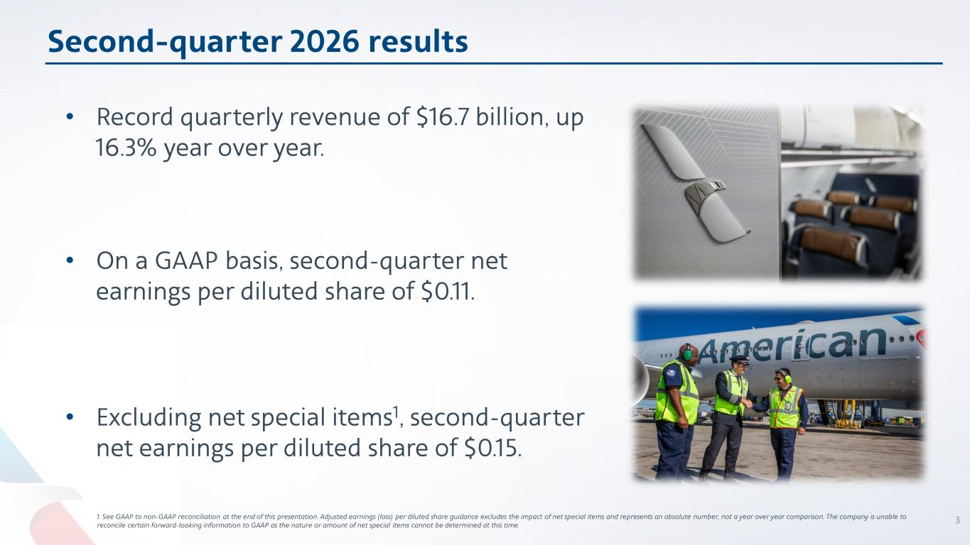
Second-quarter 2026 results • Record quarterly revenue of $16.7 billion, up 16.3% year over year. • On a GAAP basis, second-quarter net earnings per diluted share of $0.11. • Excluding net special items1, second-quarter net earnings per diluted share of $0.15. 1. See GAAP to non-GAAP reconciliation at the end of this presentation. Adjusted earnings (loss) per diluted share guidance excludes the impact of net special items and represents an absolute number, not a year over year comparison. The company is unable to reconcile certain forward-looking information to GAAP as the nature or amount of net special items cannot be determined at this time. 3

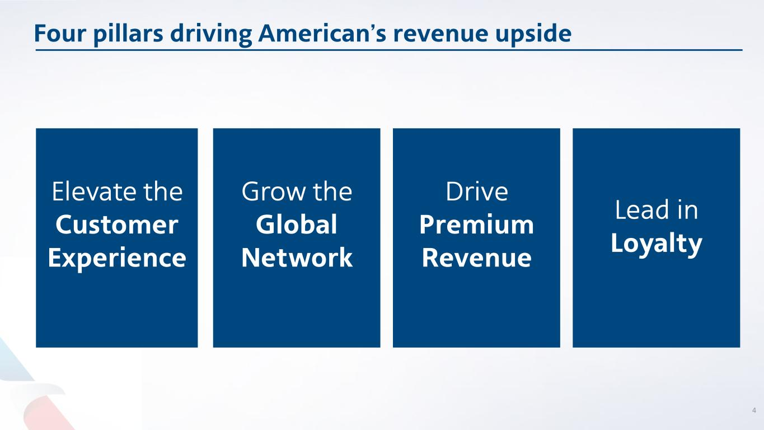
Four pillars driving American’s revenue upside Elevate the Customer Experience Lead in Loyalty Grow the Global Network Drive Premium Revenue 4

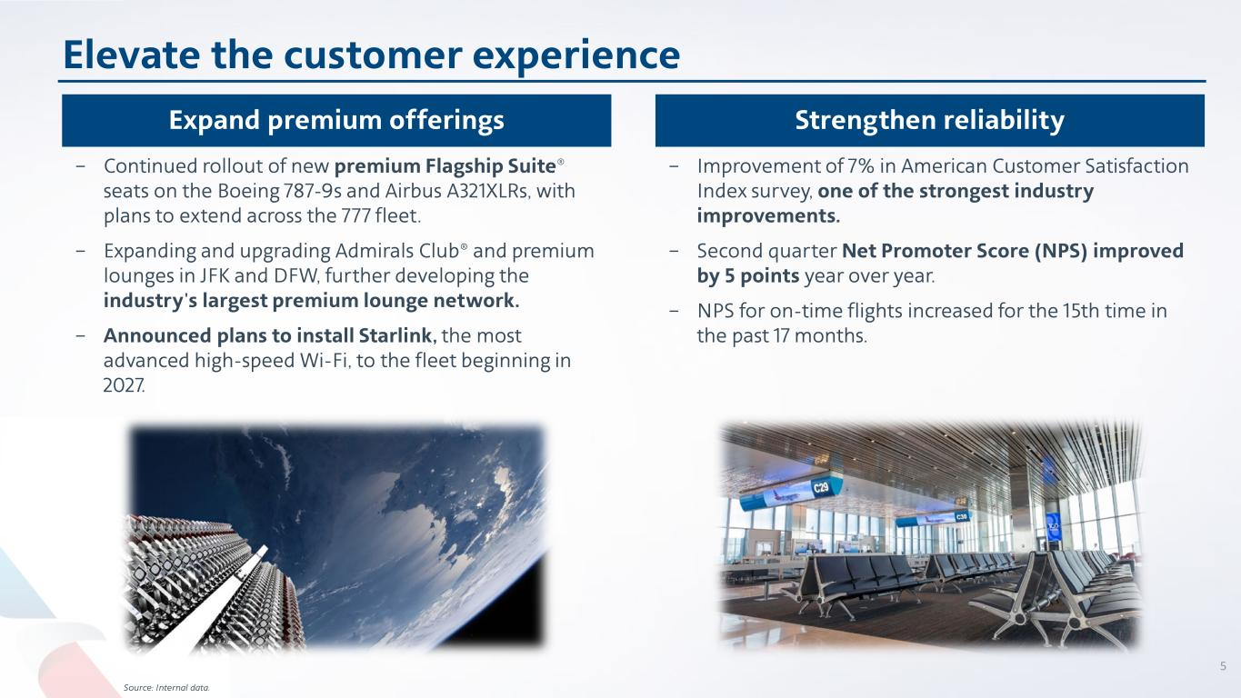
Elevate the customer experience 5 Expand premium offerings Strengthen reliability − Continued rollout of new premium Flagship Suite® seats on the Boeing 787-9s and Airbus A321XLRs, with plans to extend across the 777 fleet. − Expanding and upgrading Admirals Club® and premium lounges in JFK and DFW, further developing the industry's largest premium lounge network. − Announced plans to install Starlink, the most advanced high-speed Wi-Fi, to the fleet beginning in 2027. − Improvement of 7% in American Customer Satisfaction Index survey, one of the strongest industry improvements. − Second quarter Net Promoter Score (NPS) improved by 5 points year over year. − NPS for on-time flights increased for the 15th time in the past 17 months. Source: Internal data.

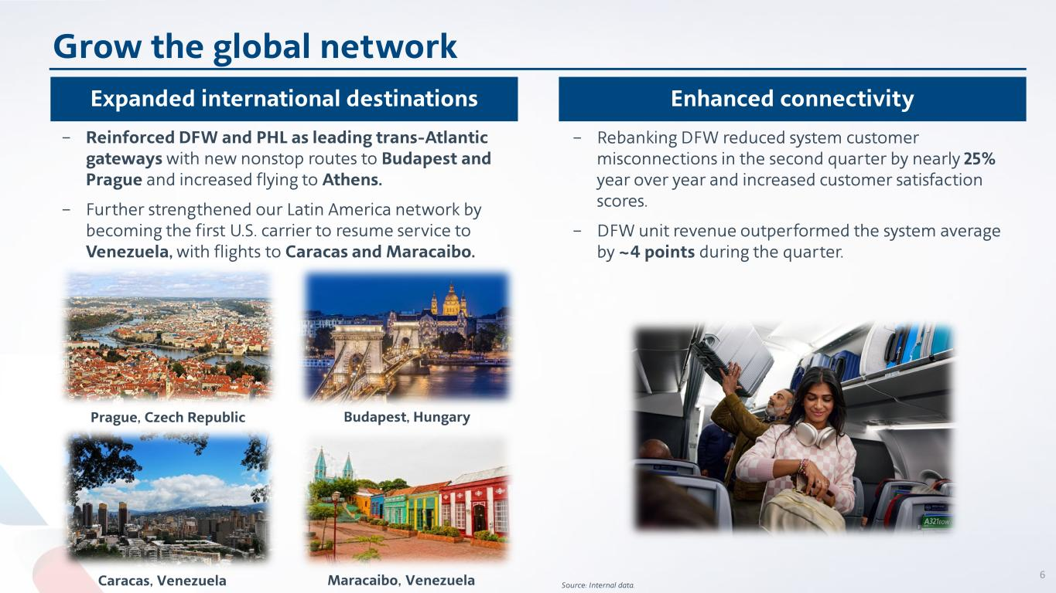
Caracas, Venezuela Grow the global network 6 Expanded international destinations Enhanced connectivity Source: Internal data. − Reinforced DFW and PHL as leading trans-Atlantic gateways with new nonstop routes to Budapest and Prague and increased flying to Athens. − Further strengthened our Latin America network by becoming the first U.S. carrier to resume service to Venezuela, with flights to Caracas and Maracaibo. Prague, Czech Republic Budapest, Hungary Maracaibo, Venezuela − Rebanking DFW reduced system customer misconnections in the second quarter by nearly 25% year over year and increased customer satisfaction scores. − DFW unit revenue outperformed the system average by ~4 points during the quarter.

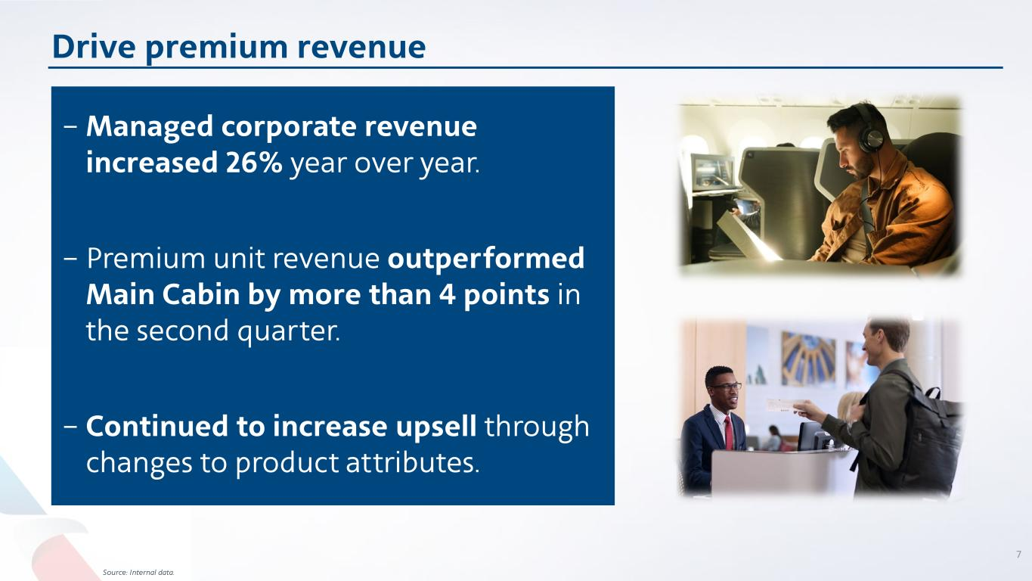
Drive premium revenue 7 Source: Internal data. − Managed corporate revenue increased 26% year over year. − Premium unit revenue outperformed Main Cabin by more than 4 points in the second quarter. − Continued to increase upsell through changes to product attributes.


Lead in loyalty 8 Source: Internal data − Second-quarter AAdvantage® enrollments increased over 30% year over year, exceeding the record growth achieved in the first quarter. − Exclusive redemption experiences like FIFA World Cup 26 TM . Expanding loyalty ecosystem − Second-quarter card spend increased 8% year over year, demonstrating sustained engagement across the portfolio. − Best airline loyalty program redemption value. Loyalty driving value creation Industry-leading loyalty program continues to evolve and offers exclusive benefits

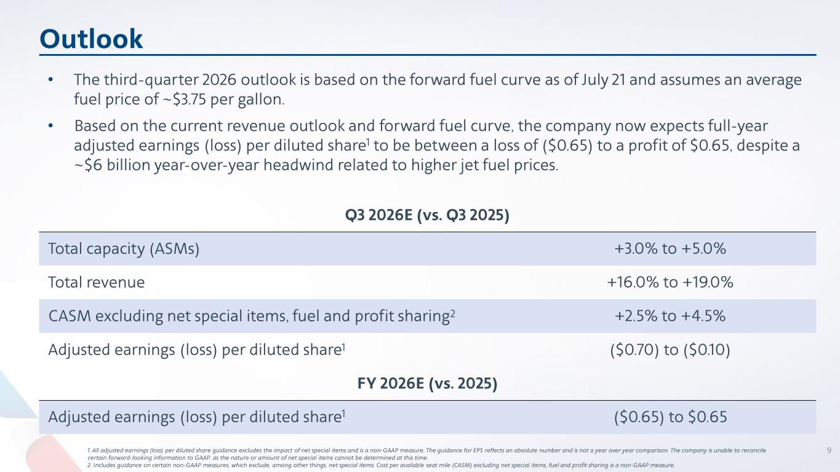
Outlook 1. All adjusted earnings (loss) per diluted share guidance excludes the impact of net special items and is a non-GAAP measure. The guidance for EPS reflects an absolute number and is not a year over year comparison. The company is unable to reconcile certain forward-looking information to GAAP, as the nature or amount of net special items cannot be determined at this time. 2. Includes guidance on certain non-GAAP measures, which exclude, among other things, net special items. Cost per available seat mile (CASM) excluding net special items, fuel and profit sharing is a non-GAAP measure. Q3 2026E (vs. Q3 2025) Total capacity (ASMs) +3.0% to +5.0% Total revenue +16.0% to +19.0% CASM excluding net special items, fuel and profit sharing2 +2.5% to +4.5% Adjusted earnings (loss) per diluted share1 ($0.70) to ($0.10) FY 2026E (vs. 2025) Adjusted earnings (loss) per diluted share1 ($0.65) to $0.65 • The third-quarter 2026 outlook is based on the forward fuel curve as of July 21 and assumes an average fuel price of ~$3.75 per gallon. • Based on the current revenue outlook and forward fuel curve, the company now expects full-year adjusted earnings (loss) per diluted share1 to be between a loss of ($0.65) to a profit of $0.65, despite a ~$6 billion year-over-year headwind related to higher jet fuel prices. 9

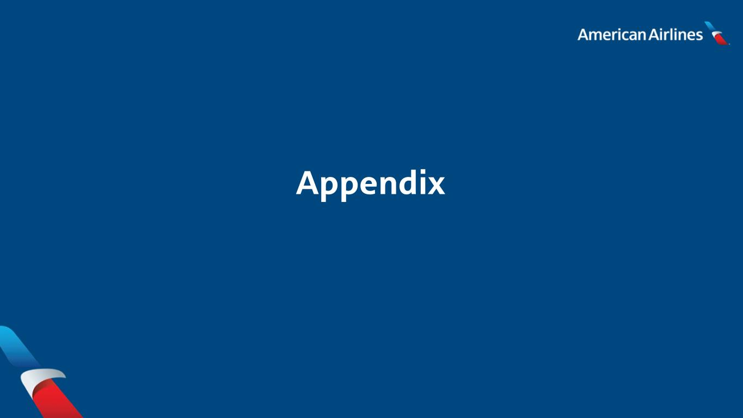
Appendix

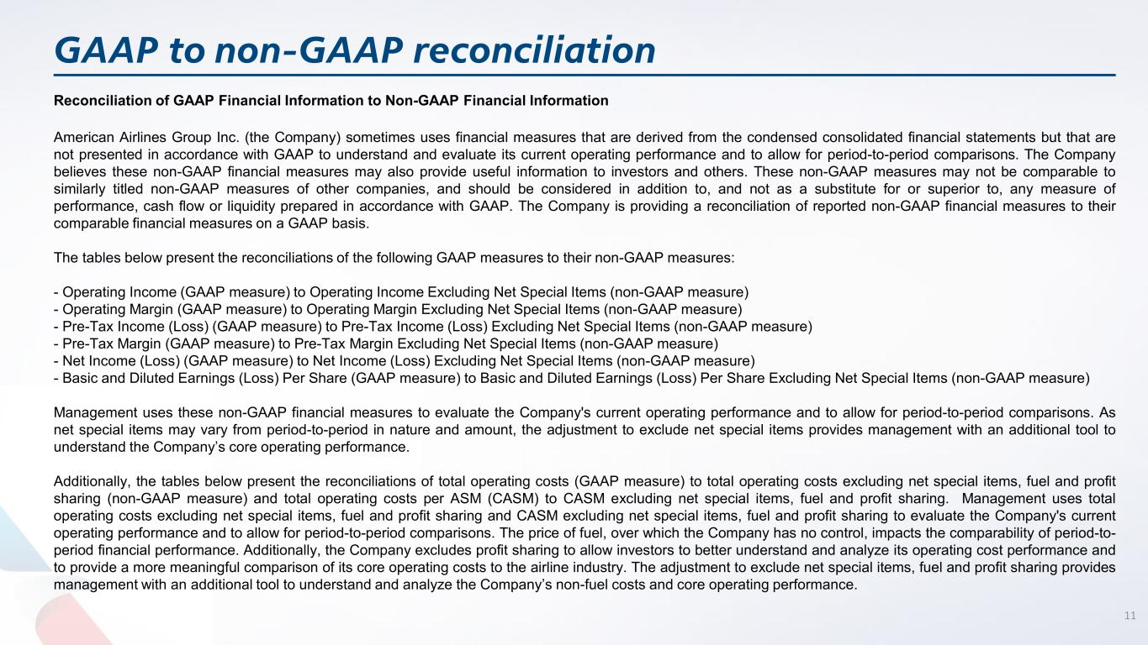
GAAP to non-GAAP reconciliation Reconciliation of GAAP Financial Information to Non-GAAP Financial Information American Airlines Group Inc. (the Company) sometimes uses financial measures that are derived from the condensed consolidated financial statements but that are not presented in accordance with GAAP to understand and evaluate its current operating performance and to allow for period-to-period comparisons. The Company believes these non-GAAP financial measures may also provide useful information to investors and others. These non-GAAP measures may not be comparable to similarly titled non-GAAP measures of other companies, and should be considered in addition to, and not as a substitute for or superior to, any measure of performance, cash flow or liquidity prepared in accordance with GAAP. The Company is providing a reconciliation of reported non-GAAP financial measures to their comparable financial measures on a GAAP basis. The tables below present the reconciliations of the following GAAP measures to their non-GAAP measures: - Operating Income (GAAP measure) to Operating Income Excluding Net Special Items (non-GAAP measure) - Operating Margin (GAAP measure) to Operating Margin Excluding Net Special Items (non-GAAP measure) - Pre-Tax Income (Loss) (GAAP measure) to Pre-Tax Income (Loss) Excluding Net Special Items (non-GAAP measure) - Pre-Tax Margin (GAAP measure) to Pre-Tax Margin Excluding Net Special Items (non-GAAP measure) - Net Income (Loss) (GAAP measure) to Net Income (Loss) Excluding Net Special Items (non-GAAP measure) - Basic and Diluted Earnings (Loss) Per Share (GAAP measure) to Basic and Diluted Earnings (Loss) Per Share Excluding Net Special Items (non-GAAP measure) Management uses these non-GAAP financial measures to evaluate the Company's current operating performance and to allow for period-to-period comparisons. As net special items may vary from period-to-period in nature and amount, the adjustment to exclude net special items provides management with an additional tool to understand the Company’s core operating performance. Additionally, the tables below present the reconciliations of total operating costs (GAAP measure) to total operating costs excluding net special items, fuel and profit sharing (non-GAAP measure) and total operating costs per ASM (CASM) to CASM excluding net special items, fuel and profit sharing. Management uses total operating costs excluding net special items, fuel and profit sharing and CASM excluding net special items, fuel and profit sharing to evaluate the Company's current operating performance and to allow for period-to-period comparisons. The price of fuel, over which the Company has no control, impacts the comparability of period-to- period financial performance. Additionally, the Company excludes profit sharing to allow investors to better understand and analyze its operating cost performance and to provide a more meaningful comparison of its core operating costs to the airline industry. The adjustment to exclude net special items, fuel and profit sharing provides management with an additional tool to understand and analyze the Company’s non-fuel costs and core operating performance. 11

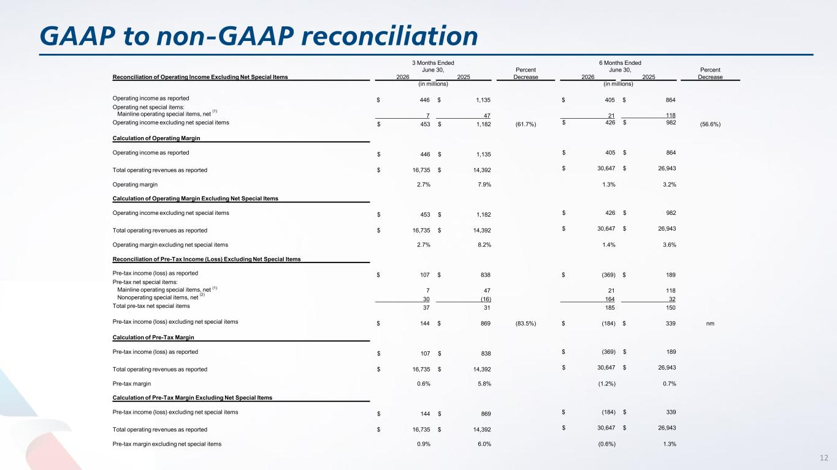
GAAP to non-GAAP reconciliation 12 Reconciliation of Operating Income Excluding Net Special Items 3 Months Ended June 30, Percent 6 Months Ended June 30, Percent 2026 2025 Decrease 2026 2025 Decrease (in millions) (in millions) Operating income as reported $ 446 $ 1,135 $ 405 $ 864 Operating net special items: Mainline operating special items, net (1) 7 47 21 118 Operating income excluding net special items $ 453 $ 1,182 (61.7%) $ 426 $ 982 (56.6%) Calculation of Operating Margin Operating income as reported $ 446 $ 1,135 $ 405 $ 864 Total operating revenues as reported $ 16,735 $ 14,392 $ 30,647 $ 26,943 Operating margin 2.7% 7.9% 1.3% 3.2% Calculation of Operating Margin Excluding Net Special Items Operating income excluding net special items $ 453 $ 1,182 $ 426 $ 982 Total operating revenues as reported $ 16,735 $ 14,392 $ 30,647 $ 26,943 Operating margin excluding net special items 2.7% 8.2% 1.4% 3.6% Reconciliation of Pre-Tax Income (Loss) Excluding Net Special Items Pre-tax income (loss) as reported $ 107 $ 838 $ (369) $ 189 Pre-tax net special items: Mainline operating special items, net (1) 7 47 21 118 Nonoperating special items, net (2) 30 (16) 164 32 Total pre-tax net special items 37 31 185 150 Pre-tax income (loss) excluding net special items $ 144 $ 869 (83.5%) $ (184) $ 339 nm Calculation of Pre-Tax Margin Pre-tax income (loss) as reported $ 107 $ 838 $ (369) $ 189 Total operating revenues as reported $ 16,735 $ 14,392 $ 30,647 $ 26,943 Pre-tax margin 0.6% 5.8% (1.2%) 0.7% Calculation of Pre-Tax Margin Excluding Net Special Items Pre-tax income (loss) excluding net special items $ 144 $ 869 $ (184) $ 339 Total operating revenues as reported $ 16,735 $ 14,392 $ 30,647 $ 26,943 Pre-tax margin excluding net special items 0.9% 6.0% (0.6%) 1.3%

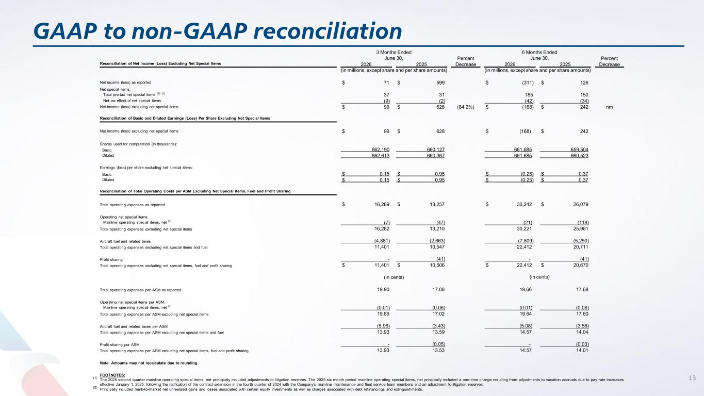
GAAP to non-GAAP reconciliation 13 3 Months Ended June 30, Percent 6 Months Ended June 30, Percent Reconciliation of Net Income (Loss) Excluding Net Special Items 2026 2025 Decrease 2026 2025 Decrease (in millions, except share and per share amounts) (in millions, except share and per share amounts) Net income (loss) as reported $ 71 $ 599 $ (311) $ 126 Net special items: Total pre-tax net special items (1), (2) 37 31 185 150 Net tax effect of net special items (9) (2) (42) (34) Net income (loss) excluding net special items $ 99 $ 628 (84.2%) $ (168) $ 242 nm Reconciliation of Basic and Diluted Earnings (Loss) Per Share Excluding Net Special Items Net income (loss) excluding net special items $ 99 $ 628 $ (168) $ 242 Shares used for computation (in thousands): Basic 662,190 660,127 661,685 659,504 Diluted 662,613 660,367 661,685 660,523 Earnings (loss) per share excluding net special items: Basic $ 0.15 $ 0.95 $ (0.25) $ 0.37 Diluted $ 0.15 $ 0.95 $ (0.25) $ 0.37 Reconciliation of Total Operating Costs per ASM Excluding Net Special Items, Fuel and Profit Sharing Total operating expenses as reported $ 16,289 $ 13,257 $ 30,242 $ 26,079 Operating net special items: Mainline operating special items, net (1) (7) (47) (21) (118) Total operating expenses excluding net special items 16,282 13,210 30,221 25,961 Aircraft fuel and related taxes (4,881) (2,663) (7,809) (5,250) Total operating expenses excluding net special items and fuel 11,401 10,547 22,412 20,711 Profit sharing - (41) - (41) Total operating expenses excluding net special items, fuel and profit sharing $ 11,401 $ 10,506 $ 22,412 $ 20,670 (in cents) (in cents) Total operating expenses per ASM as reported 19.90 17.08 19.66 17.68 Operating net special items per ASM: Mainline operating special items, net (1) (0.01) (0.06) (0.01) (0.08) Total operating expenses per ASM excluding net special items 19.89 17.02 19.64 17.60 Aircraft fuel and related taxes per ASM (5.96) (3.43) (5.08) (3.56) Total operating expenses per ASM excluding net special items and fuel 13.93 13.59 14.57 14.04 Profit sharing per ASM - (0.05) - (0.03) Total operating expenses per ASM excluding net special items, fuel and profit sharing 13.93 13.53 14.57 14.01 Note: Amounts may not recalculate due to rounding. FOOTNOTES: (1) The 2025 second quarter mainline operating special items, net principally included adjustments to litigation reserves. The 2025 six month period mainline operating special items, net principally included a one-time charge resulting from adjustments to vacation accruals due to pay rate increases effective January 1, 2025, following the ratification of the contract extension in the fourth quarter of 2024 with the Company's mainline maintenance and fleet service team members and an adjustment to litigation reserves. (2) Principally included mark-to-market net unrealized gains and losses associated with certain equity investments as well as charges associated with debt refinancings and extinguishments.


14

